VAT for Accountants
User Guide
Filing VAT for clients from Tax Optimiser — creating client organisations, mapping their spreadsheets, connecting to HMRC with your agent account, sending returns and giving clients access.
taxoptimiser.co.uk · 17 October 2026

Contents
- Filing VAT for clients: the accountant workflow — How filing VAT for clients works in Tax Optimiser - what you set up once for the firm and what you do for each client.
- Create a client organisation and enable VAT — Add a client organisation from your Organisations list - only the VAT registration number is required.
- Map the client's VAT spreadsheet — Tell Tax Optimiser which sheet and cells of the client's spreadsheet hold the nine VAT-return boxes.
- Connect to HMRC: demo mode, then live with your agent account — Practise the HMRC connection in demo mode, then go live with your firm's agent account and let the client's periods flow in.
- Upload, check and send a client's VAT return — Upload the client's spreadsheet, check the nine boxes, accept the declaration and keep HMRC's receipt.
- Give clients access to their organisation — Give a client a login to their own organisation - they only ever see the organisations they belong to.
- Add additional accountants to your firm — Add colleagues to your firm so they can act for your clients with their own login.

1. Filing VAT for clients: the accountant workflow
How filing VAT for clients works in Tax Optimiser - what you set up once for the firm and what you do for each client.
IN SHORT
- Tax Optimiser is MTD bridging software: clients keep their own spreadsheets
- You file VAT for every client from one firm login
- Your HMRC agent account connects once and covers all clients
- Per client: create org, map spreadsheet, connect, then upload and send
- You can give each client access to their own organisation

Tax Optimiser files VAT returns to HMRC under Making Tax Digital as bridging software: your client keeps their figures in their own spreadsheet, and you upload it and submit the nine VAT-return boxes digitally on their behalf. As an accountant you do this for every client from one firm login — this guide walks the whole journey, from creating a client organisation to sending its return and giving the client access.

Sign up as an accountant
If you haven’t already, click Sign up in the top-right corner, choose Accountant / Bookkeeper, and register with your details. You land on your accountant dashboard; Organisations is your list of clients.
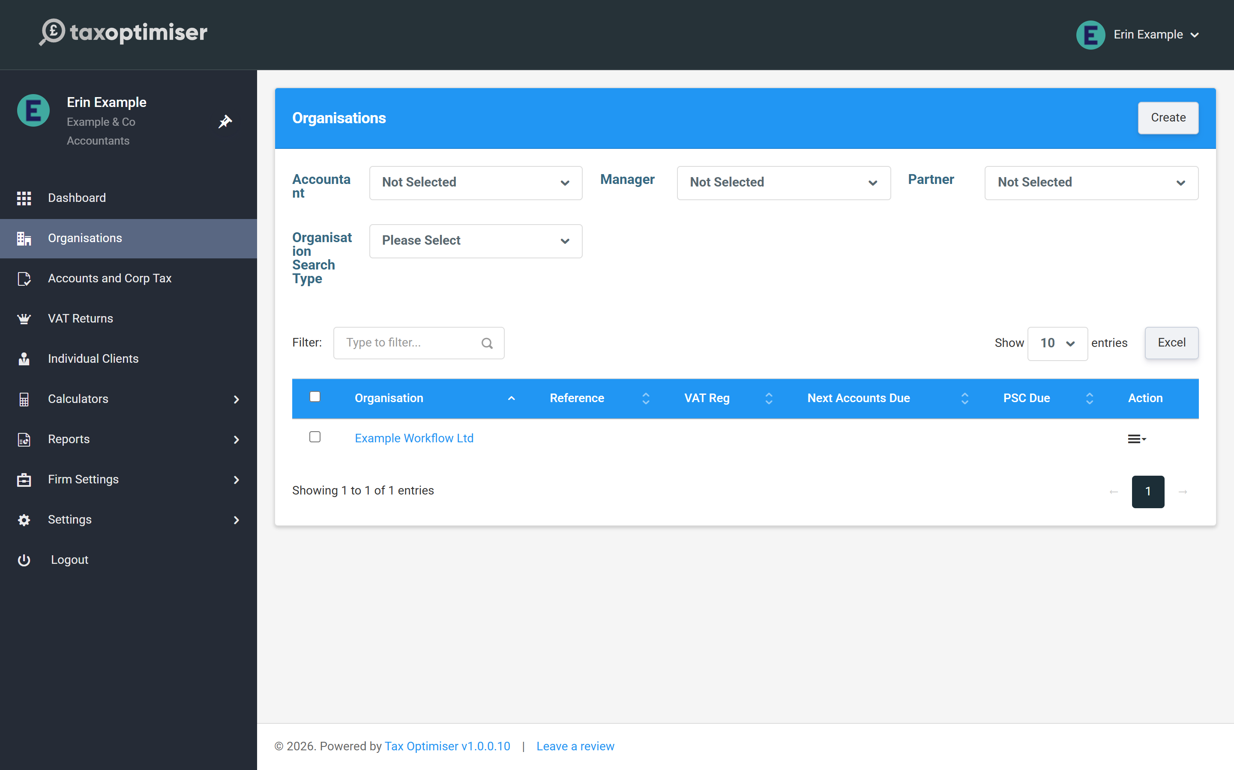

What you set up once for the firm
Connecting to HMRC for VAT uses your firm’s HMRC agent account — connect it once and you can view and submit VAT for every client you act for. You can also add colleagues to the firm so they can work alongside you (covered in the last article).

What you do for each client
- Create the organisation and record its VAT registration number.
- Map its VAT spreadsheet in VAT Settings — once per client.
- Connect to HMRC (practise in demo mode, then go live with your agent account) so the client’s VAT periods flow in.
- Each quarter, upload, check and send the return.
- Optionally give the client access to their own organisation.

2. Create a client organisation and enable VAT
Add a client organisation from your Organisations list - only the VAT registration number is required.
IN SHORT
- Each client is an organisation; create one per client
- Add from Organisations, then Actions, Add New
- Only the VAT Registration No is required to get started
- A client has its own sub-menu; the accountant menu returns to your firm view
- The VAT number and scheme live on the client's Tax & VAT settings

Every client you act for is an organisation in Tax Optimiser. You create one per client, and for VAT the only field you must complete is the client’s VAT registration number — everything else can follow later.

Add the organisation
From your dashboard click Organisations to see your client list, then Actions → Add New.
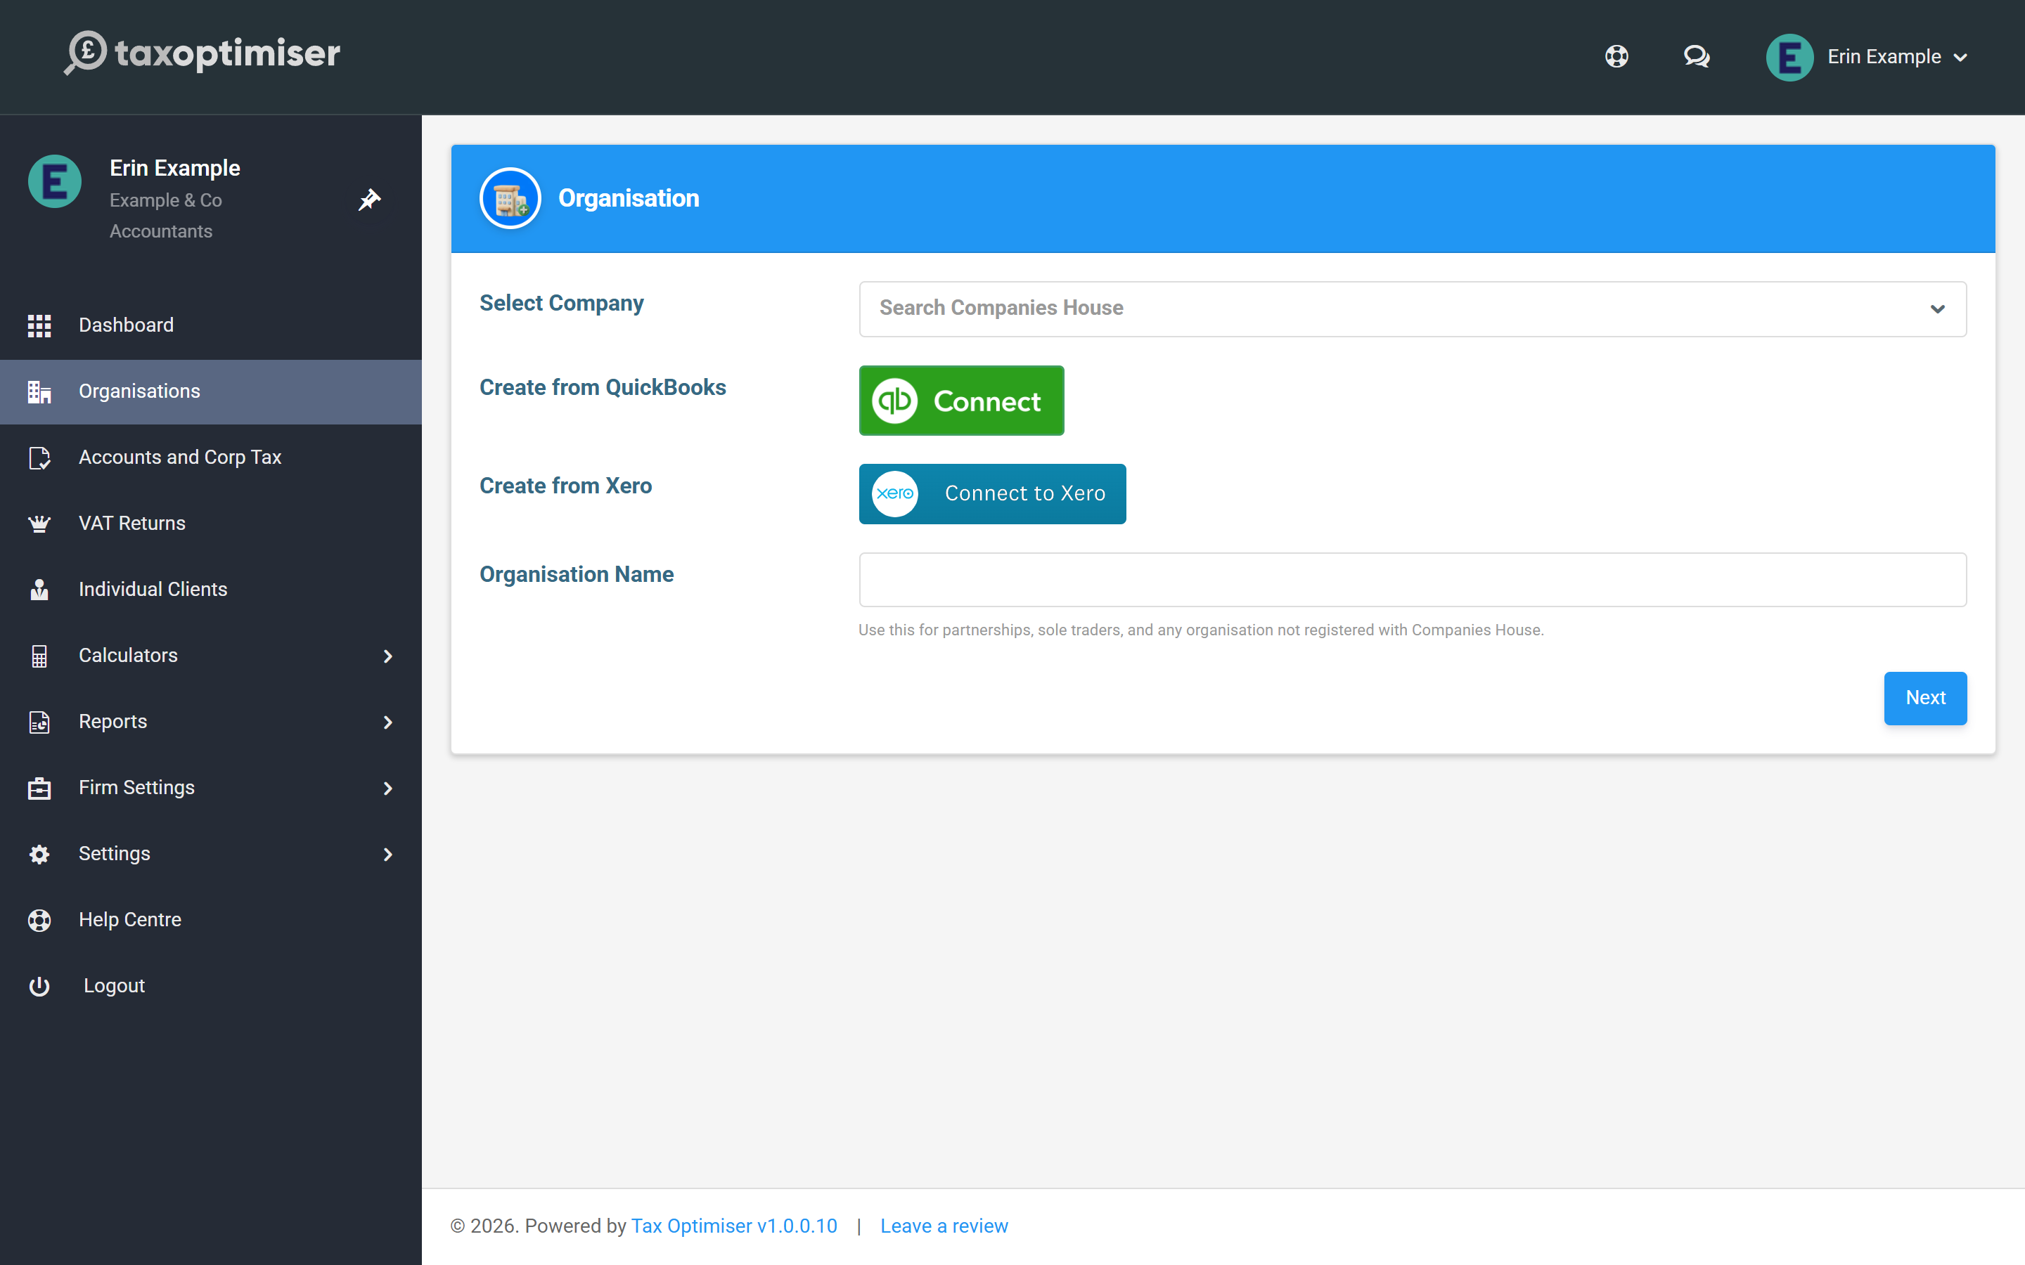
Enter the client’s details. For VAT, only the VAT Registration No is required — it’s the client’s 9-digit number from their VAT registration certificate. Press Save at the bottom.
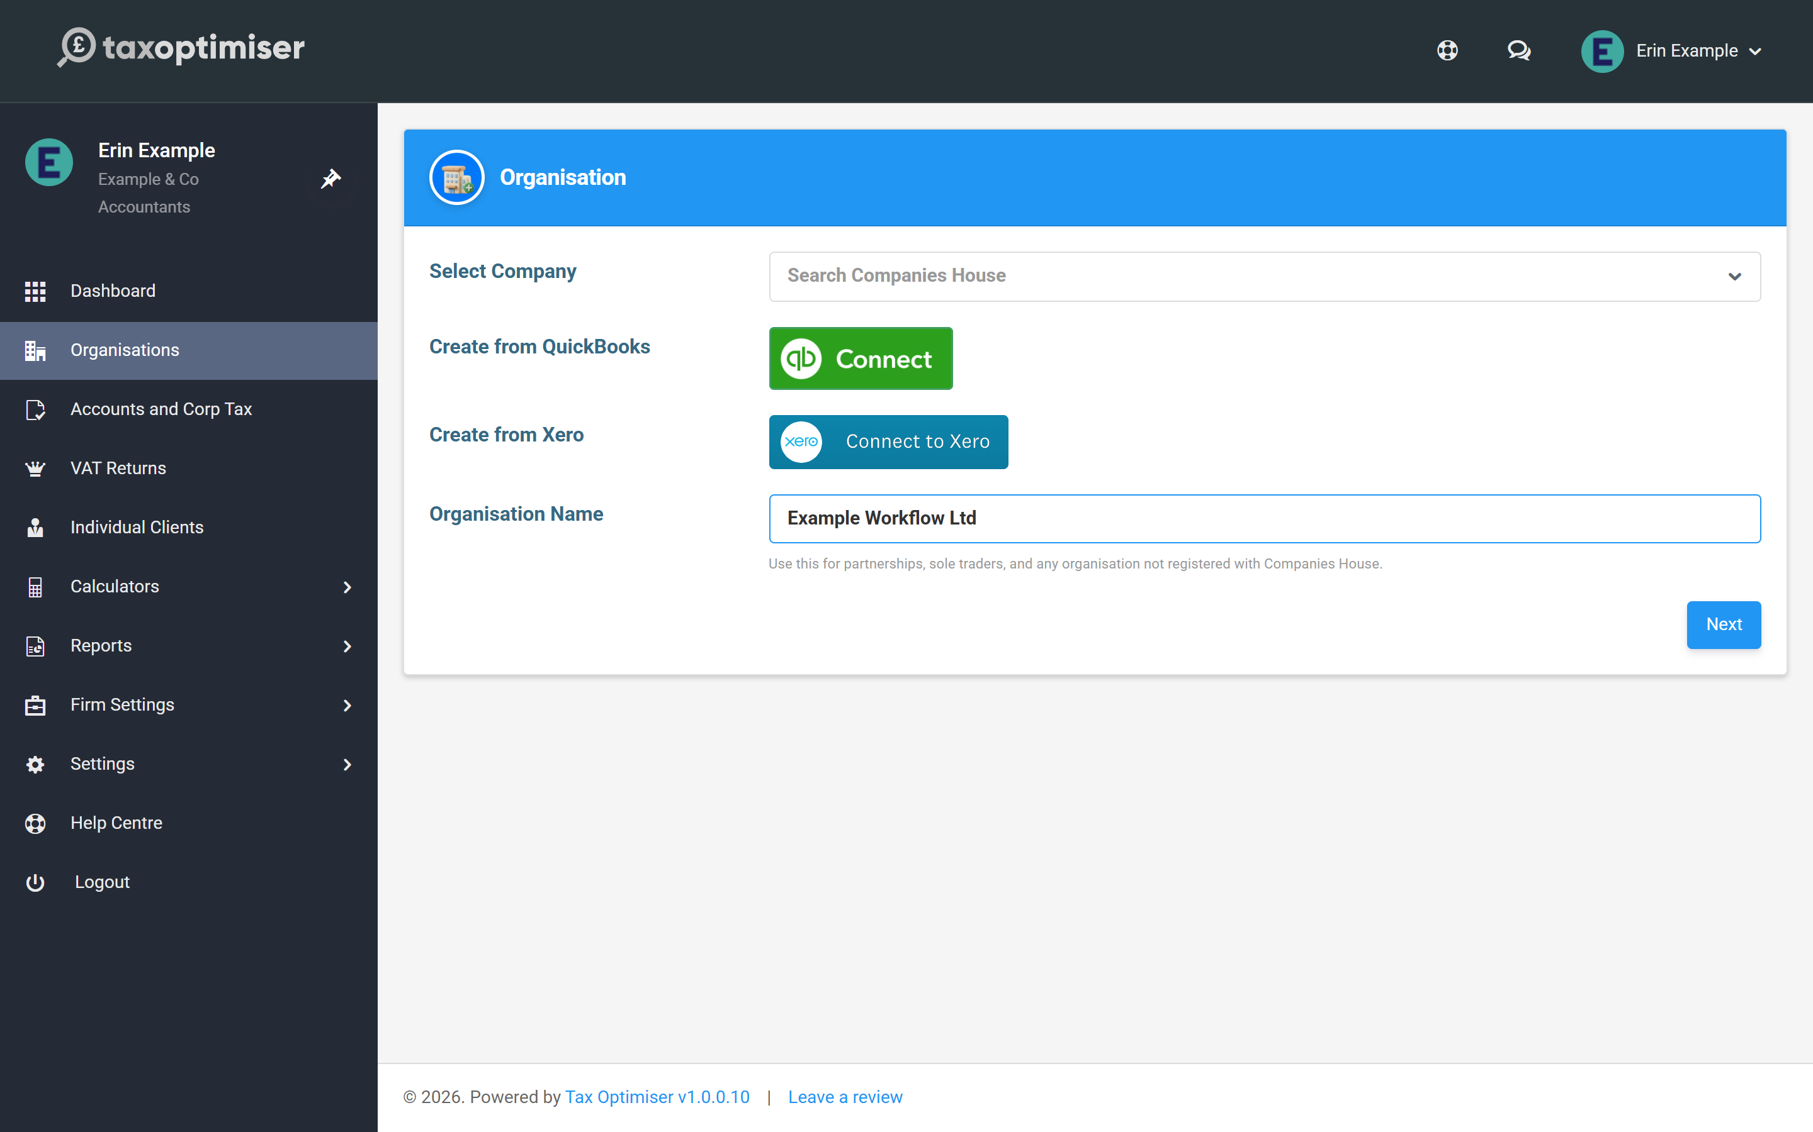

Find your way around a client
Once saved you’re inside the client’s organisation, with its own sub-menu for VAT and everything else. To get back to your firm’s view — the client list, firm settings — use the accountant menu. To add another client, return to the Organisations list and click Add New again.
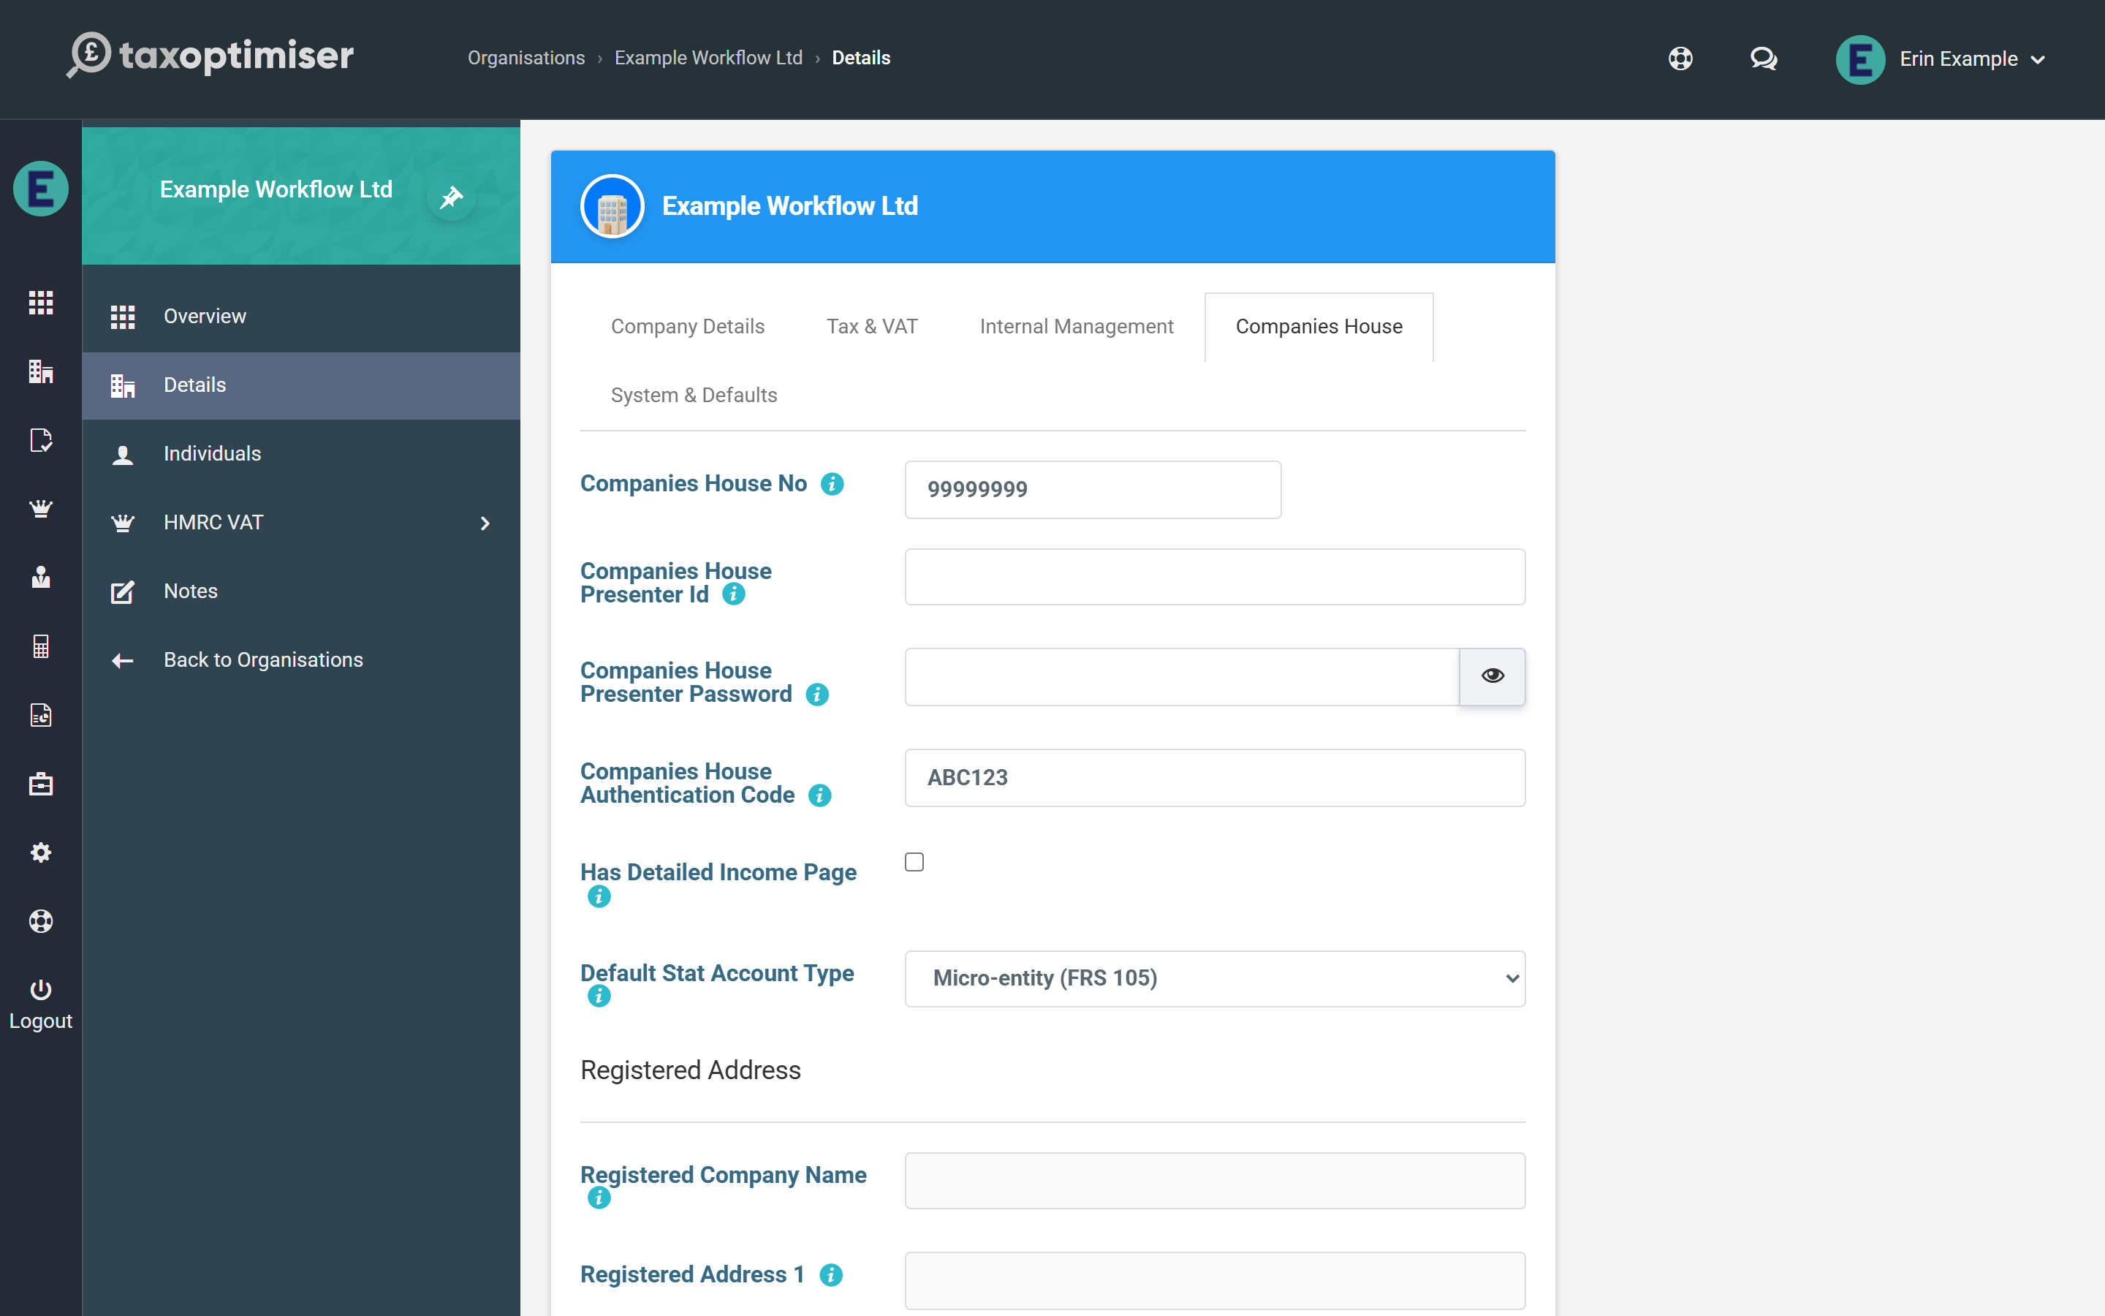

Where the VAT number lives later
If you need to check or change a client’s VAT registration number afterwards, it’s on the client’s Tax & VAT settings, alongside the VAT Scheme (most businesses are on Standard).
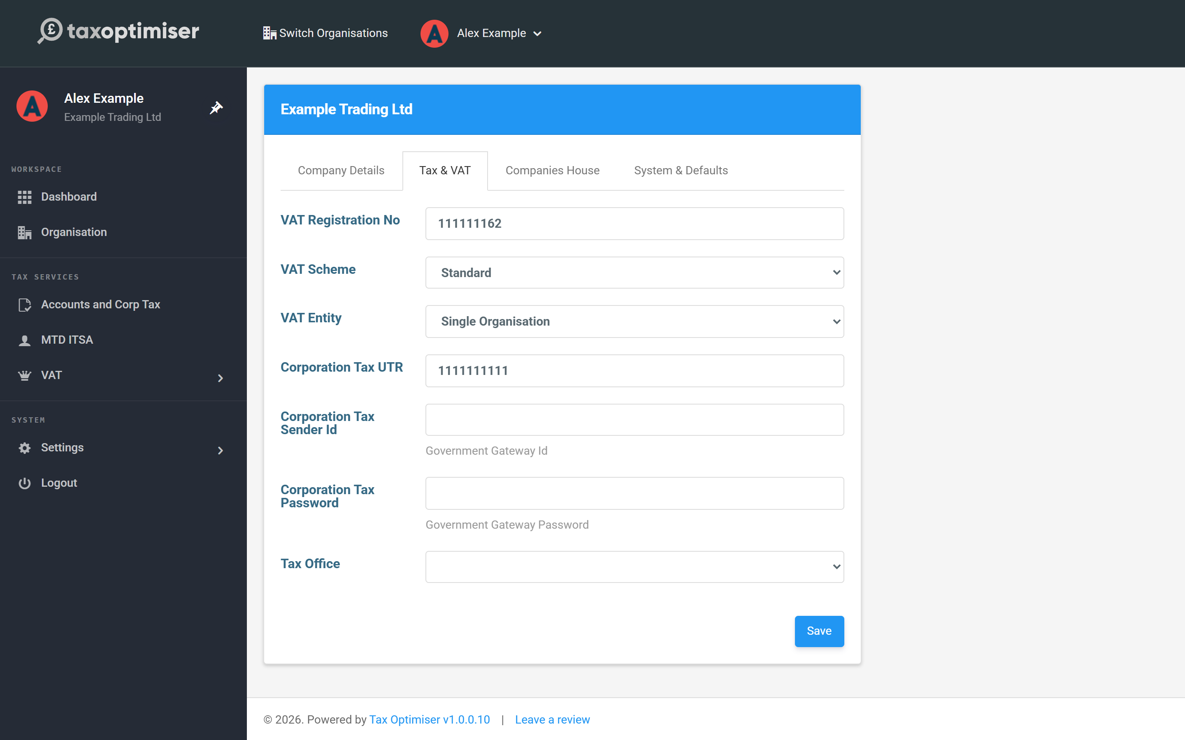

3. Map the client's VAT spreadsheet
Tell Tax Optimiser which sheet and cells of the client's spreadsheet hold the nine VAT-return boxes.
IN SHORT
- VAT Settings are per client - map each client's spreadsheet once
- Software templates pre-fill the mapping for common systems
- AI can find the cells for you, but the spreadsheet is sent to a third-party AI provider
- Check the figures AI found before saving; nothing is saved until you press Save
- Sheet name = the Excel tab name, matched exactly
- Each of the nine cell references points at one box's final figure

Each client’s VAT figures stay in their own spreadsheet, and you upload it each quarter so Tax Optimiser can read the nine HMRC boxes straight out of it. VAT Settings is where you tell it which sheet and cells to read. VAT settings are stored per organisation, so you set this up once for each client; after that the quarterly routine is just upload, check, send.

Open VAT Settings
Inside the client, open HMRC VAT → VAT Settings from the sidebar. You can also open the same settings without leaving the client’s returns: choose Actions → VAT Settings on the VAT Returns list or on a return. The VAT Submission Software name at the top is what appears on HMRC submissions as the originating software — leave it as Tax Optimiser unless told otherwise.
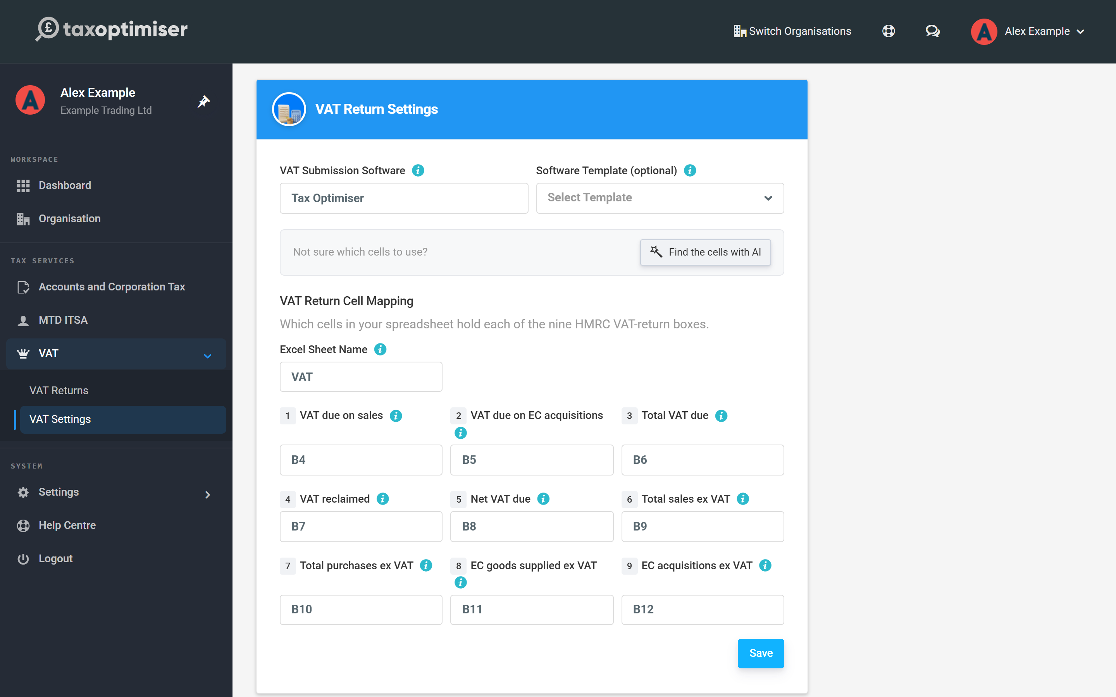

Start from a software template…
If the client exports their figures from a known system, pick it from Software Template — Sage 50, Sage 200, Access Dimensions, QuickBooks desktop, Dynamics NAV, MYOB, Manager.io and others are listed. Choosing one pre-fills the sheet name and all nine cell references; you can still adjust any of them. Press Save.
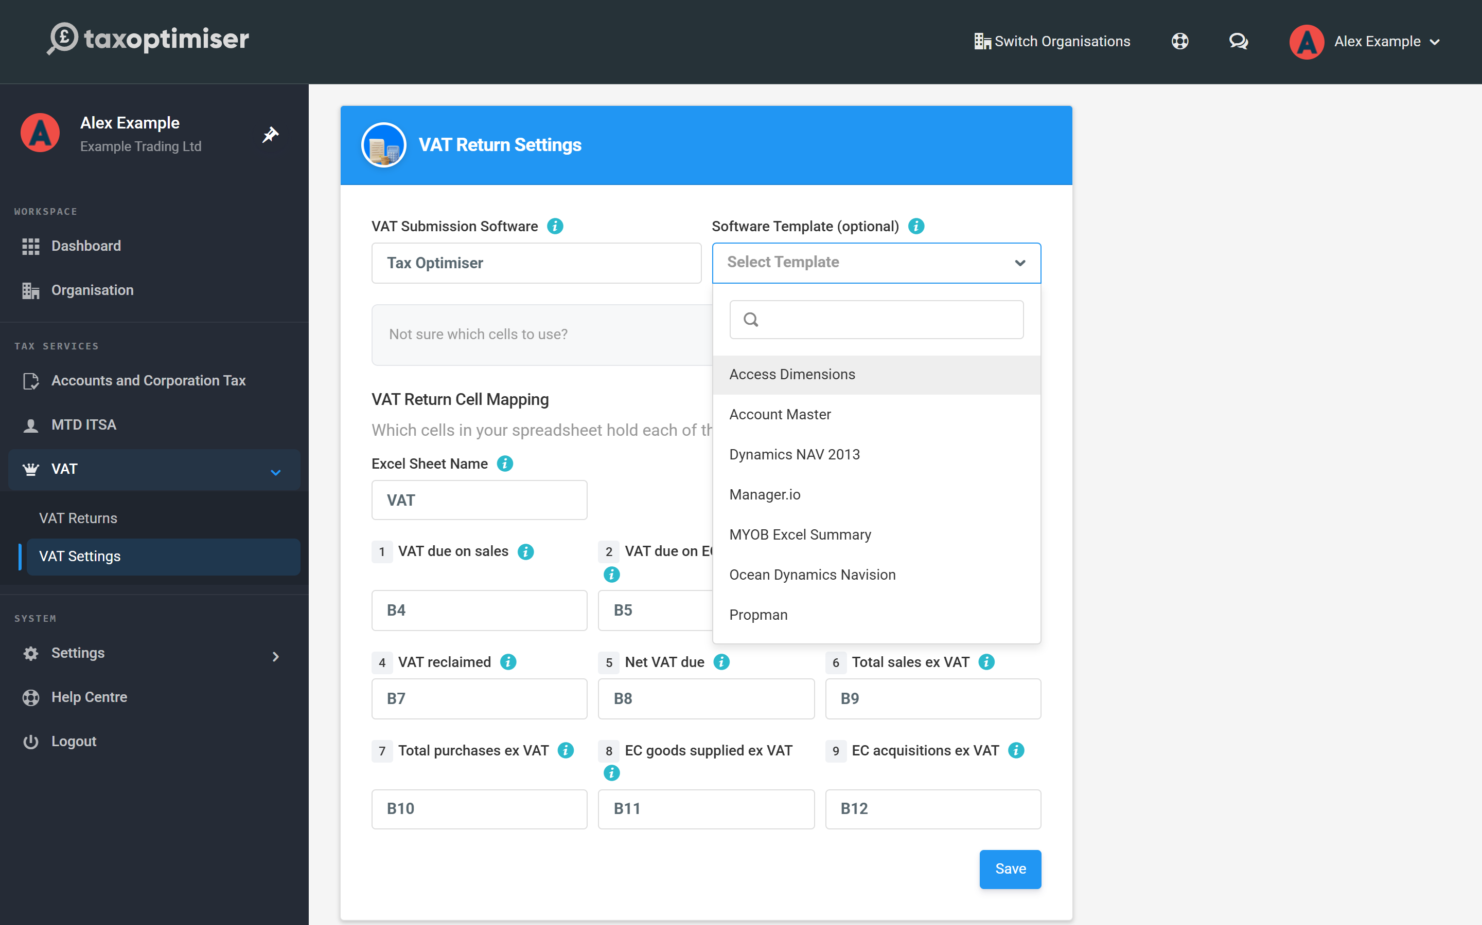

…let AI find the cells…
If the client has their own layout, Tax Optimiser can work out the mapping for you. Click Find the cells with AI, choose the client’s spreadsheet (Excel .xlsx, .xls, .xlsm or .csv), tick the box to confirm you understand, then click Find cells with AI.
Before you use it, note that the spreadsheet is sent to a third-party AI provider so it can read the layout. Don’t use this option if that isn’t acceptable for the client’s data.
AI fills in the sheet name and the nine cell references, and shows the figure it found under each cell reference. Each figure is read from the file the same way a normal upload reads it. If a cell holds text instead of a number, it is shown in red. If Box 3 doesn’t equal Box 1 + Box 2, or Box 5 doesn’t equal Box 3 − Box 4, you will see a warning.
Check every figure against the client’s spreadsheet and correct any cell before you press Save. Nothing is saved until you do. AI can make mistakes, and you remain responsible for the return you send to HMRC.

…or map the cells yourself
For a client’s own spreadsheet, fill the mapping in directly:
- Excel Sheet Name — the name of the worksheet tab along the bottom of Excel (for example VAT). It must match exactly, including spaces — it is not the filename.
- The nine cell references — one per HMRC box, such as B4. Each must point at the cell holding that box’s final figure.
Press Save. If the client would rather adopt a ready-made layout, the upload screen offers a Download Example Front Sheet Excel File that matches the default mapping out of the box.
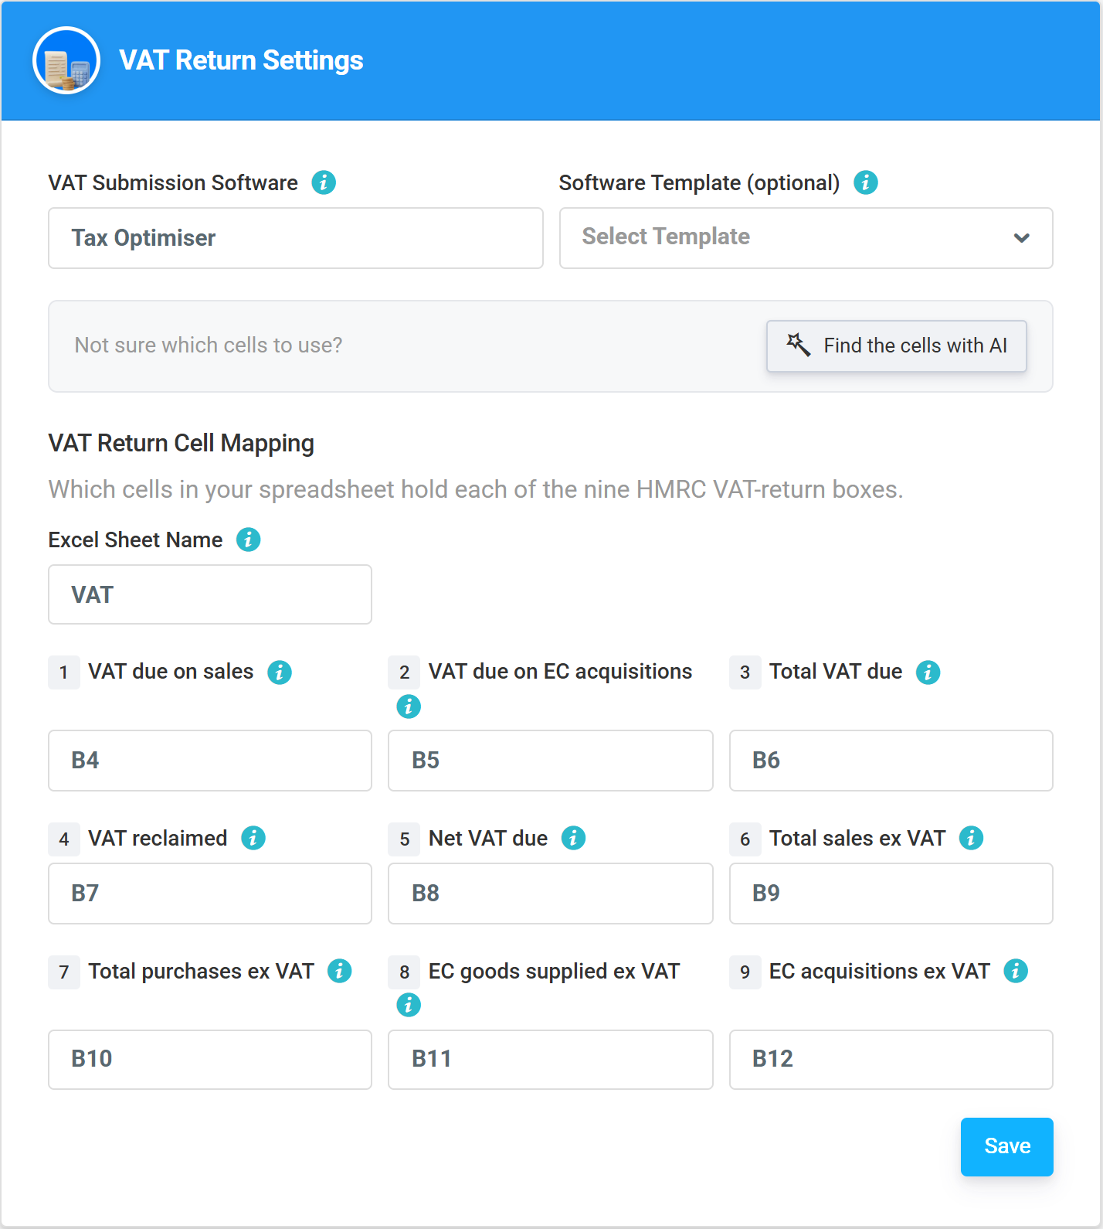

The nine boxes at a glance
- Box 1 — VAT due on sales and other outputs.
- Box 2 — VAT due on acquisitions of goods from EU member states (Northern Ireland traders only; 0 for most businesses).
- Box 3 — total VAT due: Box 1 + Box 2.
- Box 4 — VAT reclaimed on purchases and other inputs.
- Box 5 — net VAT due to (or reclaimable from) HMRC: Box 3 − Box 4.
- Box 6 — total value of sales excluding VAT, in whole pounds.
- Box 7 — total value of purchases excluding VAT, in whole pounds.
- Box 8 — total value of goods supplied to EU member states (NI traders only).
- Box 9 — total value of goods acquired from EU member states (NI traders only).

4. Connect to HMRC: demo mode, then live with your agent account
Practise the HMRC connection in demo mode, then go live with your firm's agent account and let the client's periods flow in.
IN SHORT
- Periods (obligations) are pulled from HMRC, never typed in
- Demo mode is a safe rehearsal: nothing is sent to HMRC
- Connect using the agent account to cover all your clients at once
- The client must be signed up to MTD for VAT before you go live
- Authority lasts 18 months; Refresh from HMRC re-pulls periods

Under Making Tax Digital a client’s VAT periods come from HMRC: once connected, Tax Optimiser pulls down their open and completed periods (HMRC calls them obligations) and you submit against them — you never type period dates in yourself. Every new client starts in demo mode, a safe sandbox where you can practise the whole journey without anything being sent to HMRC.

Practise in demo mode
Inside the client, open HMRC VAT → VAT Returns. A banner reminds you that nothing will be sent to HMRC. Click Connect to HMRC DEMO MODE.
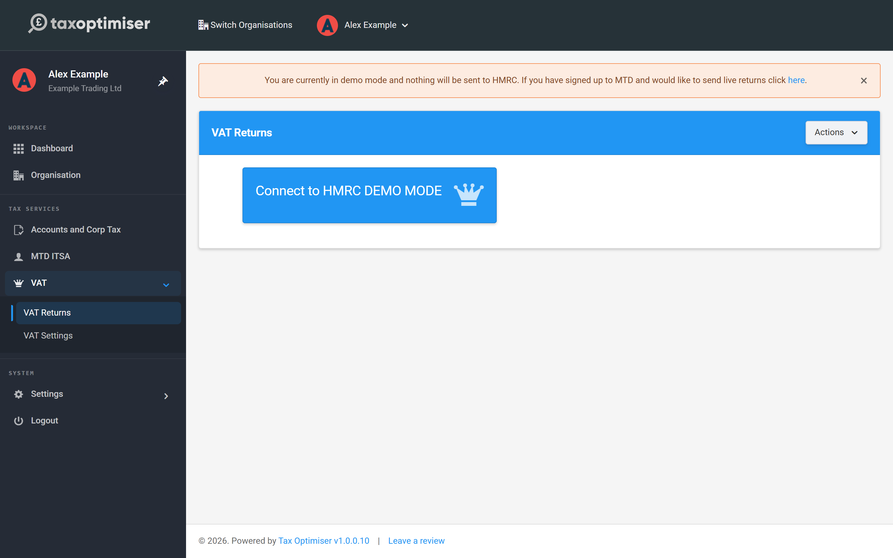
You’ll step through a simulation of HMRC’s real connection flow, so there are no surprises when you do it for real: press Continue, then Sign in on the dummy login (no credentials needed in demo mode), and finally Grant authority.
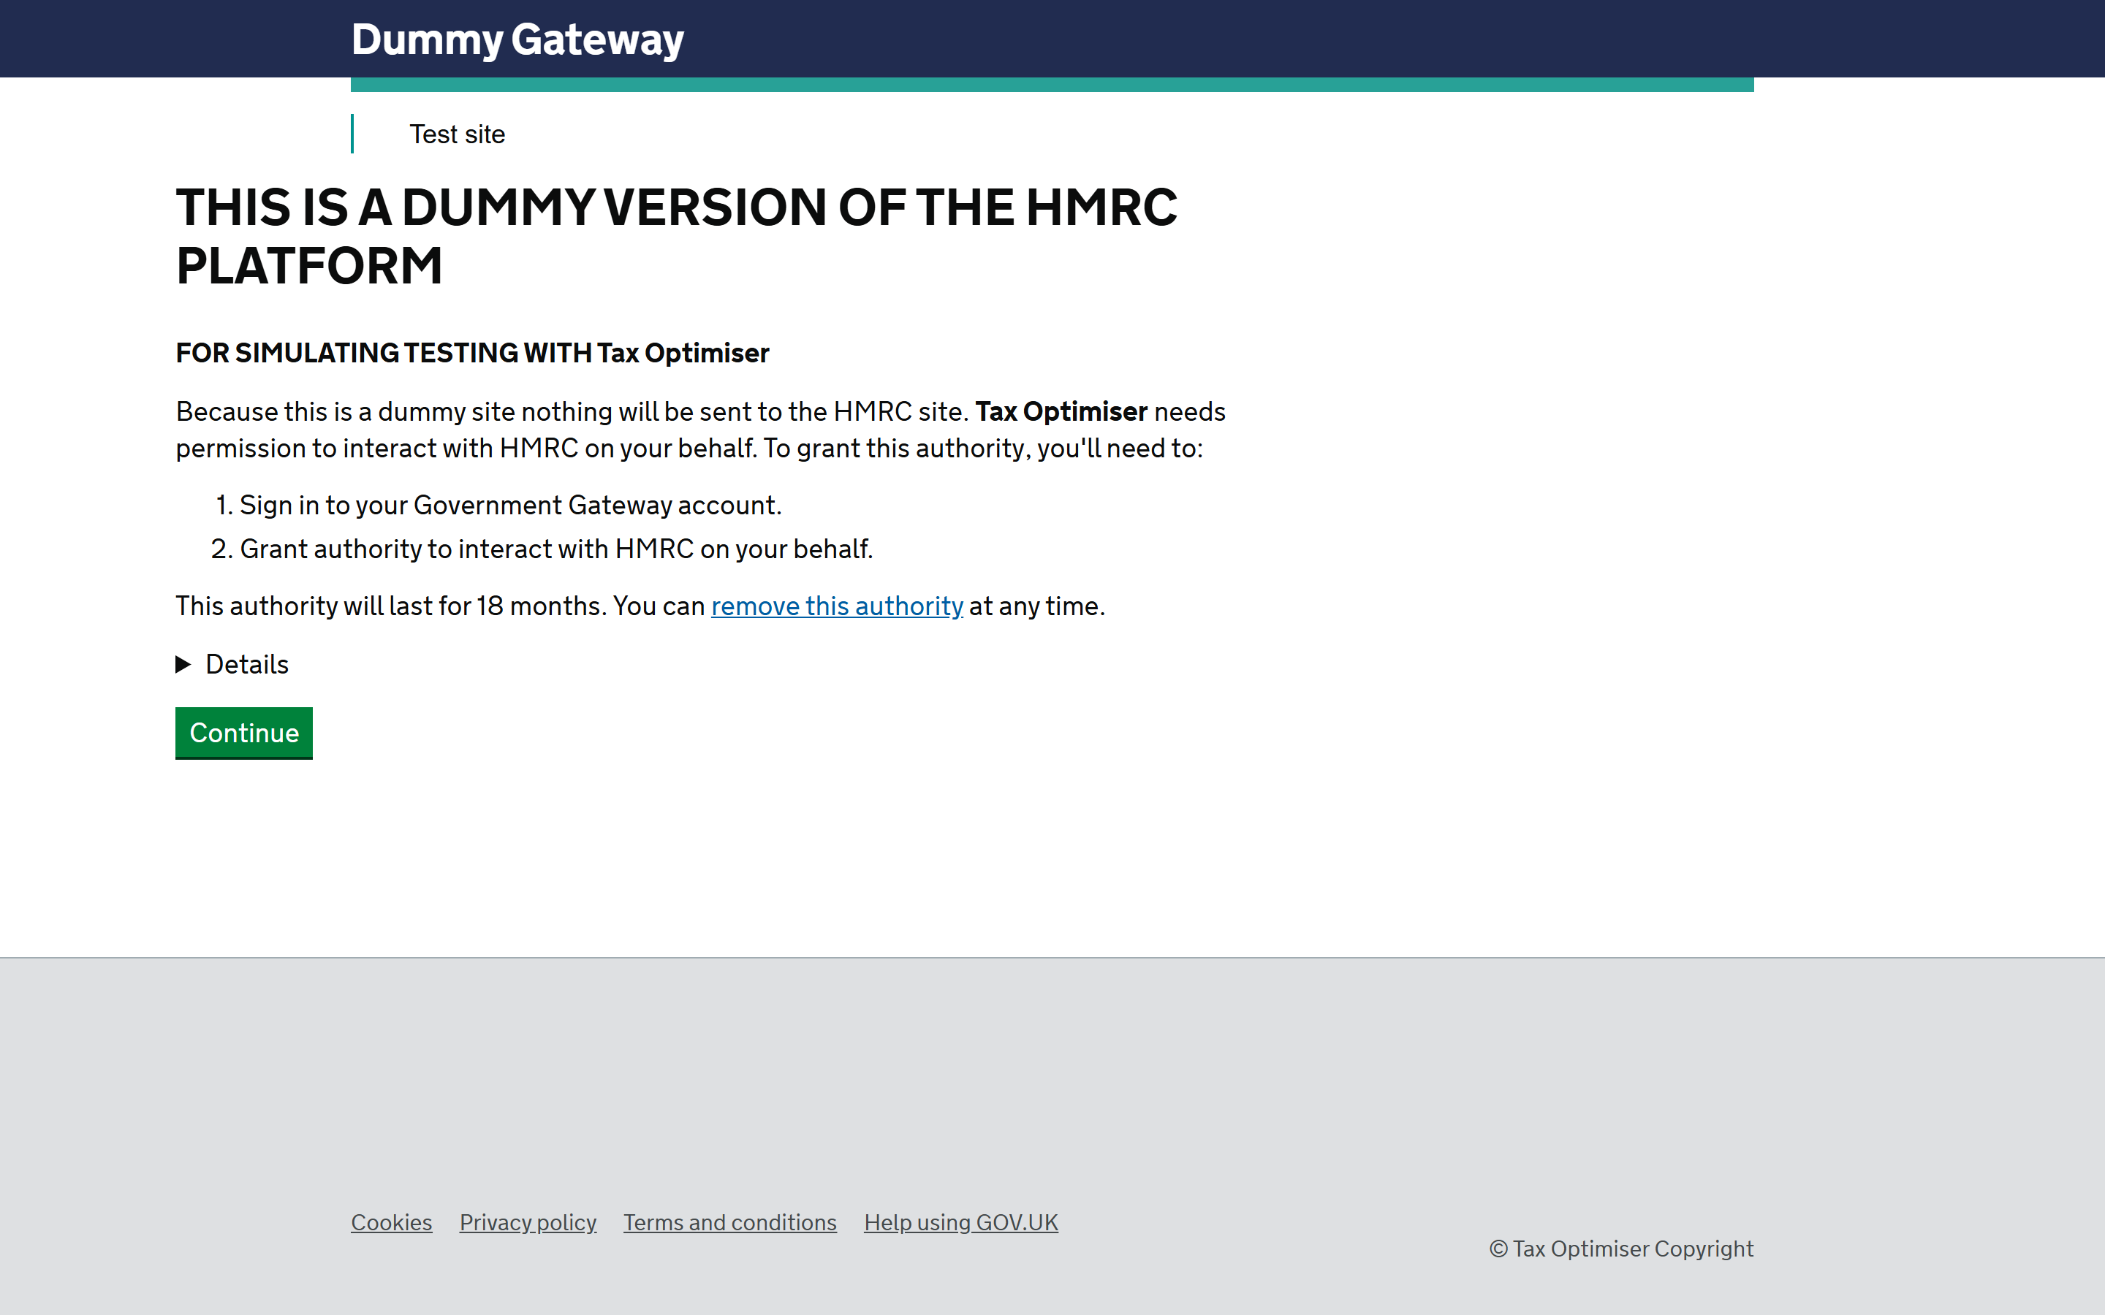
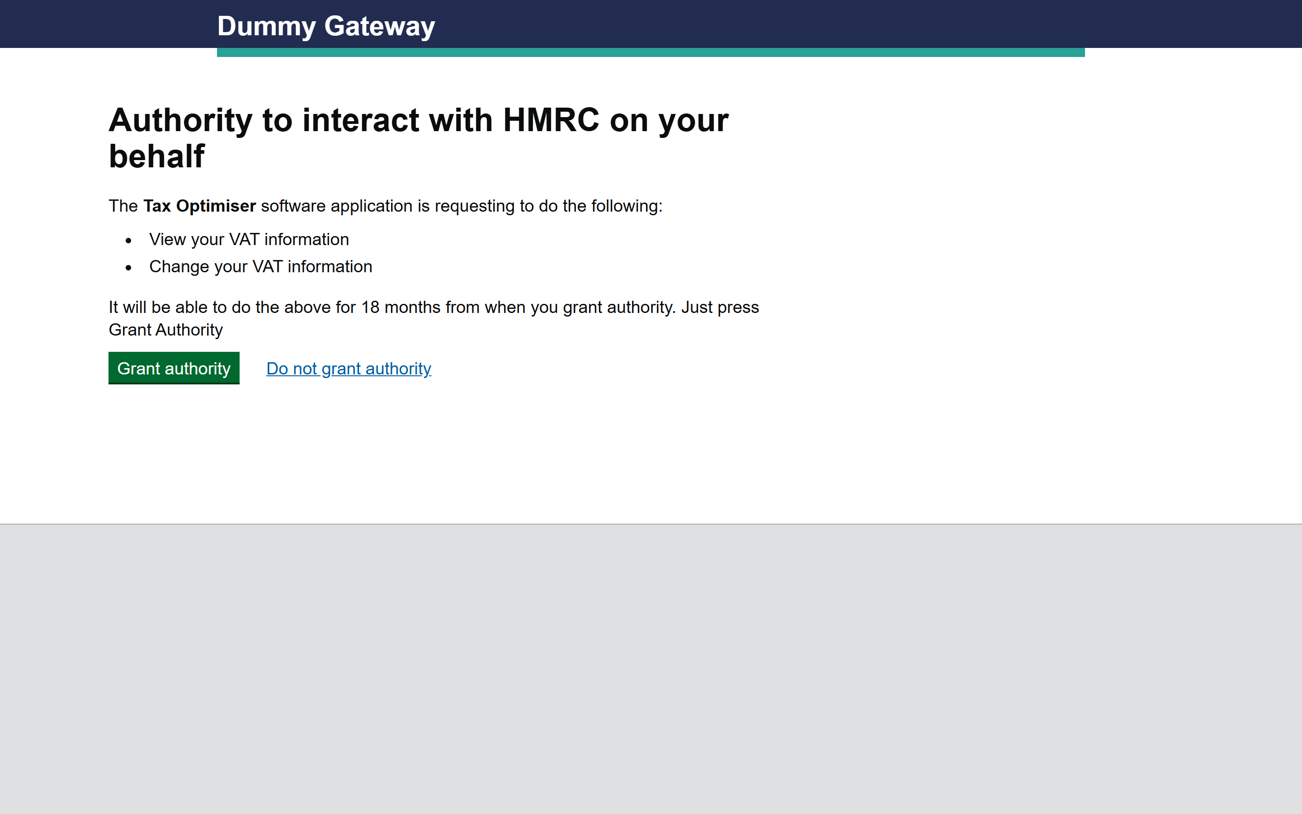
Back on VAT Returns you’ll see demo periods — one already Fulfilled (a completed return can’t be submitted against) and one Open awaiting data. In demo mode you can reset this sample data at any time with Actions → Reset Test Data.
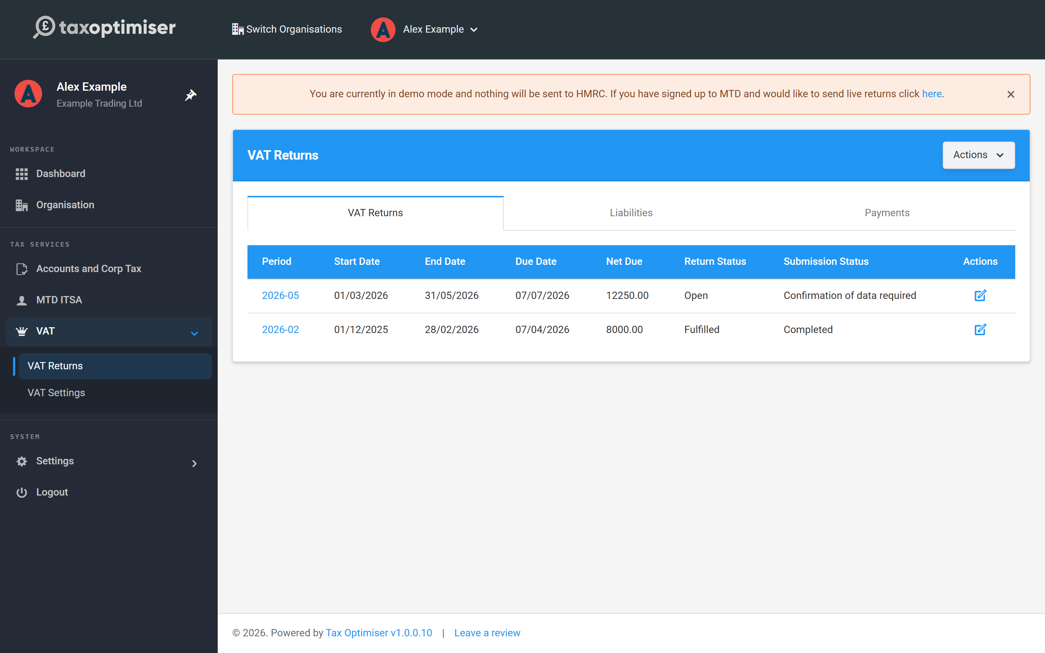

Switch to live mode
You do not need to sign the client up to Making Tax Digital for VAT before you file for real: HMRC signs up VAT-registered businesses automatically unless they are exempt, so there is no sign-up step and no confirmation email to wait for. When you’re ready, click the link in the demo banner and confirm Set to live mode.
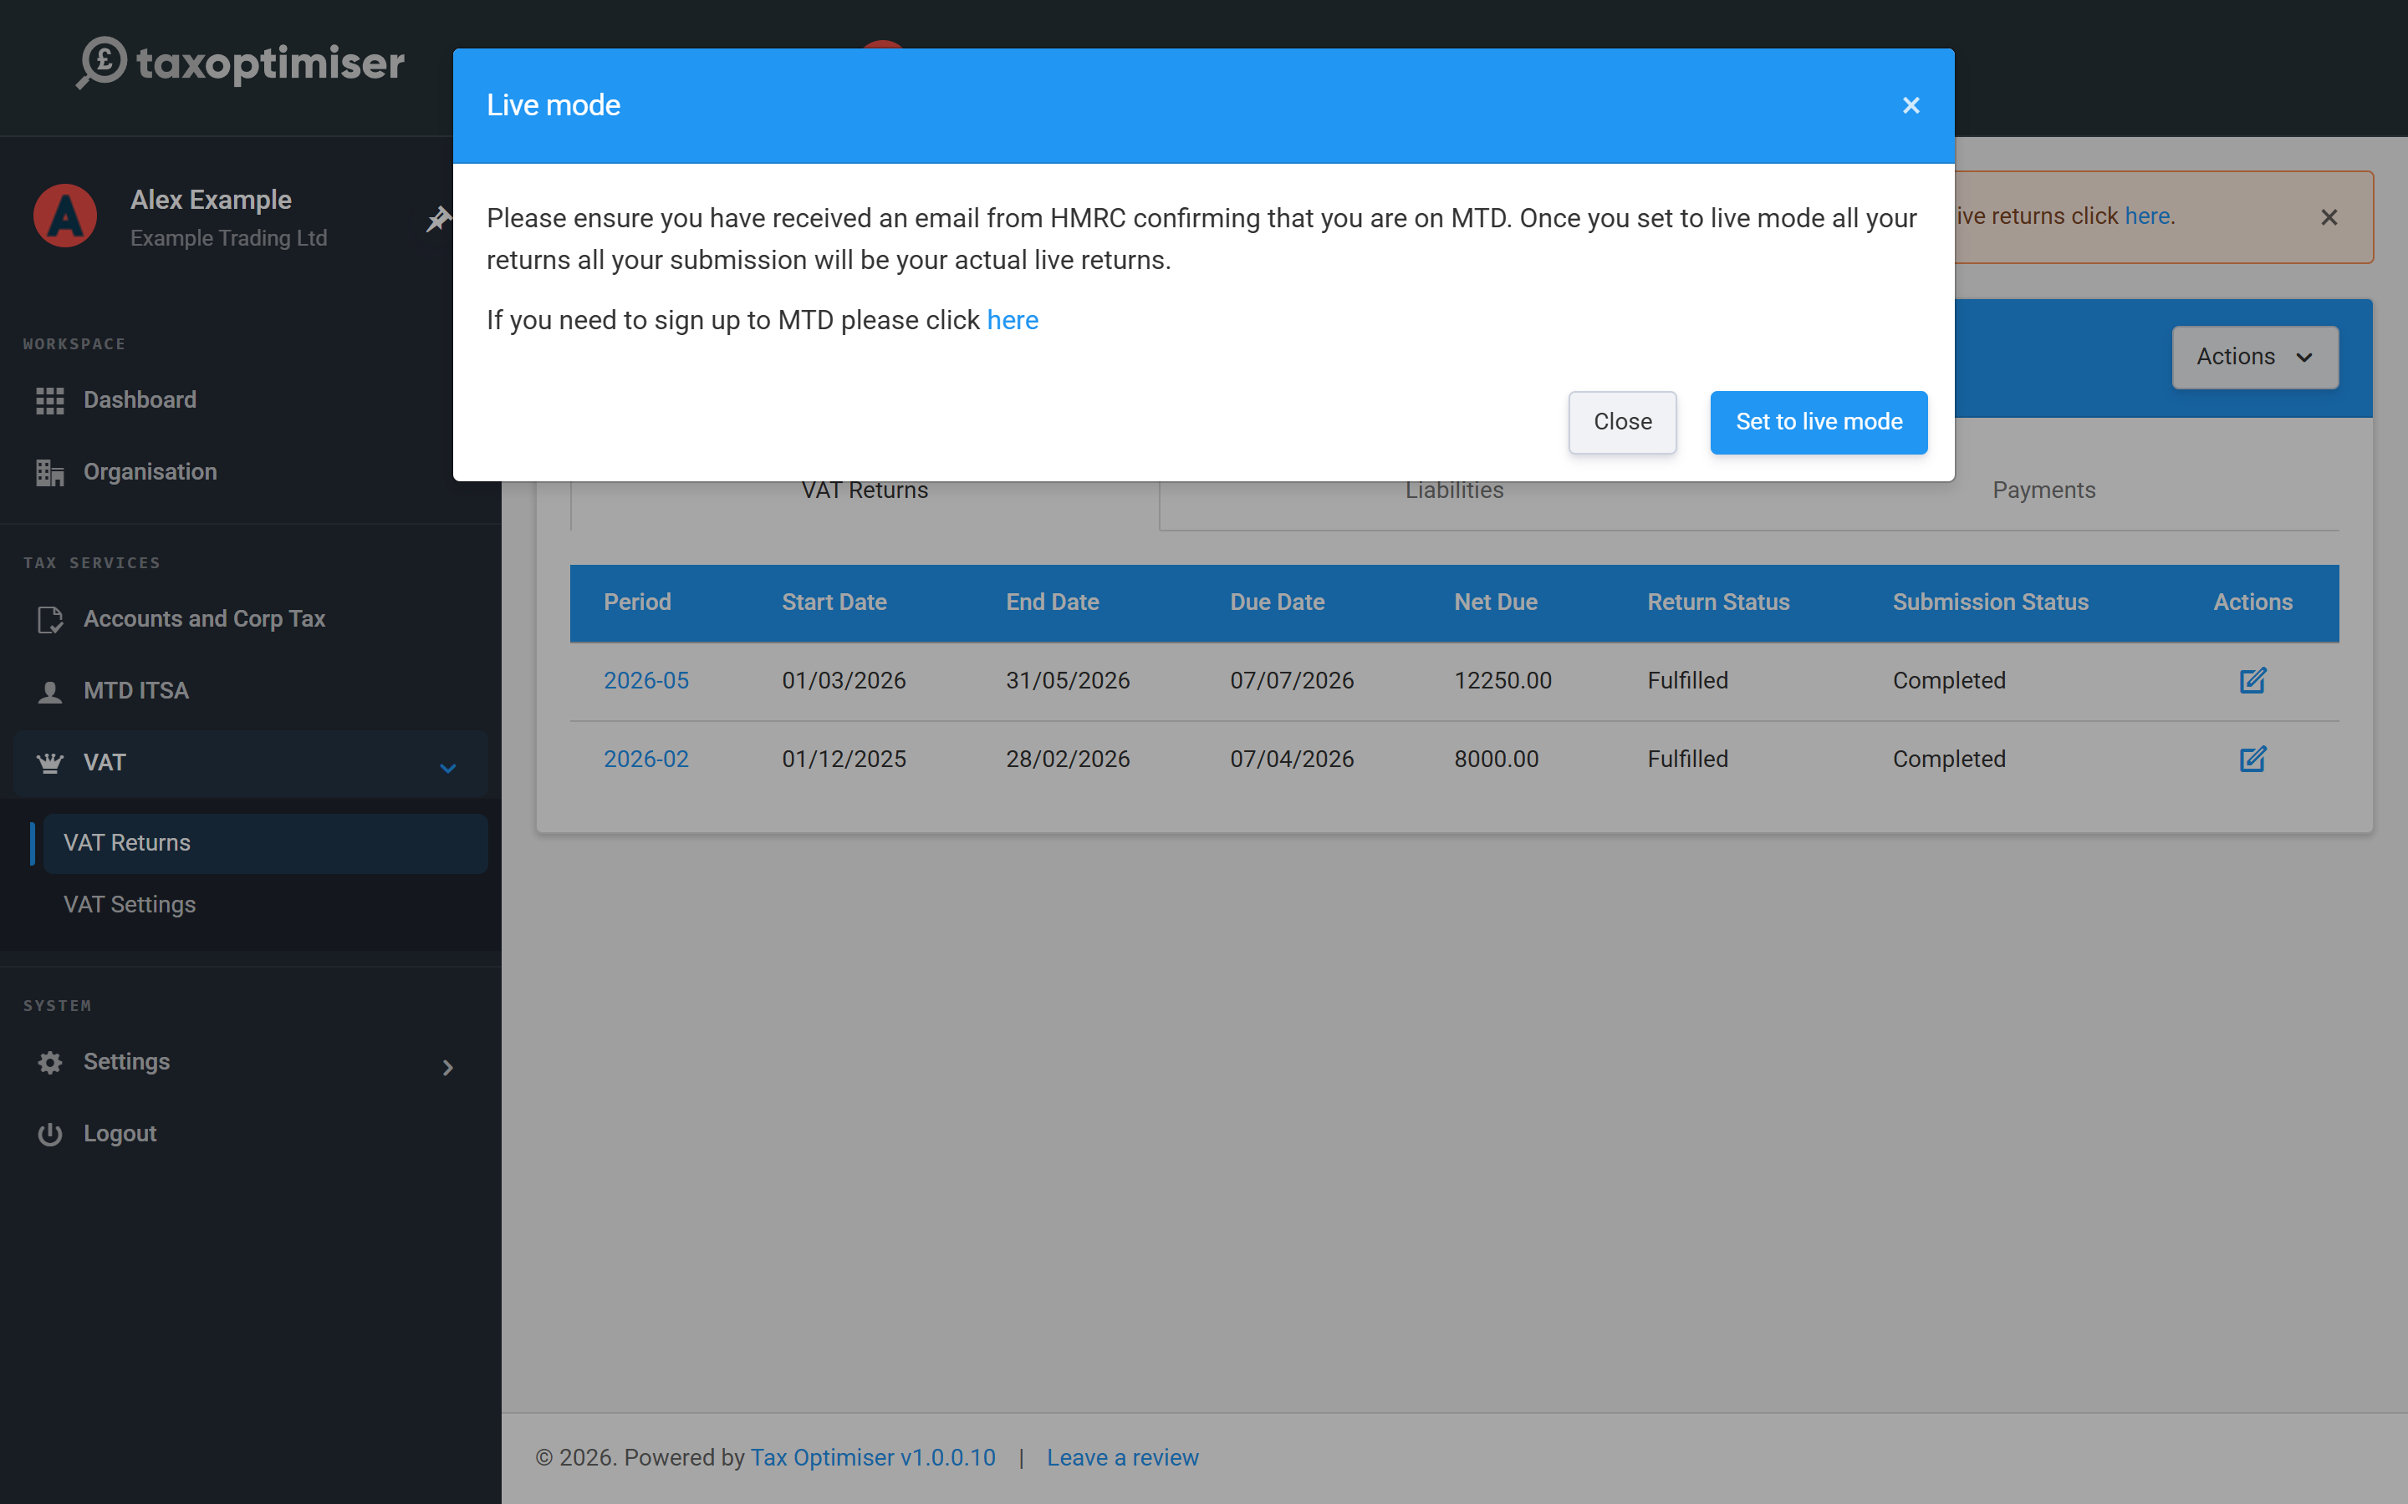

Connect with your agent account
You then choose how to connect. The same choice is available any time from Actions → Reconnect to HMRC. As an accountant, pick Connect to HMRC using Agent Account — this uses your firm’s HMRC agent services account, so the one authority lets you view and submit VAT for this and every other client you act for. (The other option, Connect to HMRC (using Organisation Account), is for a business connecting its own Government Gateway login instead.)
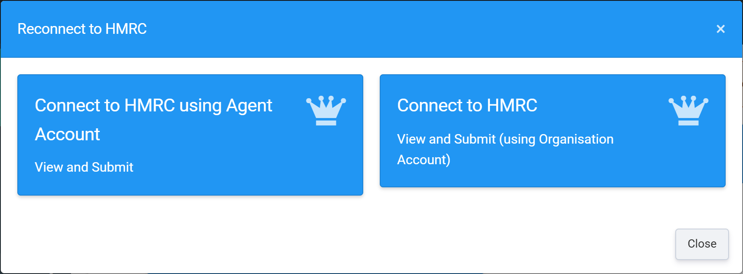
You’re taken to HMRC’s gateway: press Continue, sign in with your agent Government Gateway credentials (HMRC may ask you to complete two-factor authentication), and finally Grant authority — this lets Tax Optimiser retrieve periods and submit returns on your behalf. The authority lasts 18 months; when it expires, reconnect from Actions → Reconnect to HMRC.

Your client’s VAT periods arrive
HMRC returns the client’s real VAT periods to the returns table. To work a period, click its link and follow the next article. We refresh periods intermittently, but if one you’re expecting hasn’t appeared — or you’ve just fixed an error — click Refresh from HMRC to re-pull everything.

5. Upload, check and send a client's VAT return
Upload the client's spreadsheet, check the nine boxes, accept the declaration and keep HMRC's receipt.
IN SHORT
- The uploaded file is the source of truth; boxes are read-only
- Fix figures in the spreadsheet and re-upload, not in the app
- Nil returns: reset values to zero, then submit as normal
- The receipt (form bundle number etc.) is the client's proof of filing
- Errors: fix and retry; reconnect if your authority has expired

Each quarter you upload the client’s spreadsheet to their open period, Tax Optimiser fills the nine boxes from the cells you mapped, you check them, and you send. The boxes are read-only — the uploaded file is always the source of truth, which is exactly what Making Tax Digital’s digital-links rules want.

Open the return and upload the file
On VAT Returns, click the period link of the Open return. You’ll see the return’s dates and status, the nine boxes at zero, and an Upload File panel. Drag the client’s file onto the upload area, or click it to browse — Excel files (.xlsx, .xls, .xlsm) and .csv are accepted. Processing takes a few seconds and the page updates itself; the file stays on the return so you can Download it later or Delete it and upload a corrected version.
If the upload fails because the sheet or a cell in VAT Settings doesn’t match the client’s file, the error message offers Review settings with AI. It reads the file you just uploaded and suggests the sheet and cells, showing the figure it found in each one. As in VAT Settings, the file is sent to a third-party AI provider and you confirm that first. Check the figures, then press Save and re-process file. The new settings are saved and the same file is read again, without uploading it a second time.
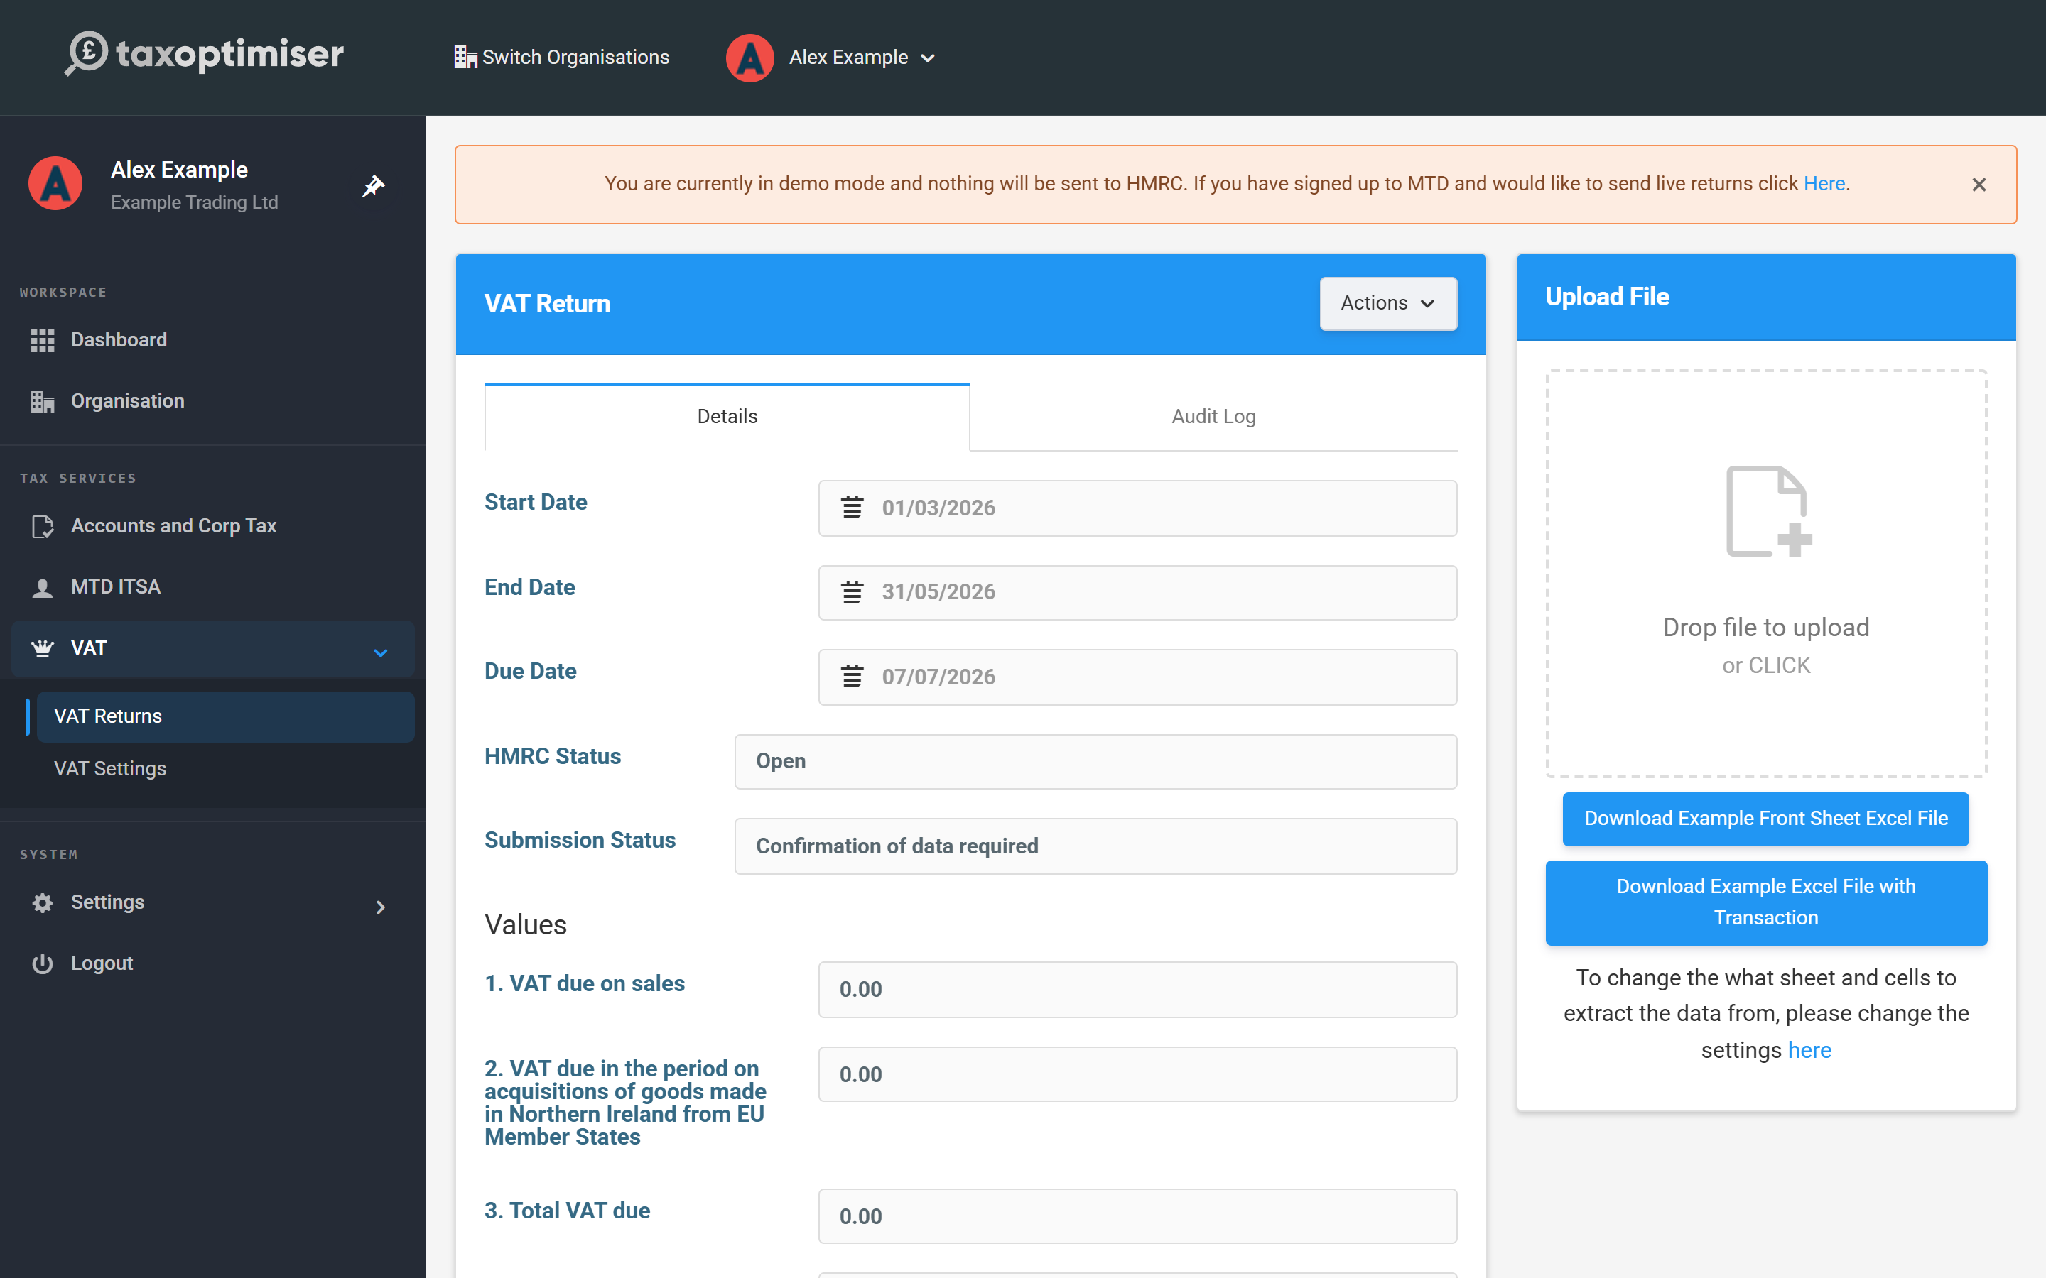

Check the nine boxes
The boxes now show what was read from the spreadsheet — check them against the client’s records before sending. In our example the quarter’s standard-rated sales were £85,400, so Box 1 shows £17,080.00 of output VAT, Box 4 reclaims £4,830.00 of input VAT, and Box 5 lands on £17,080 − £4,830 = £12,250.00 net VAT due. If a box is wrong, fix the cell in the spreadsheet and upload again — don’t re-point the mapping unless the layout itself changed. For a nil return, use Actions → Reset all values to zero rather than uploading a file of zeros — you still have to submit it.
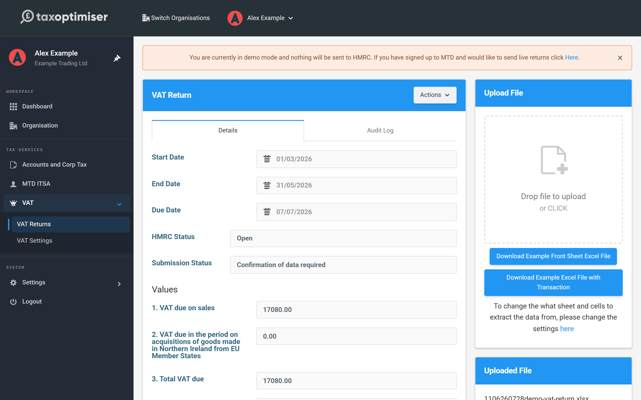

Send and keep the receipt
Click Send VAT Return. The declaration is the legal confirmation HMRC requires that the figures are true and complete — only accept it once you’ve checked the boxes. You can add an internal note (it stays in Tax Optimiser). Click Accept.
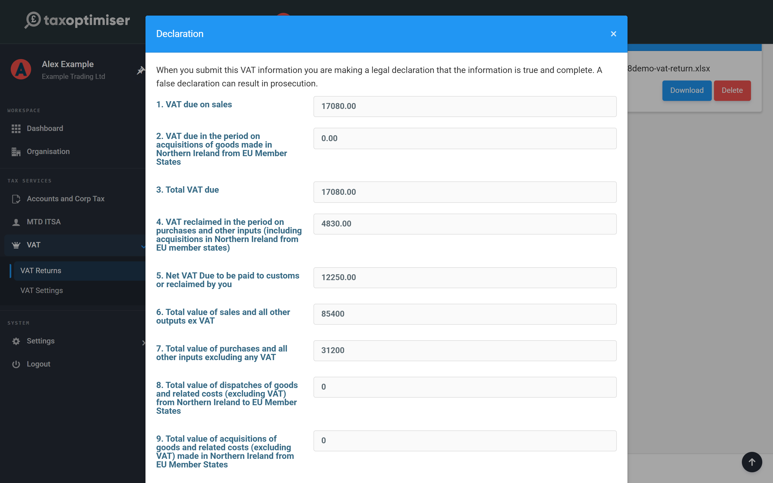
The return is submitted to HMRC using the authority you granted, and the Submission Status moves to Submission Accepted — the screen updates itself. On acceptance the HMRC Confirmation Receipt fills in: the Processing Date, the Payment Indicator, the Form Bundle Number and, where money is due, a Charge Ref Number. These are generated by HMRC and are your client’s proof the return was filed; Generate Receipt turns them into a PDF you can keep or send on. In demo mode the cycle completes instantly and nothing leaves Tax Optimiser.
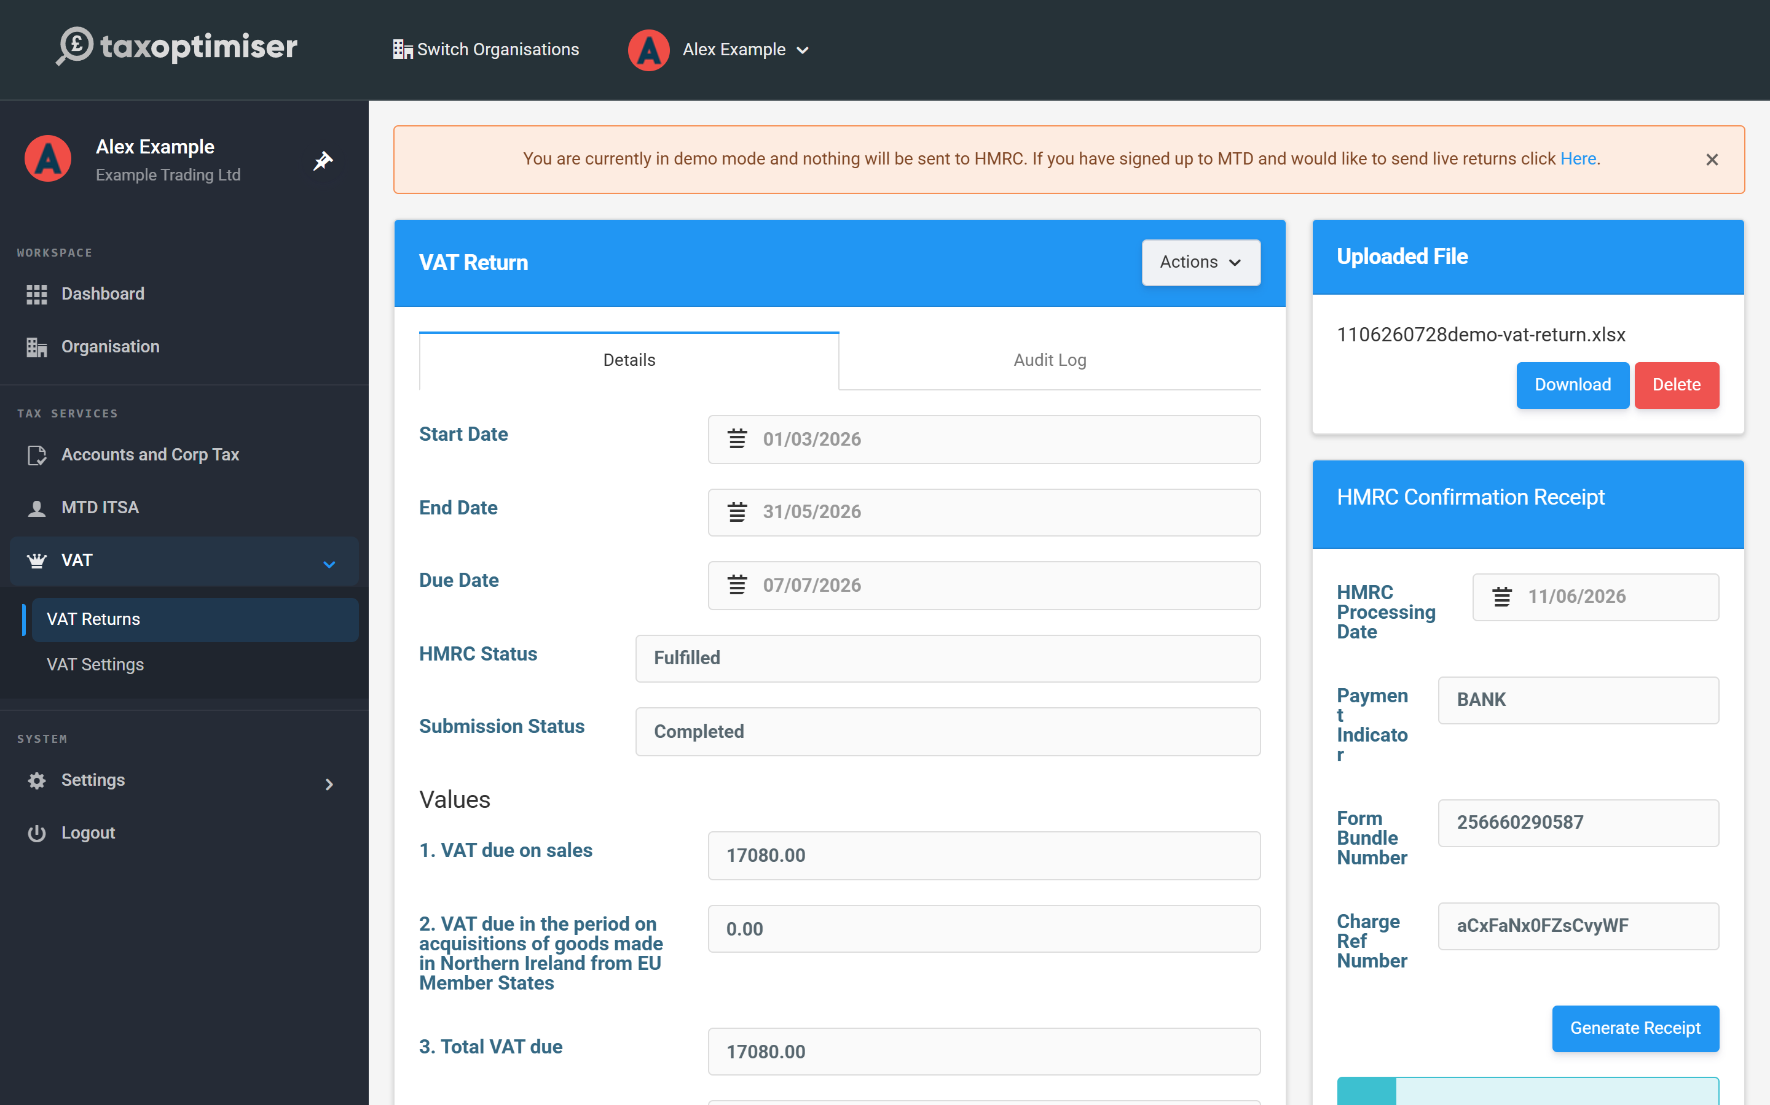
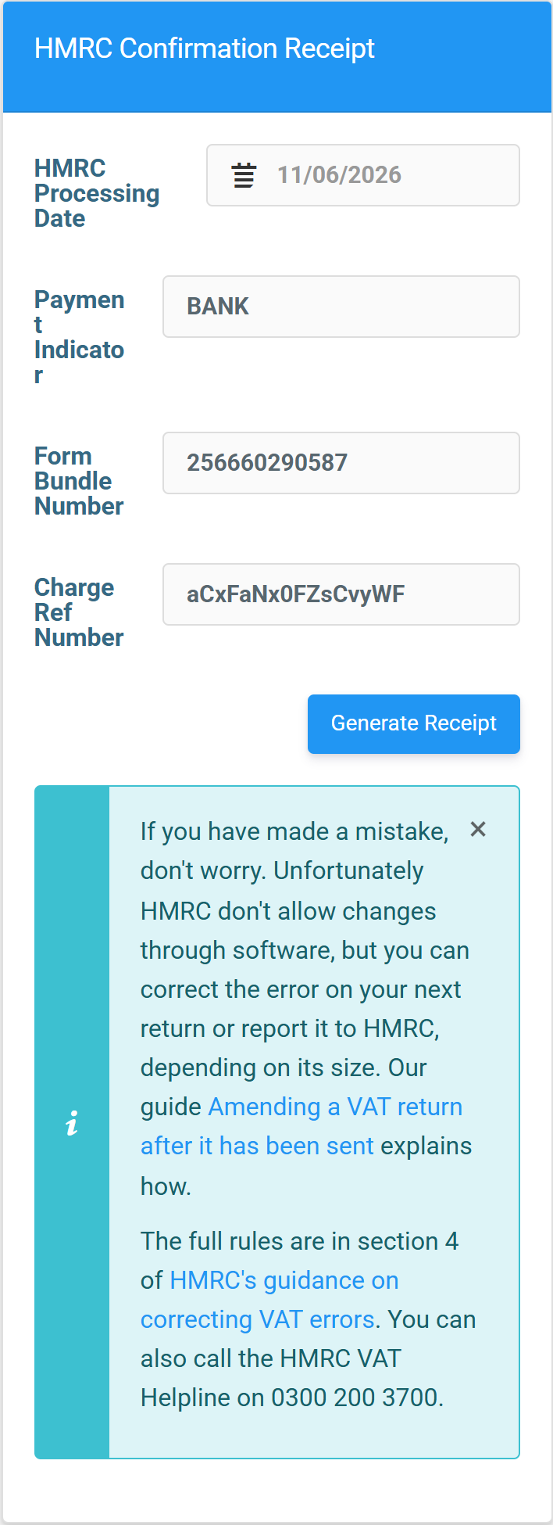

If something goes wrong
A rejected return shows the HMRC error and the status changes to Submission Error — fix the cause and send again with Retry sending VAT return. If the error doesn’t make sense, contact support@taxoptimiser.co.uk. Two cases worth knowing: if your authority has expired the error links you straight to the reconnect flow; and an “already submitted” warning means HMRC has the return on file already (filed here or elsewhere) — check the period in HMRC and confirm it filed.

6. Give clients access to their organisation
Give a client a login to their own organisation - they only ever see the organisations they belong to.
IN SHORT
- Give clients a login from the organisation's Individuals tab
- Only first name, last name and email are needed
- Choose Send Credentials and they get a link to set a password
- Clients only see organisations they belong to
- The other details are for later (e.g. Self Assessment)

You can give a client a login to their own organisation — handy when they upload their own VAT spreadsheet or just want to see their returns. They’ll only ever see the organisations they belong to, never your other clients.

Add an individual
Inside the client organisation, click Individuals, then Add New. You only have to enter the first name, last name and email address, and choose Send Credentials. The person then receives an email with a link to set their own password.
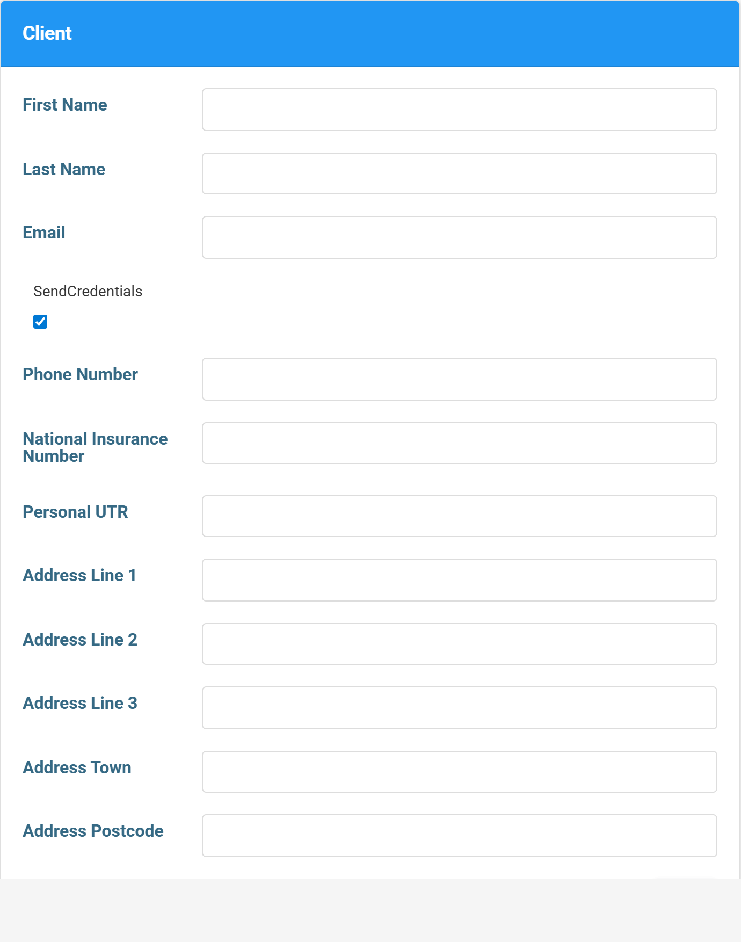

The rest can wait
The other details on the individual’s record are used later for things like Self Assessment — you don’t need them just to give VAT access, so leave them for now and come back when needed.

7. Add additional accountants to your firm
Add colleagues to your firm so they can act for your clients with their own login.
IN SHORT
- Add colleagues from Firm Settings, Accountants, Add New
- Only first name, last name and email are needed
- Optionally mark them as an admin or journal approver
- They get an email invite with a link to set their password
- Firm users can then work across all your clients

If colleagues work on VAT alongside you, add them to the firm so they can act for your clients with their own login.

Add a firm user
Go to Firm Settings → Accountants, then Add New. You only need the first name, last name and email address; you can optionally tick Is an admin or Can approve journals to set their permissions. Press Save and they’ll receive an email with a link to create a password, after which they can sign in and work across your firm’s clients.
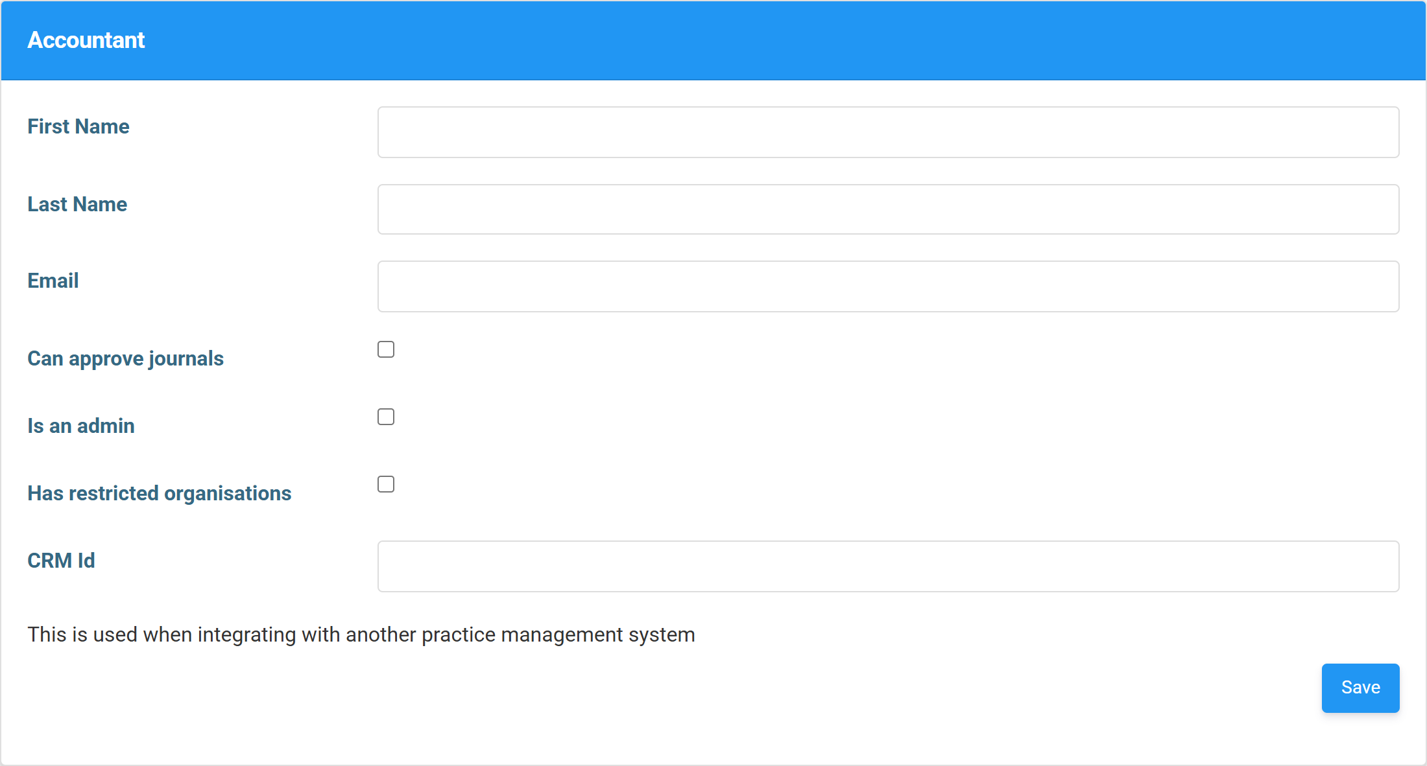

Set their permissions
A few optional tick-boxes control what a new colleague can do: Is an admin gives them full access to firm settings, including adding further users; Can approve journals lets them sign off journals where your firm uses approvals; and Has restricted organisations limits them to specific clients rather than the whole firm. Leave them all unticked for a standard user who simply files for clients.

