Self Assessment Tax Returns
User Guide (beta)
Preparing and filing the SA100 Self Assessment return in Tax Optimiser — opening a client's return, entering income and the supplementary pages, reliefs and student loans, the live tax calculation and SA302, submitting to HMRC, and amending.
Beta feature — Self Assessment tax returns are currently in beta and are switched on for one accountant firm at a time. To gain access for your firm, email support@taxoptimiser.co.uk and the team will enable it and help you get started.
taxoptimiser.co.uk · 7 October 2026

Contents
- Self Assessment tax returns in Tax Optimiser (beta) — Prepare and file full SA100 Self Assessment returns for clients not in MTD — with a live tax calculation — from inside Tax Optimiser. Beta access via support@taxoptimiser.co.uk.
- Getting started with a client's return — Opening a client's first Self Assessment year, the pre-filled personal details, choosing the return's pages with Add Section, moving between sections, and the save-as-you-go model.
- Entering income: employment, self-employment, property and investments — Entering the return's income pages: multiple employments, self-employment short and full pages, UK property, and interest and dividends — with the HMRC box references on every field.
- The supplementary pages: partnership, foreign income, trusts, capital gains and more — Partnership shares, foreign income with FTCR, trust and estate income, capital gains, residence status and the SA101 pages — how each supplementary schedule is entered and calculated.
- Reliefs, student loans and the rest of the return — Pension contributions, Gift Aid, Marriage Allowance, the High Income Child Benefit Charge, student loan plans, and the return's closing boxes.
- The tax calculation and the SA302 PDF — The live SA302-style calculation: the staged statement, the band-by-band breakdown, PAYE coding adjustments and the claim to reduce payments on account, warnings, and the downloadable SA302 PDF.
- Submitting the return to HMRC — Filing a prepared return: the pre-flight checks and their fix links, the declaration, what happens during submission, and reading the submission history.
- Amending an accepted return — Accepted years lock; Reopen for amendment files a replacement return. The amendment deadline, rejections, and chasing stuck submissions.

1. Self Assessment tax returns in Tax Optimiser (beta)
Prepare and file full SA100 Self Assessment returns for clients not in MTD — with a live tax calculation — from inside Tax Optimiser. Beta access via support@taxoptimiser.co.uk.
IN SHORT
- Full SA100 returns for non-MTD clients, prepared and filed inside Tax Optimiser
- The tax calculation runs live as you type - no waiting for HMRC
- Beta covers 2025-26 with every SA100 page, including the supplementary schedules
- BETA: email support@taxoptimiser.co.uk to enable it for your firm

Tax Optimiser can now prepare and file the full Self Assessment tax return (the SA100 and its supplementary pages) for individual clients who are not in Making Tax Digital — the traditional annual return, filed to HMRC through their online channel. You enter the return box by box, watch the tax calculation build live, download an SA302-style calculation for the client, and submit to HMRC without leaving Tax Optimiser.

How this differs from the MTD ITSA screens
Tax Optimiser’s MTD ITSA screens are for clients in Making Tax Digital: digital records, quarterly updates, and HMRC doing the tax calculation. The Self Assessment screens are for everyone else — clients below the MTD threshold or not yet mandated, who still file one annual return. Because the traditional channel has no HMRC calculation service, Tax Optimiser calculates the tax itself, live as you type, so you always see the position before anything is filed. Both features can be used side by side across your client base.
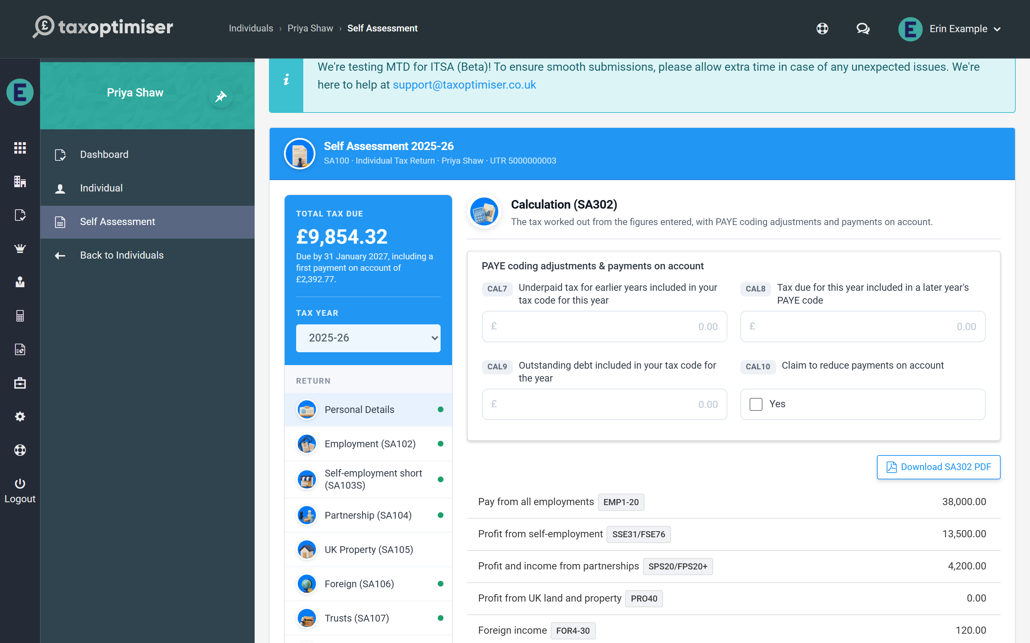

What is supported today
The beta supports tax year 2025-26 (6 April 2025 to 5 April 2026) with the full set of SA100 pages:
- Employment (SA102) — any number of employments
- Self-employment, short and full (SA103S / SA103F)
- Partnership (SA104), short and full statements — any number of partnerships
- UK Property (SA105)
- Foreign (SA106), Trusts (SA107), Capital Gains (SA108), Residence (SA109) and Additional Information (SA101)
- Interest & dividends, state benefits and pensions, other UK income
- Tax reliefs — pension contributions, Gift Aid, Marriage Allowance, Blind Person’s Allowance, the High Income Child Benefit Charge
- Student and postgraduate loans
A handful of genuinely specialist entries remain outside the calculation for now — life-insurance policy gains needing top-slicing relief, the remittance basis and FIG-regime claims, non-resident trust and Transfer of Assets Abroad charges, double-taxation partial-relief amounts, non-resident CGT and pension annual-allowance charges. If a return uses one of those boxes the calculation says so clearly and online filing is blocked, so nothing incorrect can reach HMRC. See the supplementary pages article for the details.

Getting access
The feature is enabled per accountant firm while in beta. Email support@taxoptimiser.co.uk from your firm’s account and the team will switch it on, walk you through the first return, and agree when live filing is enabled for your firm. Feedback during beta directly shapes what gets built next.

2. Getting started with a client's return
Opening a client's first Self Assessment year, the pre-filled personal details, choosing the return's pages with Add Section, moving between sections, and the save-as-you-go model.
IN SHORT
- The 2025-26 return is created automatically on first open
- Personal details pre-fill from the client record; set the taxpayer status
- A valid UTR and NINO are required before filing
- Add Section picks the return's pages; data is kept if a section is hidden
- A green dot in the menu marks a section that holds figures
- Boxes save as you leave them - the tax total updates live

Once the beta is enabled for your firm, every individual client gains a Self Assessment entry in their menu. Open the client from your Individuals list and choose it — Tax Optimiser creates the 2025-26 return automatically the first time, so you land straight in the capture screen.

Personal details come pre-filled
The Personal Details section is snapshotted from the client’s record when the year is created: name, National Insurance number and address are already in place, and stay with the return even if the client record changes later. Set the Taxpayer status here — Rest of UK, Scotland or Wales — because it drives which Income Tax bands the calculation uses.
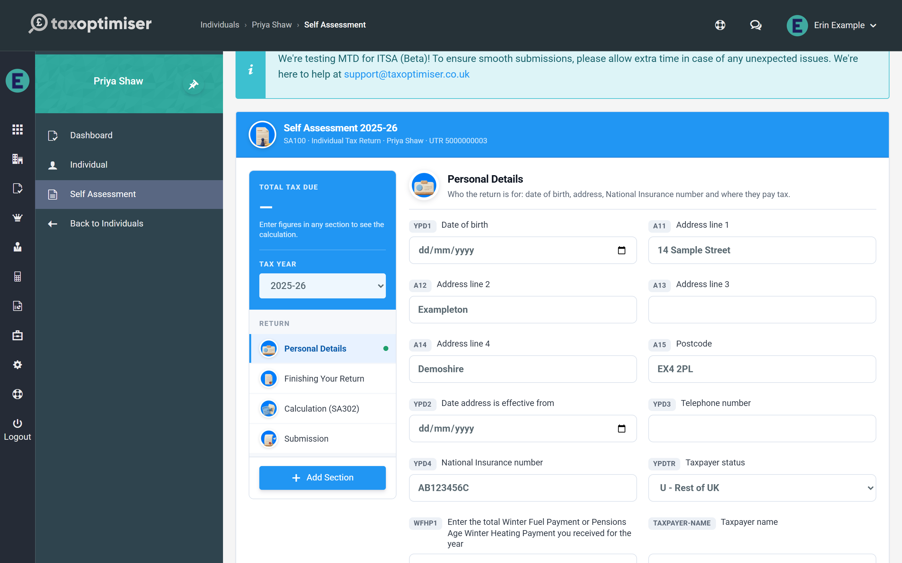
The blue header shows the tax year, the client’s name and their UTR, so you can always see whose return is open. Two things worth checking before you go further:
- The client’s Unique Taxpayer Reference must be on their Tax Optimiser record (open Individual from the menu to add it). It has to be the real ten-digit UTR: the pre-flight checks test it against HMRC’s check-digit rule and will not let a return without a valid one reach HMRC.
- The National Insurance number in Personal Details is required for filing too.

Pick the pages the return needs
A Self Assessment return is the core SA100 plus whichever supplementary pages apply. Press Add Section and tick the pages this client needs — each one appears in the left-hand menu. The pages are grouped under Income, Other supplementary pages and Reliefs and repayments, and each tile carries a line saying what belongs on it, so it is easy to tell the short self-employment page from the full one.
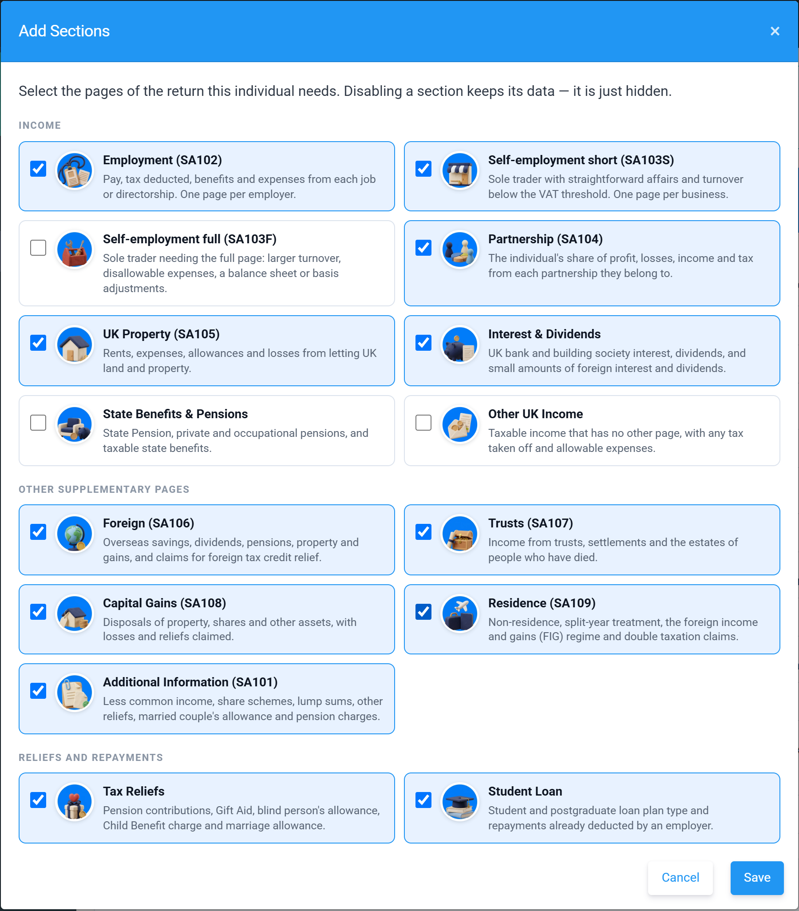
Tick exactly what this client’s return needs; anything left unticked stays out of the menu and the filing. Unticking a section later just hides it: the data is kept, so nothing is lost if you change your mind, and a tile whose page already holds entries is marked Has figures so you can see what you would be hiding.

Finding your way around
The left-hand menu lists the sections in the order of the return. A green dot beside a section means figures have been entered on it, and a red number beside Calculation counts the problems that would stop the return being filed online. Click any section to open it, or use Back and Next at the foot of the screen to work through the return in order — the footer also shows which section you are on and whether your changes are saved.

Everything saves as you go
Each box saves when you leave the field, and the tax calculation re-runs automatically. The card at the top of the section menu updates within a moment of each entry: it shows the Total Tax Due by 31 January, including any first payment on account, or Repayment Due when the client has overpaid. There is no separate save button to remember — the footer reads All changes saved once an entry is stored. If you type something into a money box that is not a number, the box turns red, says it has not been saved, and keeps what you typed so you can correct it.

3. Entering income: employment, self-employment, property and investments
Entering the return's income pages: multiple employments, self-employment short and full pages, UK property, and interest and dividends — with the HMRC box references on every field.
IN SHORT
- Every box shows its HMRC reference - cross-check against the paper forms
- Groups follow the paper form and show how many boxes are filled
- Total boxes offer the sum of the boxes above them - press Use this
- Add one card per employment and per self-employed business
- PAYE reference + director question are mandatory on every employment
- Business description + start/cease questions are mandatory on every business
- Mortgage interest earns the 20% reducer automatically

Every box in the capture screen carries a small badge with its HMRC box reference (EMP1, SSE9, INC4…) matching the paper forms and HMRC’s own notes — so if you are working from a P60, accounts or last year’s return, you can cross-check box by box.

How each page is laid out
The boxes on a page are gathered into groups under headings that follow the paper form — Pay and tax, Employer, Allowable expenses and so on. Each heading shows how many of its boxes are filled (“2 of 5”) and can be clicked to fold the group away. On the longer pages a link at the top, Show only groups with figures, hides every empty group so you can review what has been entered without scrolling past the rest.
Some boxes only apply once a question has been answered Yes — the date a business started, for example — and appear when it is. Free-text boxes accept only the characters HMRC allows (letters, numbers, spaces and a few symbols such as & ( ) , - . /); type anything else, such as a colon or semicolon, and the box warns you straight away, because HMRC would reject the whole return for it.

Employment (SA102)
Open Employment (SA102) and press Add Employment for each job — a return can carry any number, each in its own card titled by employer name. Enter the pay and tax taken off from the P45/P60, plus any benefits and allowable expenses.
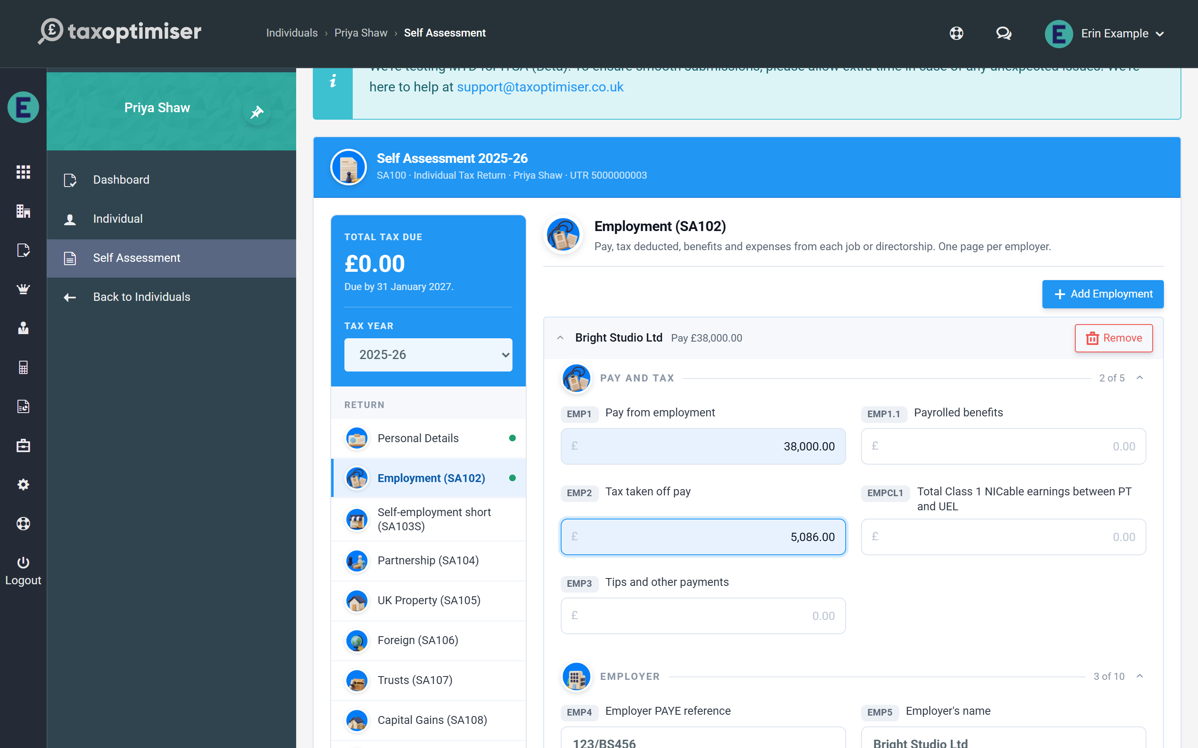
Two boxes are required by HMRC for every employment: the employer’s PAYE reference and the “company director” yes/no. A return missing either is rejected by HMRC’s systems, so answer them even when they feel obvious.
When a client has more than one employment the cards are listed closed, each showing the employer and the pay, and open one at a time. Remove asks you to confirm before it deletes a card’s figures.

Self-employment (SA103S / SA103F)
Choose short pages for straightforward businesses under the VAT threshold, or full pages where turnover is higher or the accounts need the detailed breakdown. As with employments, add one business card per trade.
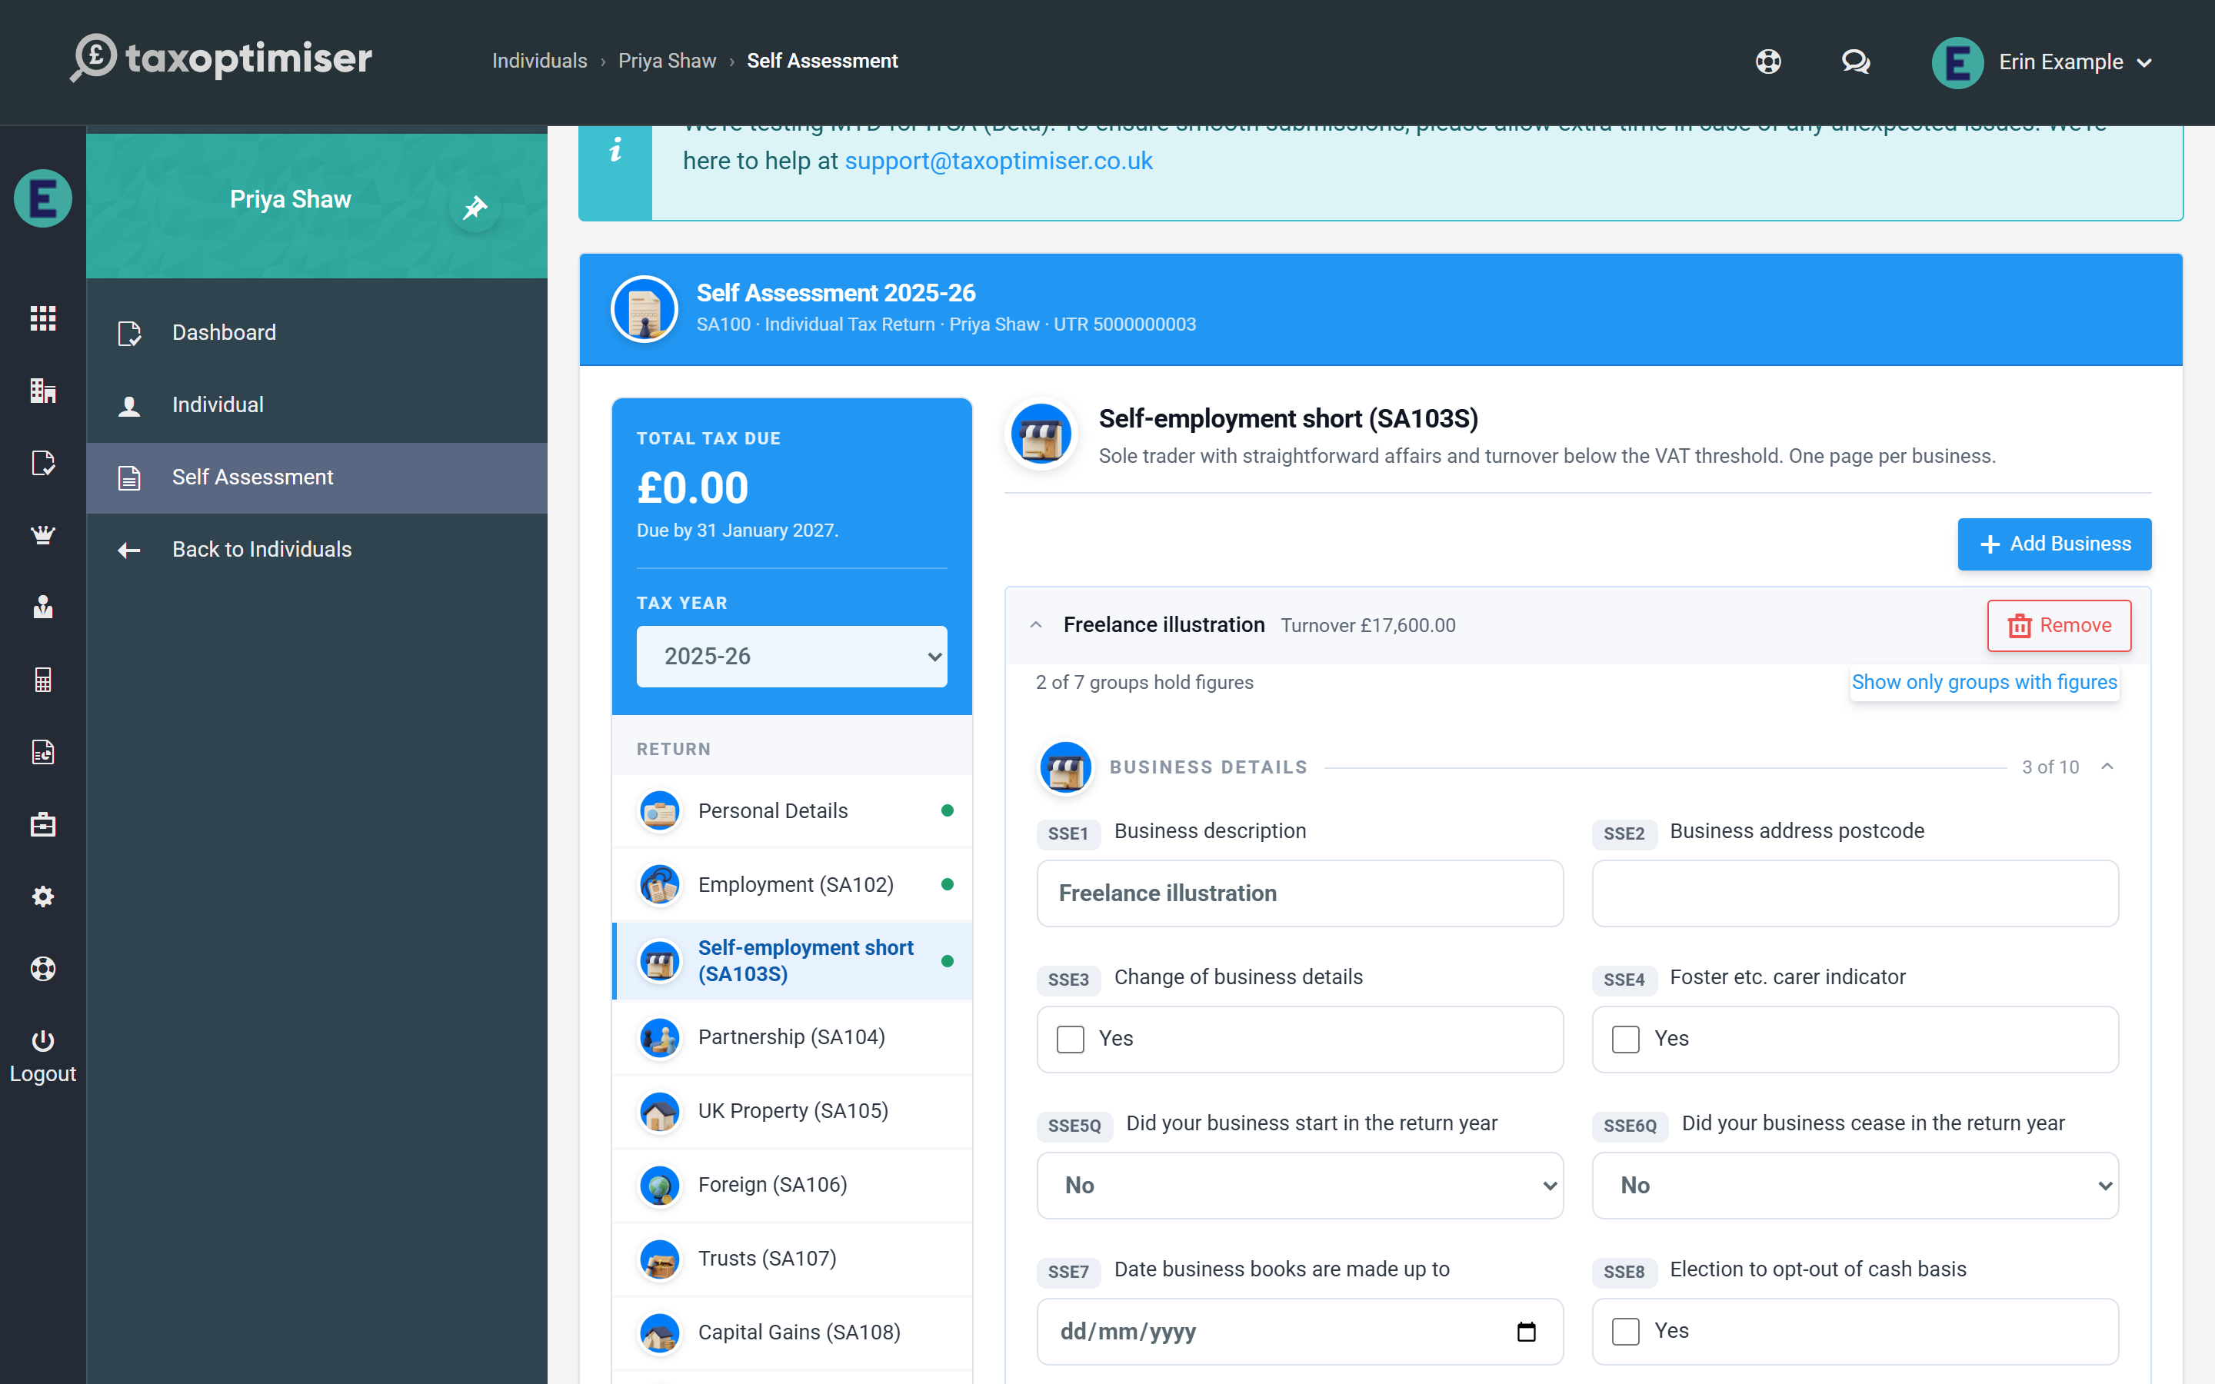
The business description and the did the business start / cease in the year questions are required by HMRC on every business. Enter the turnover and expense boxes, then the profit boxes as they appear on the accounts — the taxable profit you enter in the “total taxable profits” box is what flows into the tax calculation, including Class 4 National Insurance.
Where a total box is simply the sum of the boxes above it, Tax Optimiser adds them up for you. Enter the individual expenses and the total box shows what they come to, with a Use this link that fills it in; once the total agrees it shows a tick. The total is never overwritten for you, because HMRC lets a small business enter total expenses on their own without the breakdown.
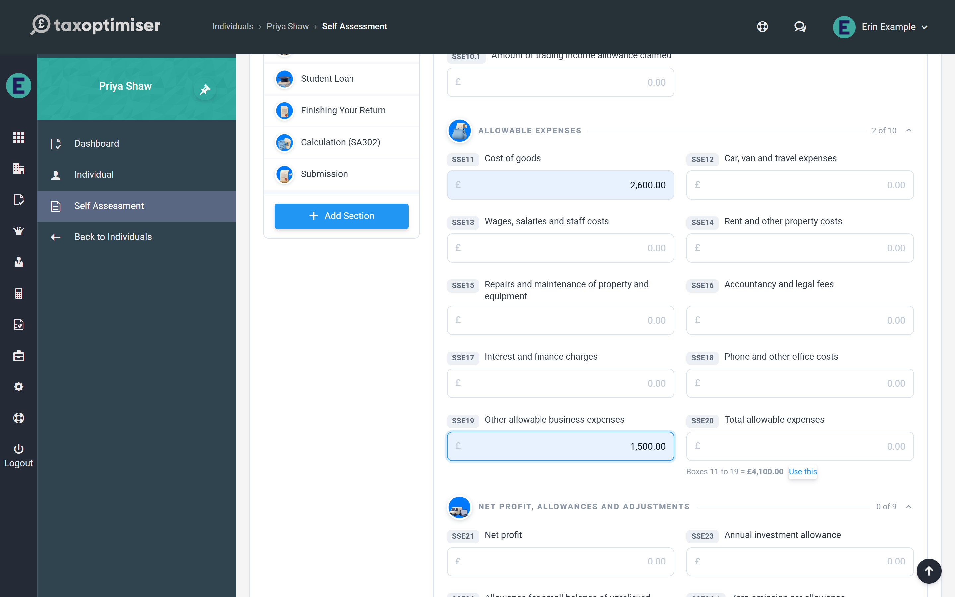

UK Property (SA105)
The property page follows the SA105 layout: rents and other income, the expense categories, and the adjusted and taxable profit for the year. Residential finance costs (mortgage interest) go in their own box — the calculation gives the 20% tax reduction automatically rather than deducting them from profits.
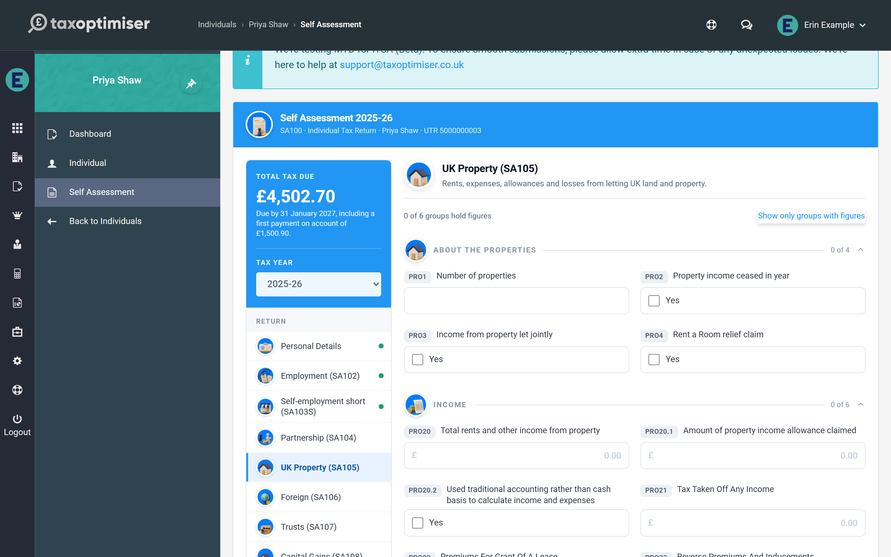

Interest, dividends and other income
Interest & Dividends takes bank and building society interest (taxed interest is entered net, exactly as the paper form asks, and grossed up in the calculation) and dividends from companies and unit trusts. State Benefits & Pensions and Other UK Income cover the rest of the SA100’s core income boxes.
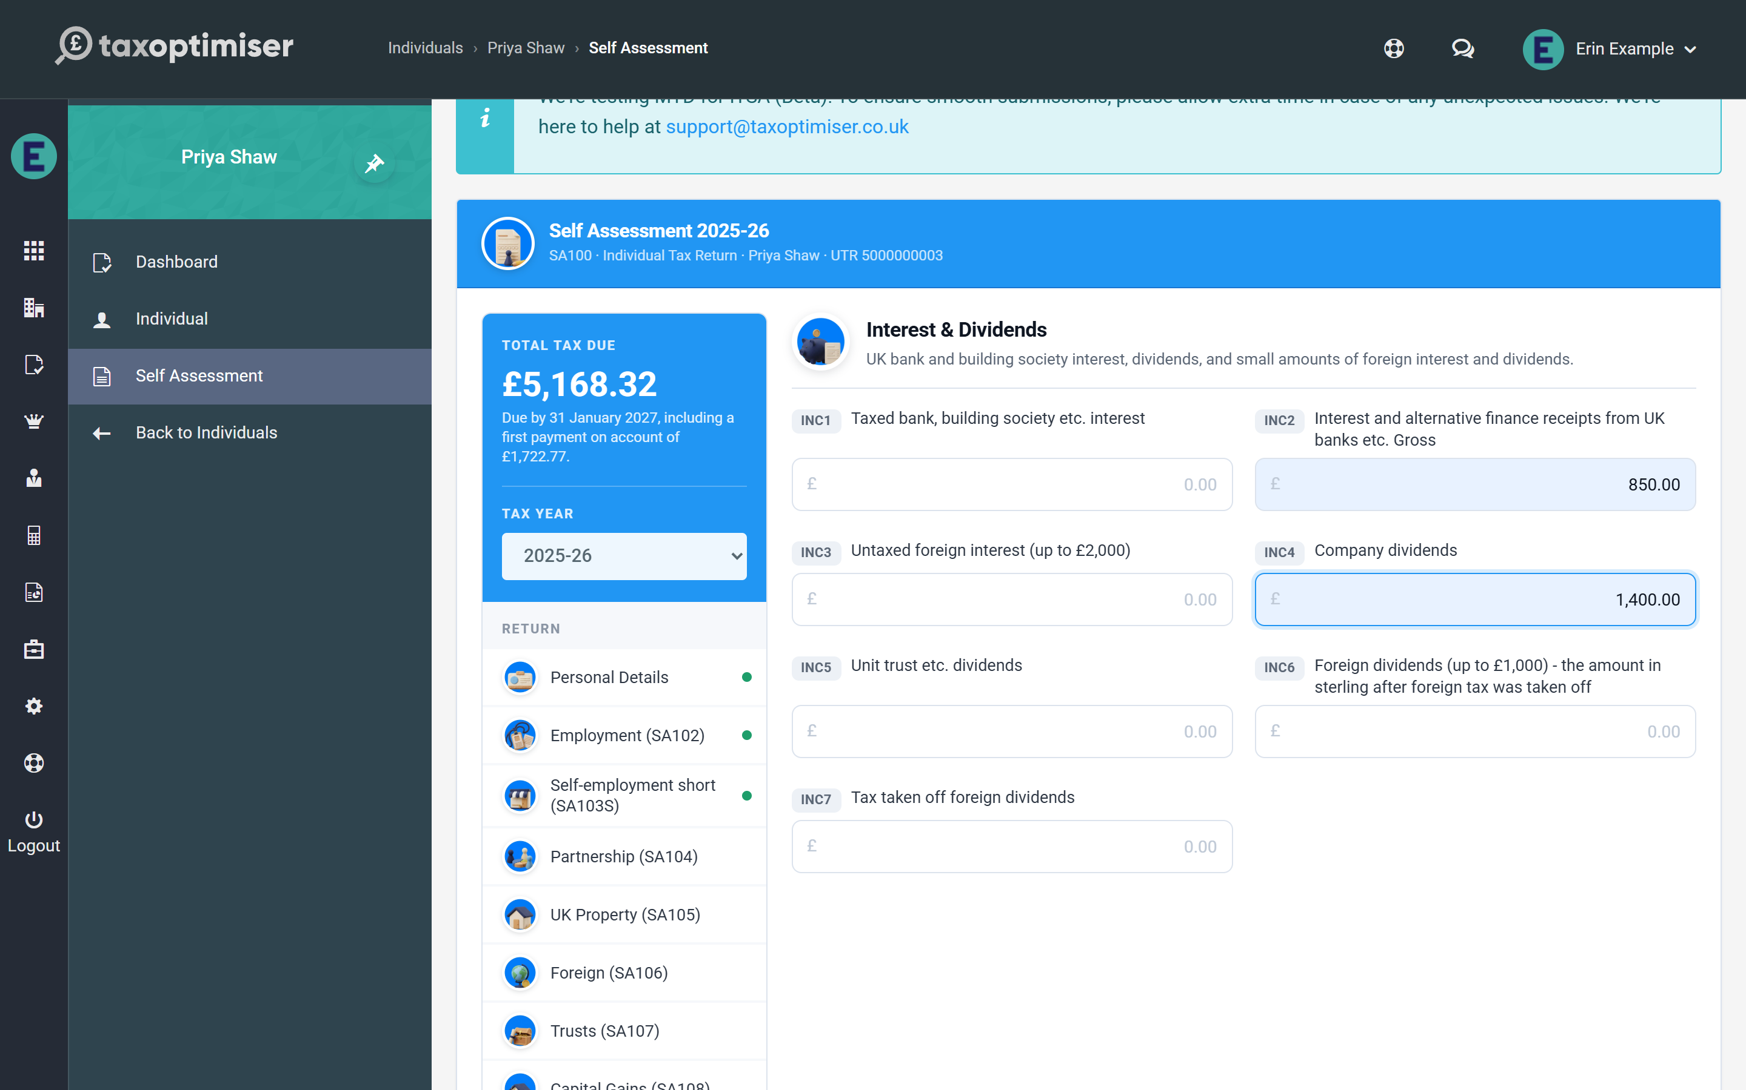
Partnership shares, foreign income, trust and estate income, capital gains, residence status and the Additional Information pages each have their own section — they are covered together in the supplementary pages.

4. The supplementary pages: partnership, foreign income, trusts, capital gains and more
Partnership shares, foreign income with FTCR, trust and estate income, capital gains, residence status and the SA101 pages — how each supplementary schedule is entered and calculated.
IN SHORT
- Add one card per partnership - profit shares drive Class 4 NIC automatically
- Enter trust income net from the R185; the gross-up and credits are automatic
- FTCR comes from the HS263 working sheet, credited up to the tax charged
- CGT: losses and the £3,000 AEA first, then 18%/24% around the unused basic band
- A capital gains page needs the computation summary in box 54 before it can be filed
- Non-residents lose the Personal Allowance unless boxes 15/16 claim it
- Specialist boxes that block filing are flagged in red before submission

Beyond the core income sections, the return’s supplementary pages each have their own entry in the section picker. As everywhere else, every box carries its HMRC reference badge, saves as you leave it, and feeds the live calculation immediately.

Partnership (SA104)
Choose short or full statements to match what the partnership issued, and press Add Partnership for each one — a client can carry any number, each in its own card titled by the partnership’s name. Enter the shares exactly as they appear on the partnership statement: the profit share flows into the calculation including Class 4 National Insurance (with the exemption tick and adjustment box honoured), voluntary Class 2 can be chosen here too, and the full statement adds the client’s shares of savings, dividend, property and other income plus any tax deducted at partnership level.
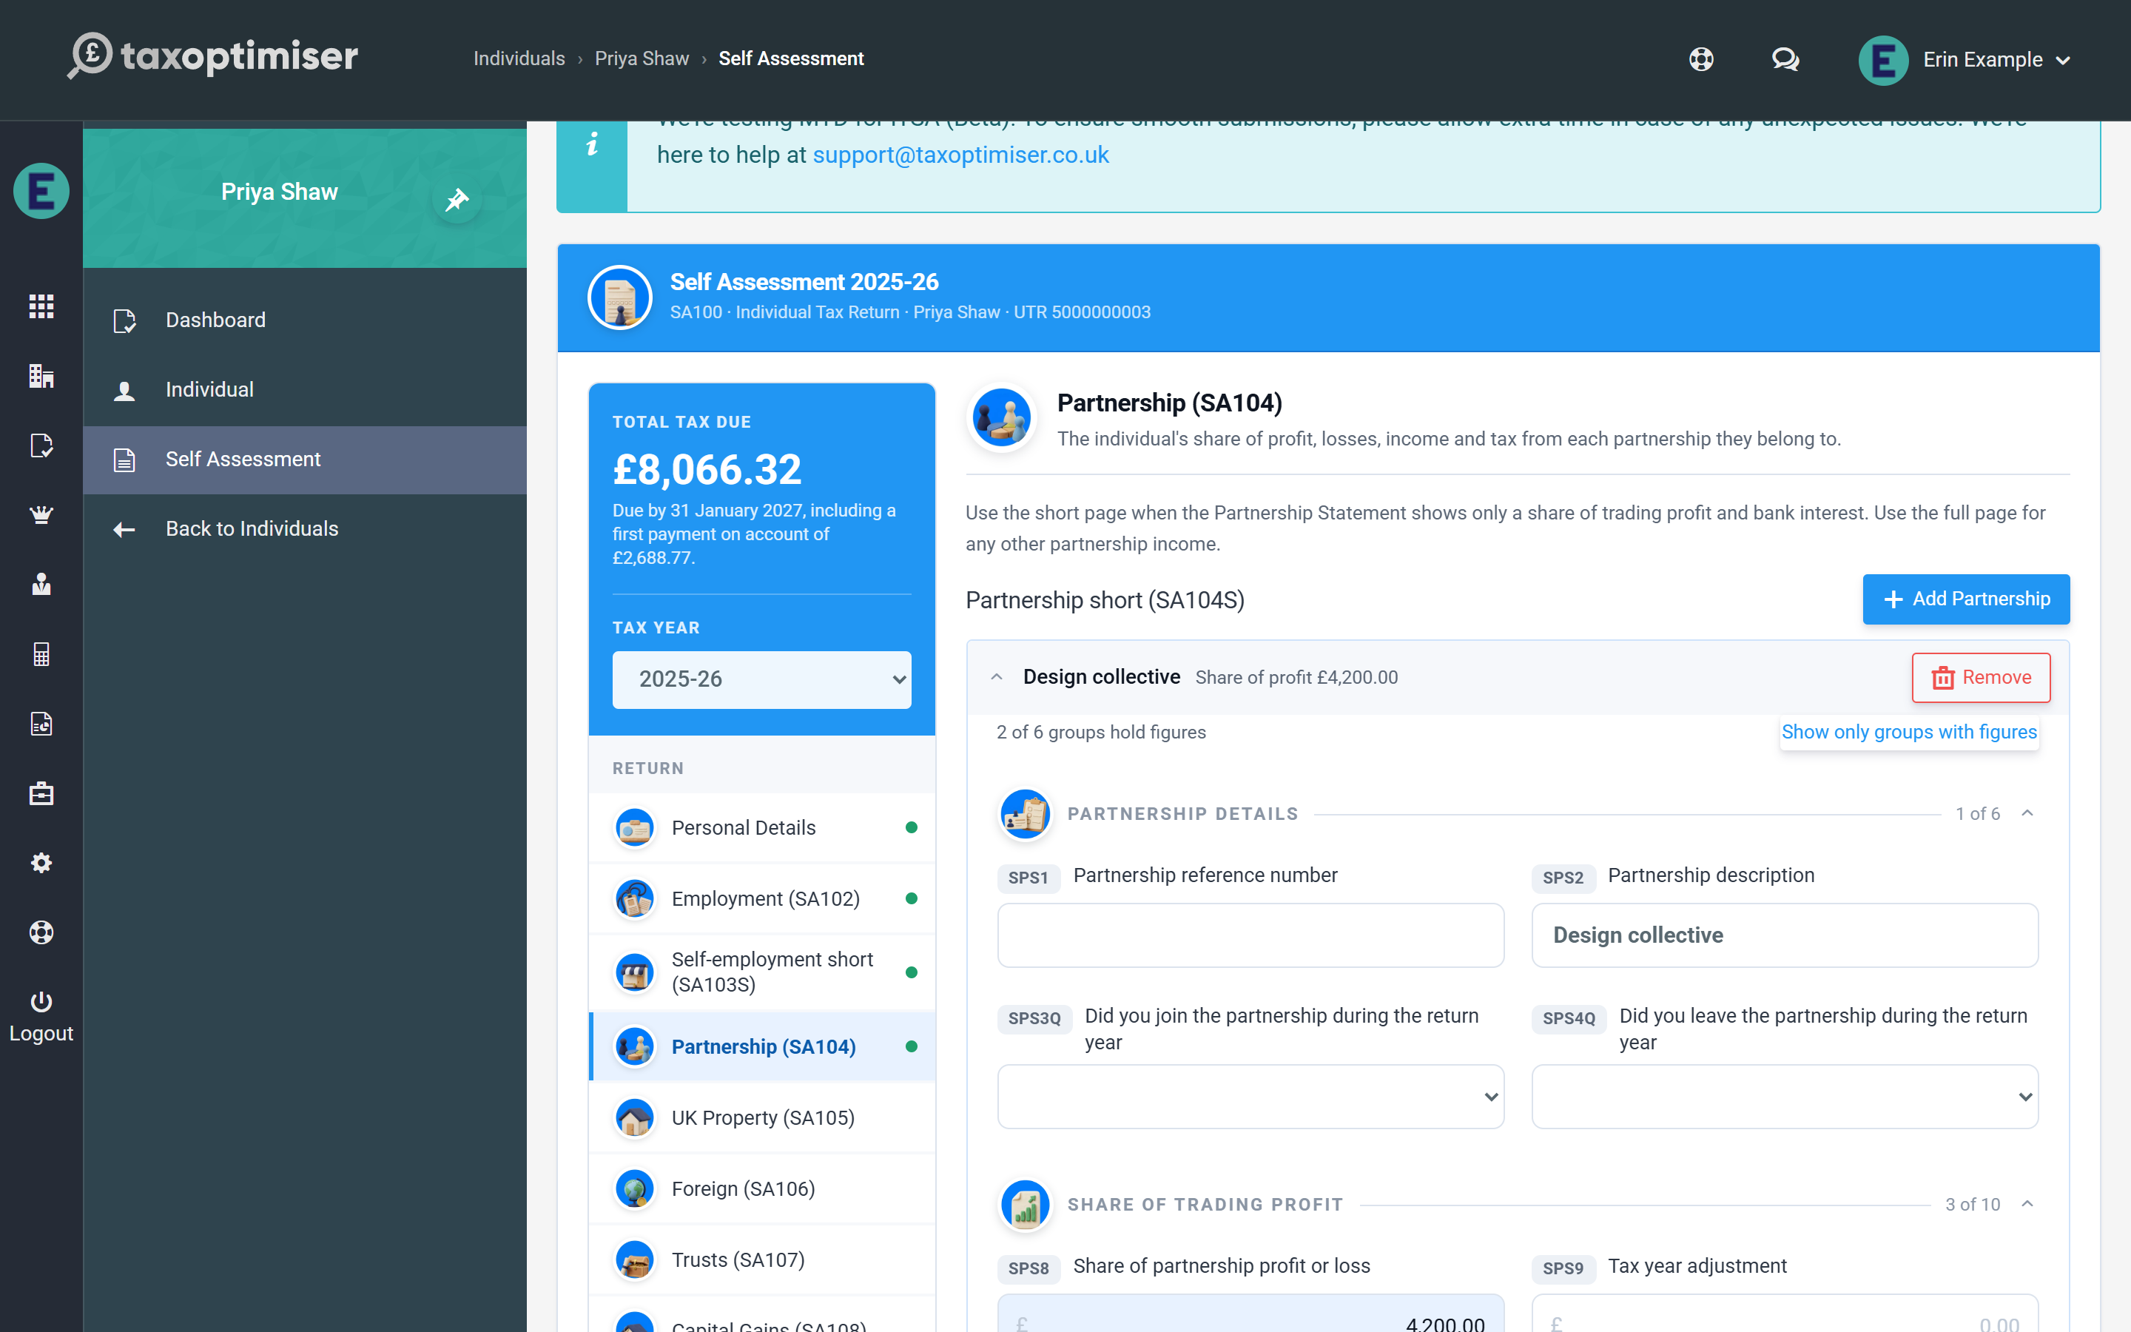

Foreign (SA106)
The foreign page takes the taxable totals by category — overseas savings interest, dividends, pensions, property and other income — together with any special withholding tax or UK tax already accounted for, which is credited like tax deducted at source. Foreign Tax Credit Relief works as it does on the paper form: work out the relief on HMRC’s HS263 working sheet and enter it in box 2; the calculation credits it up to the tax charged and notes that HMRC may recompute it. Overseas residential finance costs earn the same 20% reducer as UK property.
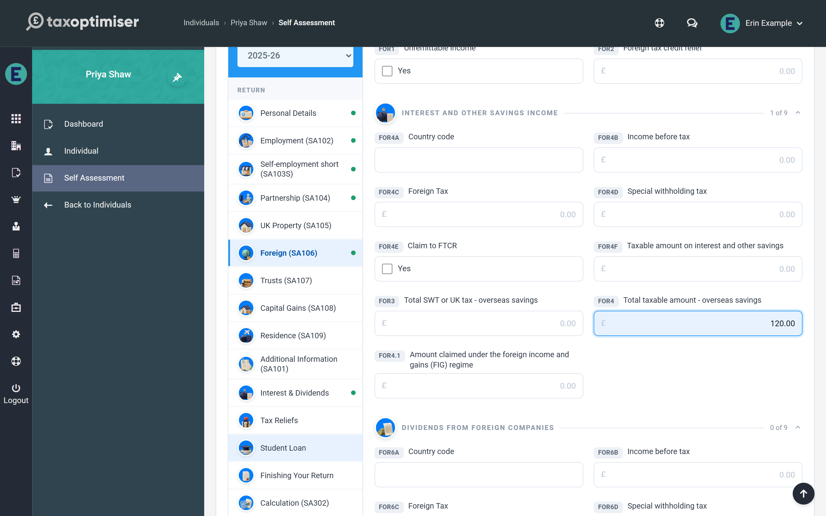

Trusts and estates (SA107)
Enter trust and estate income net, exactly as the R185 shows it — the calculation grosses each box up at the rate the trustees or personal representatives accounted for (basic, savings, dividend or trust rate) and credits the tax automatically. Two credits are non-repayable by law — payments from settlor-interested trusts and estate income taxed at the non-repayable basic rate — and the calculation caps them at the tax due rather than ever creating a refund from them.
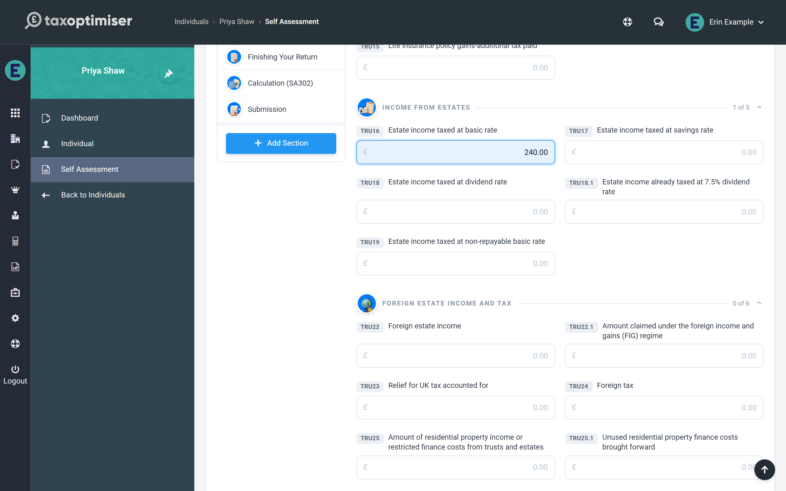

Capital Gains (SA108)
Enter the year’s totals per asset category — residential property, listed and unlisted shares, crypto-assets, other assets — with disposals counts, proceeds, costs, gains and losses, exactly as on the paper form. The calculation applies in-year and brought-forward losses and the £3,000 annual exempt amount, then taxes what remains at 18% within any unused basic-rate band and 24% above it, with Business Asset Disposal Relief and Investors’ Relief gains at their 14% rate and carried interest at its own rate. Tax already charged on in-year property (PPD) or real-time returns is credited against the Capital Gains Tax due, up to the amount due — any excess is not repaid through the return, and the calculation says so. Capital Gains Tax joins the balancing payment but never the payments on account.
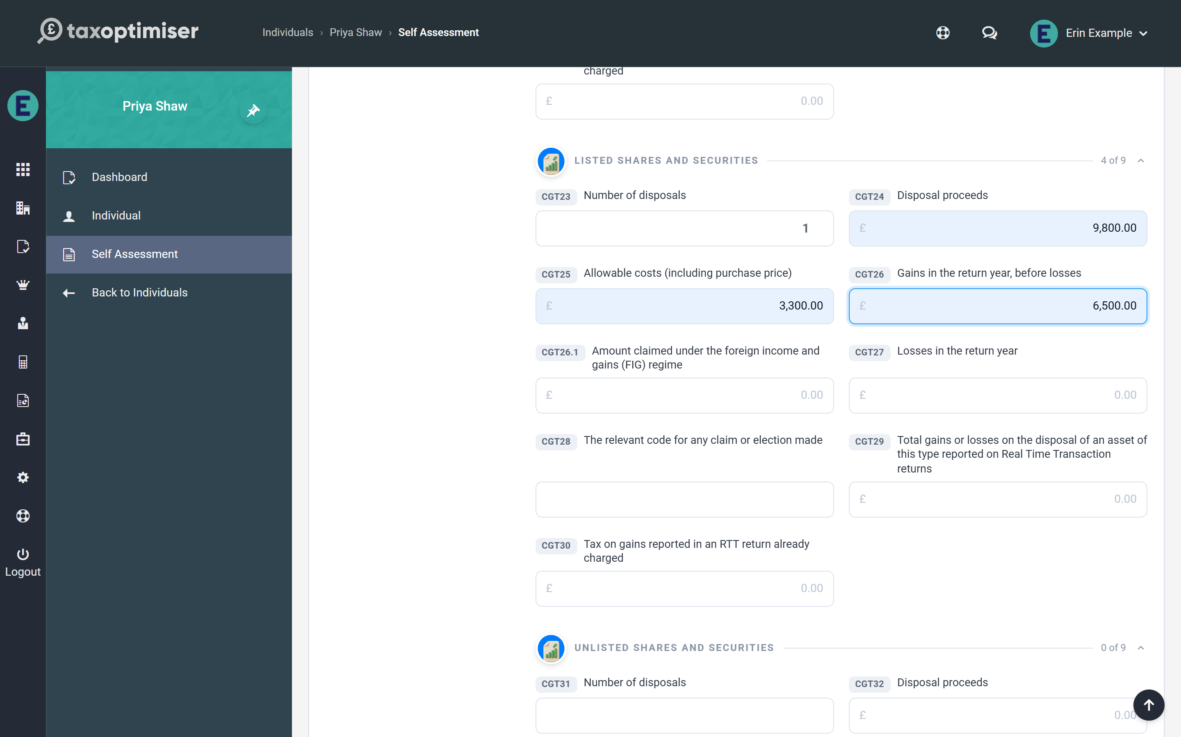
HMRC will not accept a capital gains page without a summary of the computation. Put it in the Additional Information box (box 54) at the foot of the page — a line per disposal with proceeds, costs and the gain is enough. Until it is there, the pre-flight checks on the Submission section flag it and link you straight back to this page.

Residence (SA109)
The residence page carries the statutory residence test entries — residence status, split-year treatment, day counts and ties — plus the personal allowance claim boxes. One entry changes the tax directly: a client marked not UK resident loses the Personal Allowance unless boxes 15 or 16 claim it (under a double taxation agreement or another basis), and the calculation shows a note whenever it has removed the allowance. A non-resident’s UK dividends also carry a non-repayable credit at the dividend ordinary rate, which the calculation sets against the bill automatically.
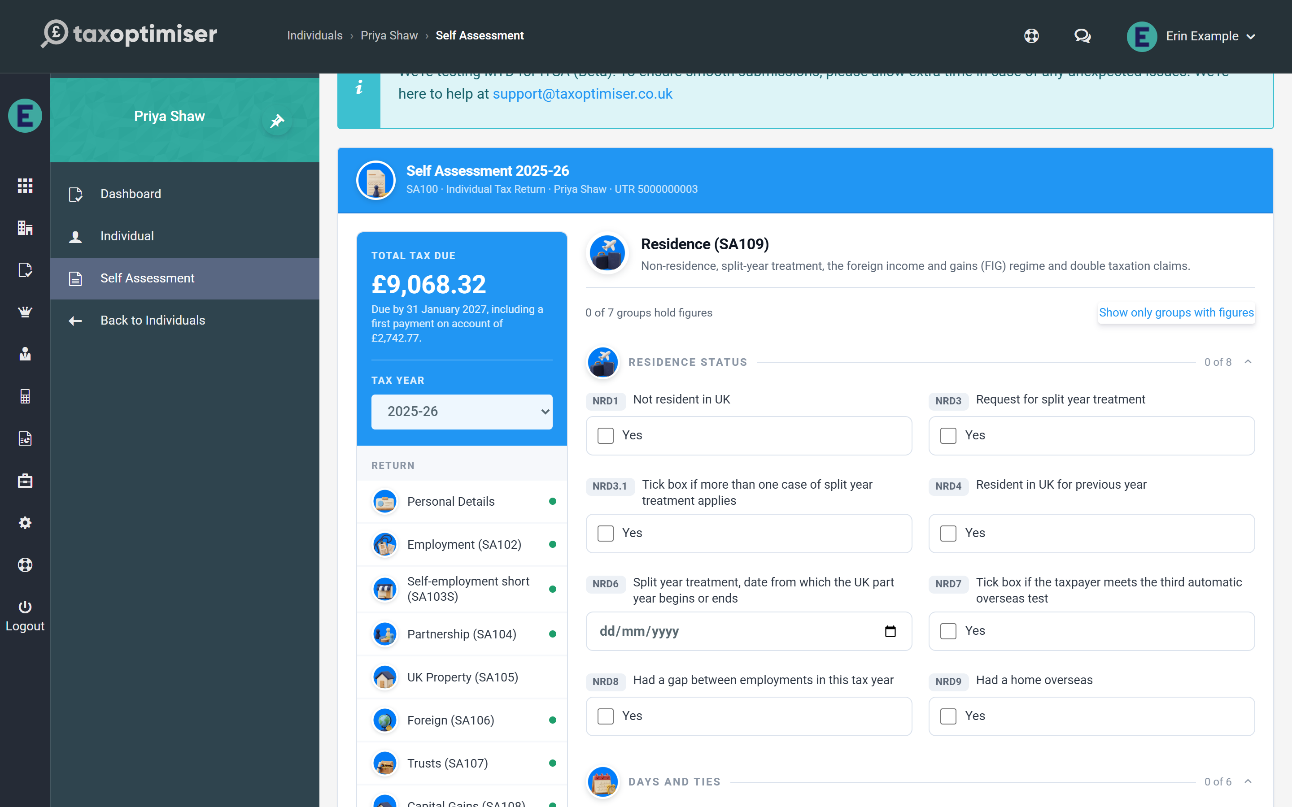

Additional Information (SA101)
The SA101 catch-all page covers the less common entries: gilt interest (entered gross with its tax credited), stock dividends and bonus issues, share schemes and employment lump sums (enter the taxable amounts in boxes 3 to 5 — the exemption boxes 8 to 10 are for information and are not deducted again), seafarers’ and foreign-earnings deductions, and the extra reliefs — qualifying loan interest, annuities and, for investments, EIS (30%), SEIS (50%), VCT (30%) and Community Investment Tax Relief, each capped at the tax charged. The age-related Married Couple’s Allowance (a spouse born before 6 April 1935) is worked out here too, with its income taper and transfer options.
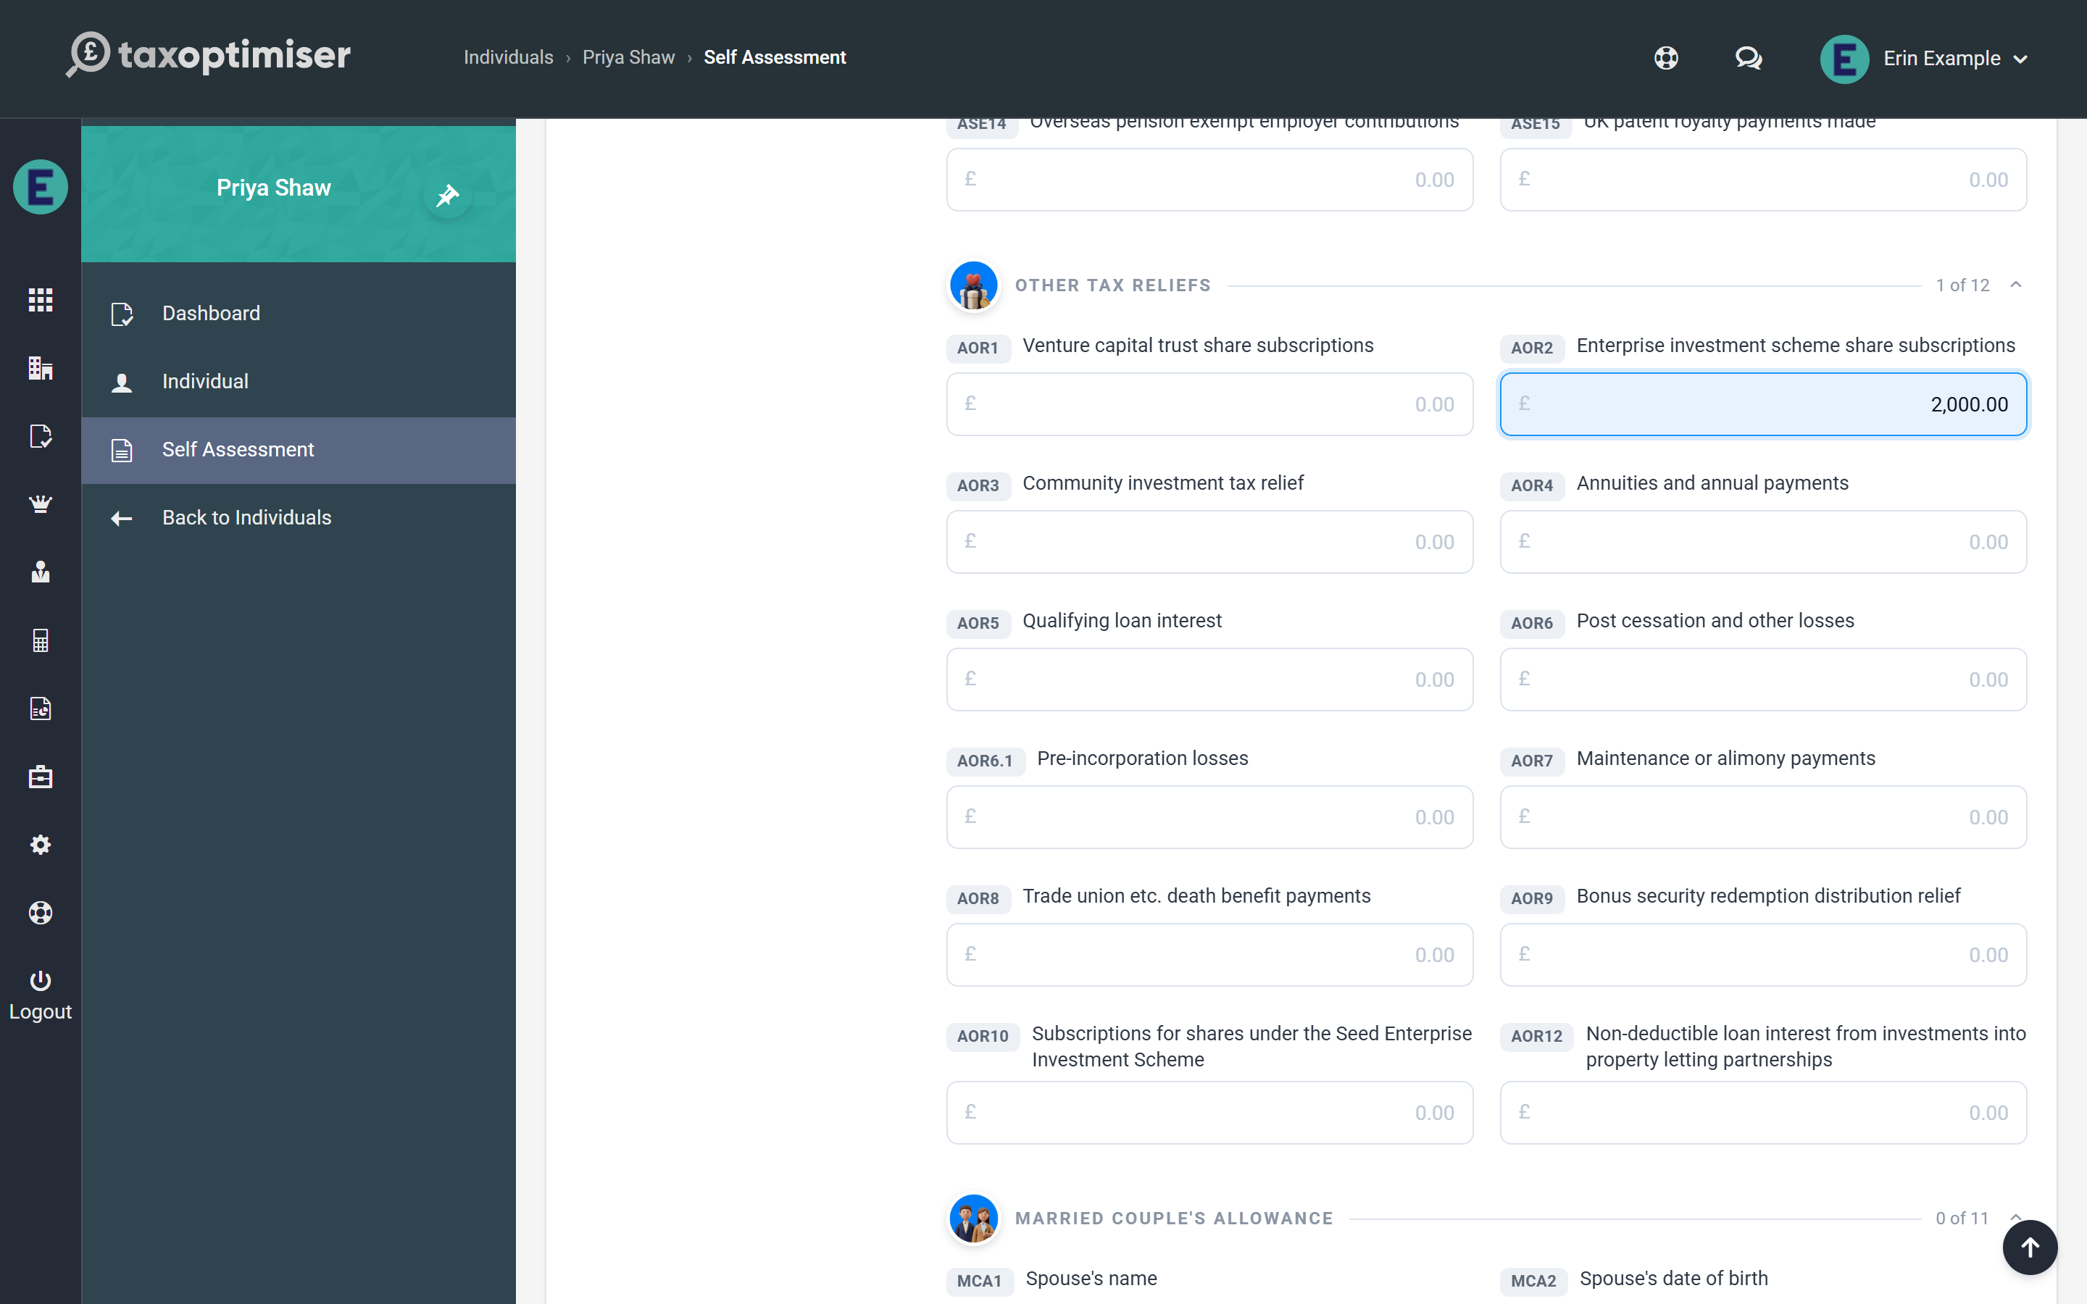

What still blocks online filing
A small set of genuinely specialist boxes remains outside the calculation. Using any of them raises a blocking warning on the Calculation section and the pre-flight checks refuse to file, so a wrong self-calculated return can never reach HMRC:
- life-insurance policy gains needing top-slicing relief (SA101, SA106 and SA107 life-gain boxes)
- remittance-basis and foreign income and gains (FIG) regime claims
- non-resident settlor-interested trusts and Transfer of Assets Abroad charges
- double taxation agreement partial relief amounts, Overseas Workday Relief and Temporary Repatriation Facility elections
- non-resident CGT and QAHC/excluded-securities gains
- pension annual allowance and unauthorised payment charges
Returns needing those entries should be filed through other means for now; everything else on these pages files online as normal.

5. Reliefs, student loans and the rest of the return
Pension contributions, Gift Aid, Marriage Allowance, the High Income Child Benefit Charge, student loan plans, and the return's closing boxes.
IN SHORT
- Enter Gift Aid and pension payments as paid - the calculation does the grossing up
- Watch the basic-rate band grow in the band breakdown after a Gift Aid entry
- Marriage Allowance is one tick in either direction
- HICBC is automatic once Child Benefit received is entered
- Student loan plan type + PAYE deductions drive the SA repayment

The Tax Reliefs and Student Loan sections carry the SA100’s claims and charges. Everything here feeds the live calculation the moment it is entered, so you can see exactly what each claim is worth.

Tax reliefs
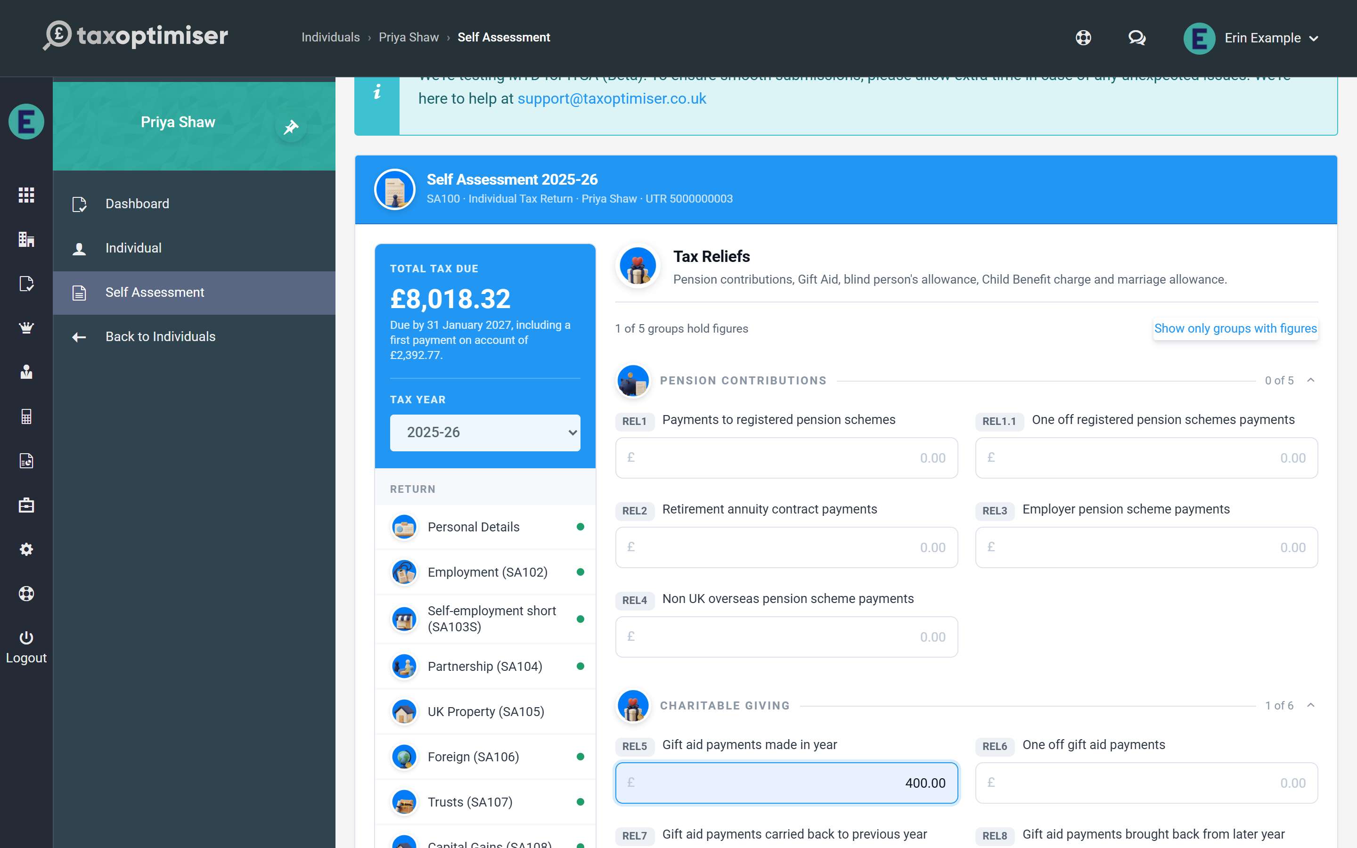
The page is grouped by relief: pension contributions, charitable giving, Blind Person’s Allowance, the High Income Child Benefit Charge and Marriage Allowance.
- Pension contributions — enter relief-at-source payments gross (as the form asks); the calculation extends the basic-rate band and protects the Personal Allowance taper accordingly. Retirement annuity and overseas scheme payments are deducted from income.
- Gift Aid — enter what the client actually paid; the gross-up and band extension happen in the calculation. You can see the effect in the band breakdown: the basic-rate band grows by the grossed-up gift.
- Marriage Allowance — tick whether the client is receiving from or transferring to their partner; the £252 reduction (or reduced allowance) is applied automatically. The spouse identity boxes are also here.
- High Income Child Benefit Charge — enter the Child Benefit received and number of children; the charge is calculated from adjusted net income (1% per £200 over £60,000, fully clawed back at £80,000).
- Blind Person’s Allowance — tick registered blind and the allowance is added.
- Winter Fuel Payment — this one sits in Personal Details, not here: enter the payment received and the calculation charges it back where the client’s income is over £35,000.

Student and postgraduate loans
Tick the notification box, pick the plan type, and enter anything already repaid through PAYE — the calculation works out the Self Assessment repayment from total income (unearned income counts once it exceeds £2,000) and nets off the PAYE deductions.
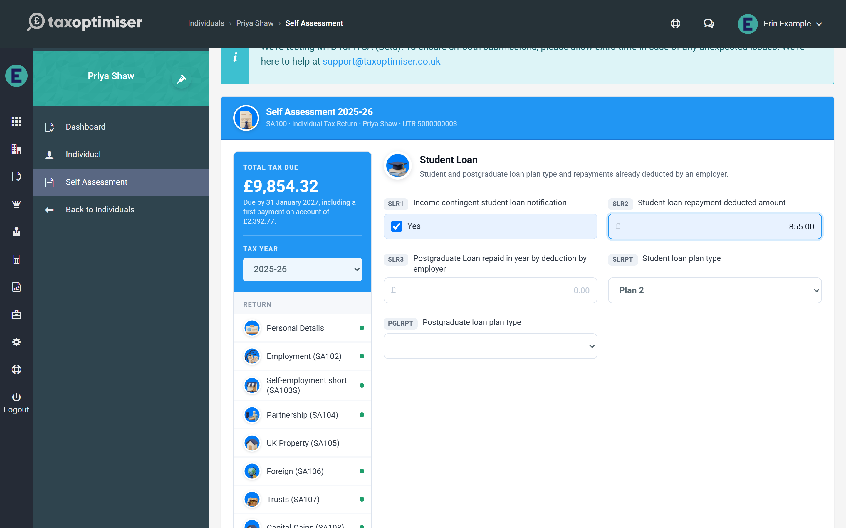

Finishing your return
The Finishing Your Return section carries the SA100’s closing boxes, grouped as on the form — refunds and tax code, repayment bank details, the tax adviser’s details, other information (including the provisional-figures indicator), and signing on behalf of someone else. Repayment bank details are all-or-nothing: HMRC expects the bank name, sort code and account number together, not one without the others. The declaration itself is confirmed on the Submission screen at filing time, so nothing here blocks day-to-day data entry.

6. The tax calculation and the SA302 PDF
The live SA302-style calculation: the staged statement, the band-by-band breakdown, PAYE coding adjustments and the claim to reduce payments on account, warnings, and the downloadable SA302 PDF.
IN SHORT
- Recalculated on every save - never stale
- The band table shows exactly which rate taxed each slice of income
- Coding notice amounts and the POA reduction claim are entered on the Calculation section
- Red blocking warnings stop online filing before it can go wrong
- The SA302 PDF is the document mortgage lenders ask for
- Advisory until HMRC accepts - HMRC's own calculation is definitive

Because the traditional Self Assessment channel has no HMRC calculation service, Tax Optimiser computes the full tax position itself — recalculated on every save, so the Calculation (SA302) section and the Total Tax Due card are never stale. The card spells out what the figure is: the amount due by 31 January including any first payment on account, or the repayment due when the client has overpaid.

Reading the calculation
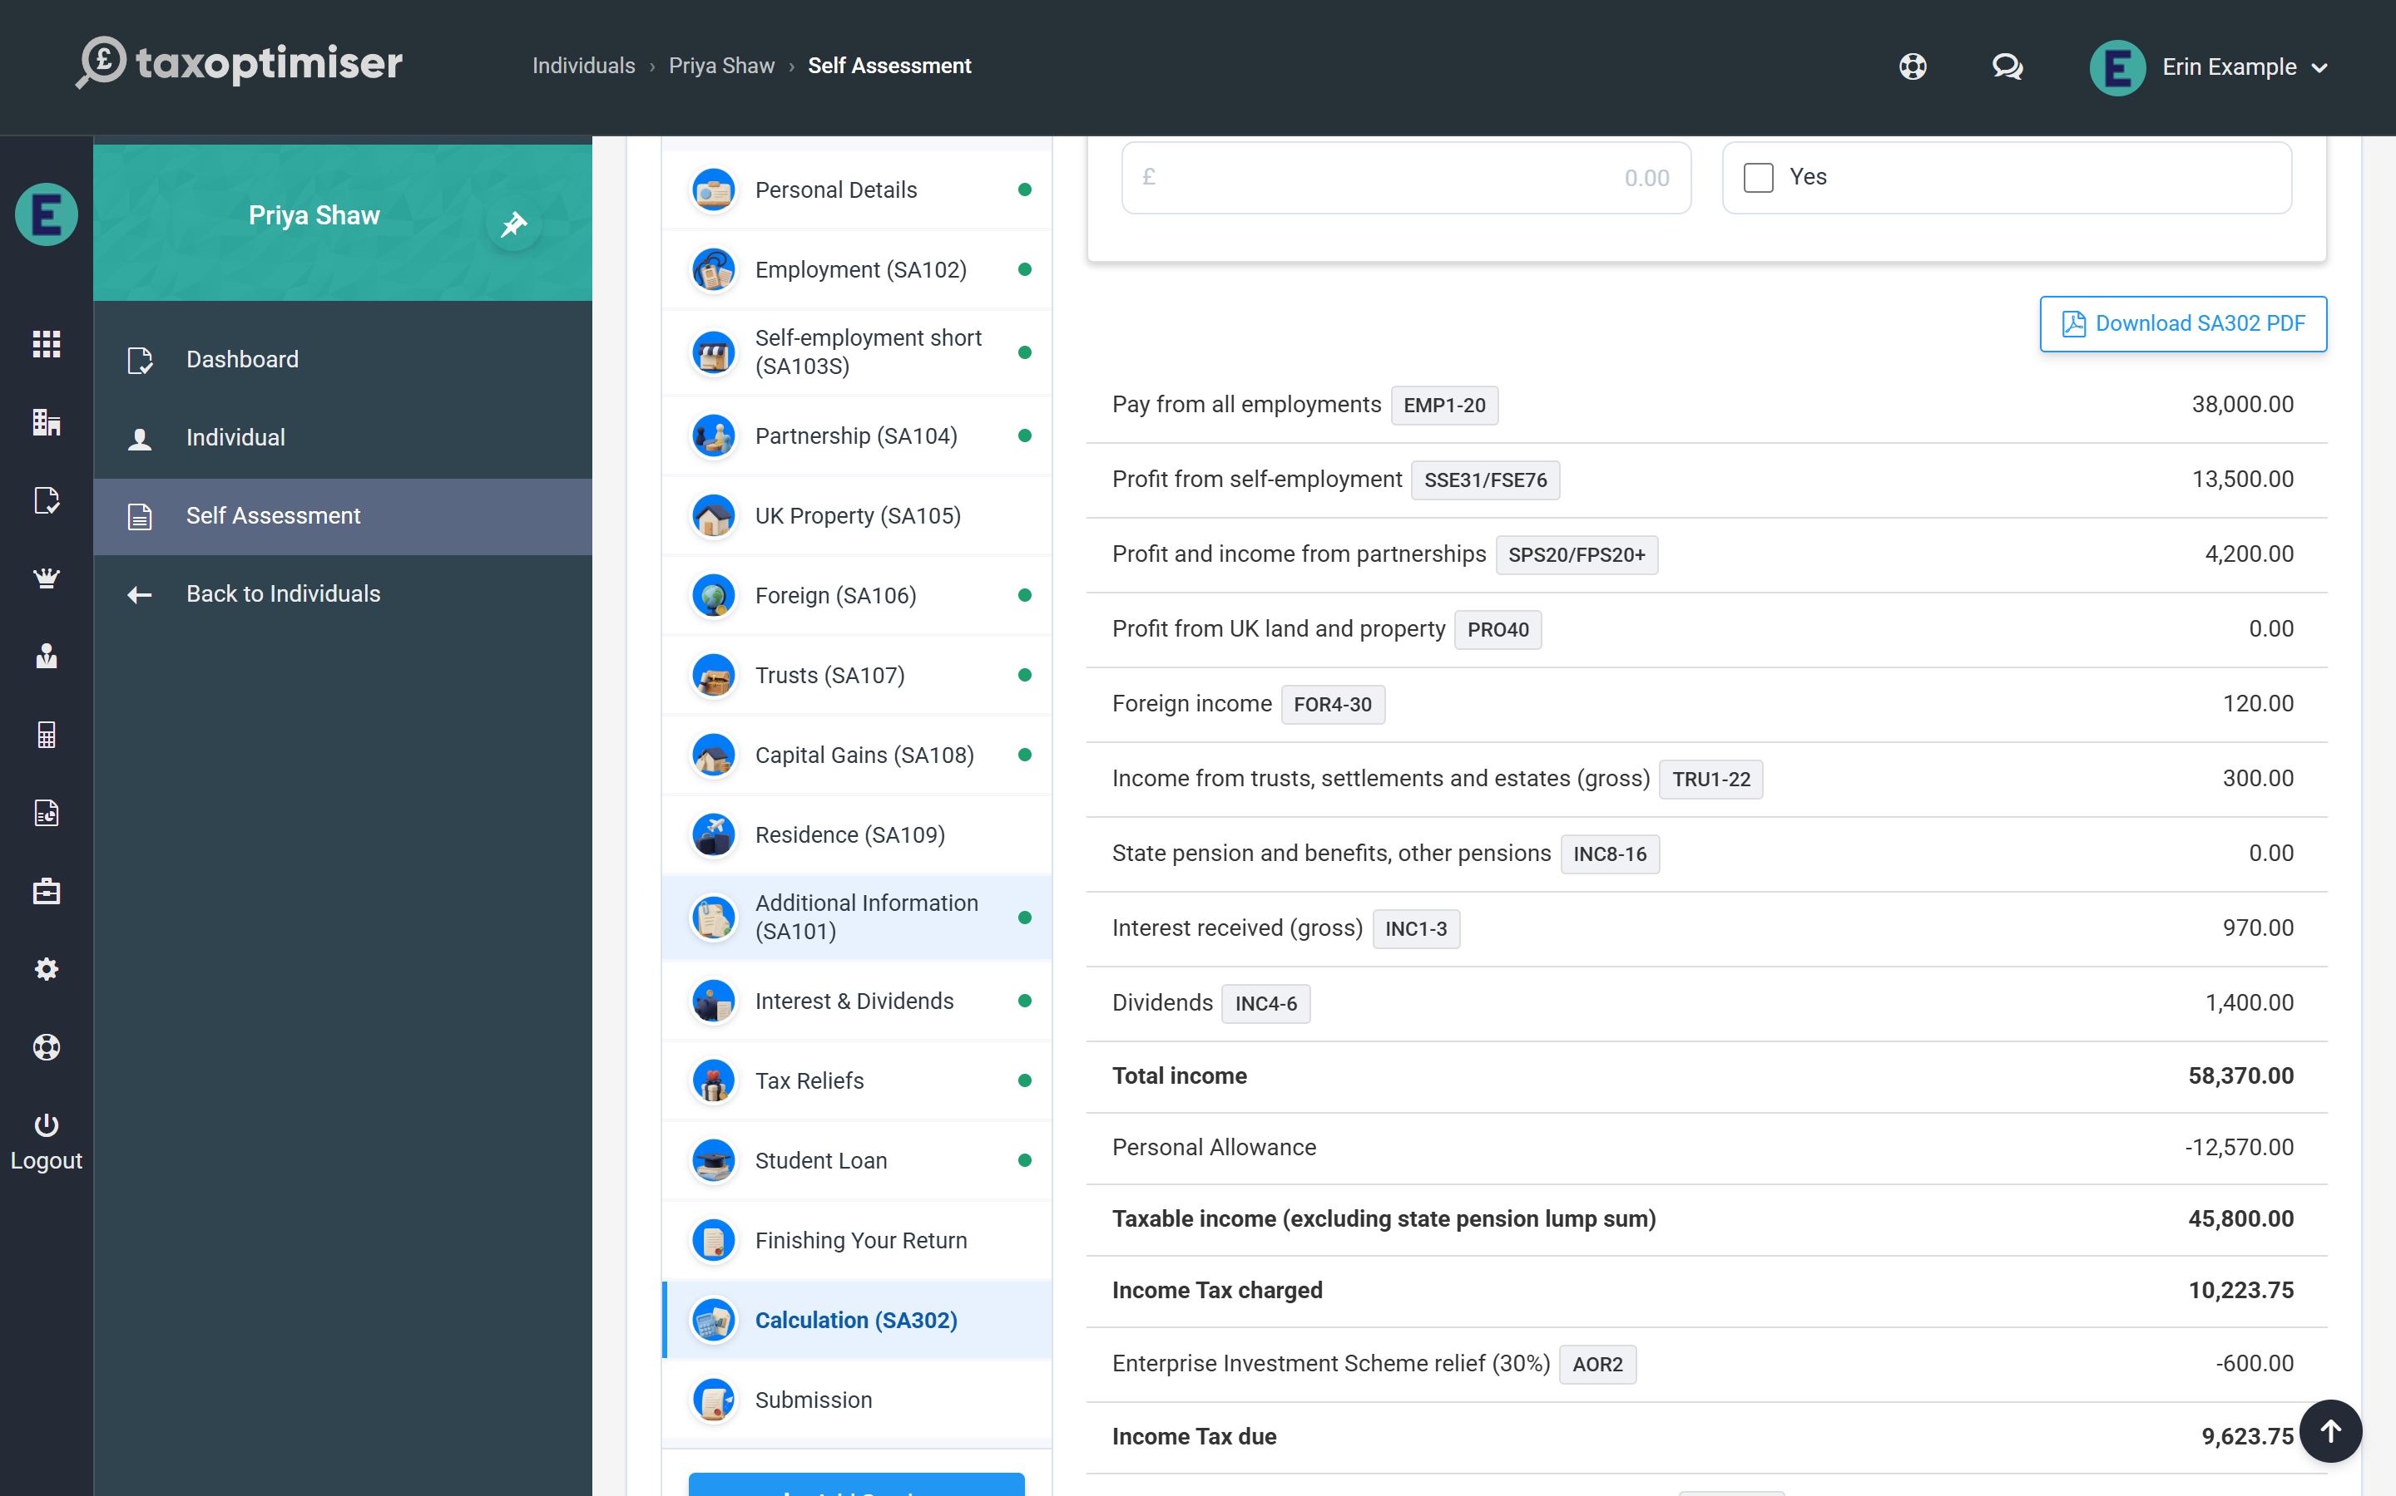
The statement follows the same staged shape as HMRC’s SA302: income by type, deductions and the Personal Allowance (with the £100,000 taper where it applies), Income Tax, Capital Gains Tax where the SA108 page is in use, Class 4 and Class 2 National Insurance, student loan repayments, tax already deducted at source (PAYE, CIS, taxed interest, trust credits), and finally the balancing payment and any payments on account for the following year with their due dates. Capital Gains Tax joins the balancing payment but never the payments on account.

PAYE coding adjustments and reducing payments on account
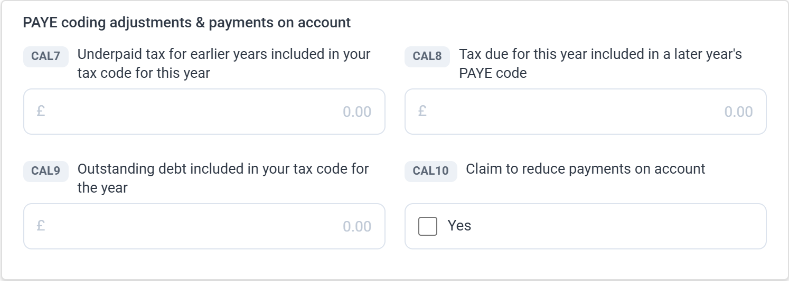
The card at the top of the Calculation section carries the SA110 boxes that adjust what is actually payable:
- Underpaid tax for earlier years in this year’s code and outstanding debt in the code — these add to the balancing payment, because that slice of the year’s PAYE was collecting old amounts, not this year’s tax. Take both from the client’s PAYE coding notice.
- Tax due for this year included in a later year’s code — this defers, reducing the balancing payment (it can bring it to zero but never create a repayment).
- Claim to reduce payments on account — tick the claim and enter the reduced first payment where next year’s income will be lower. The claim can only reduce: an amount at or above the calculated figure is ignored, with a note saying so.

How the tax was worked out
Below the statement, the band breakdown shows every slice of income against the band and rate that taxed it — including the 0% slices (Personal Savings Allowance, dividend allowance, savings starting rate) and any band extension from Gift Aid or pension contributions. Scottish taxpayers see the Scottish bands on non-savings income, with savings and dividends staying on UK-wide bands, exactly as HMRC applies them.
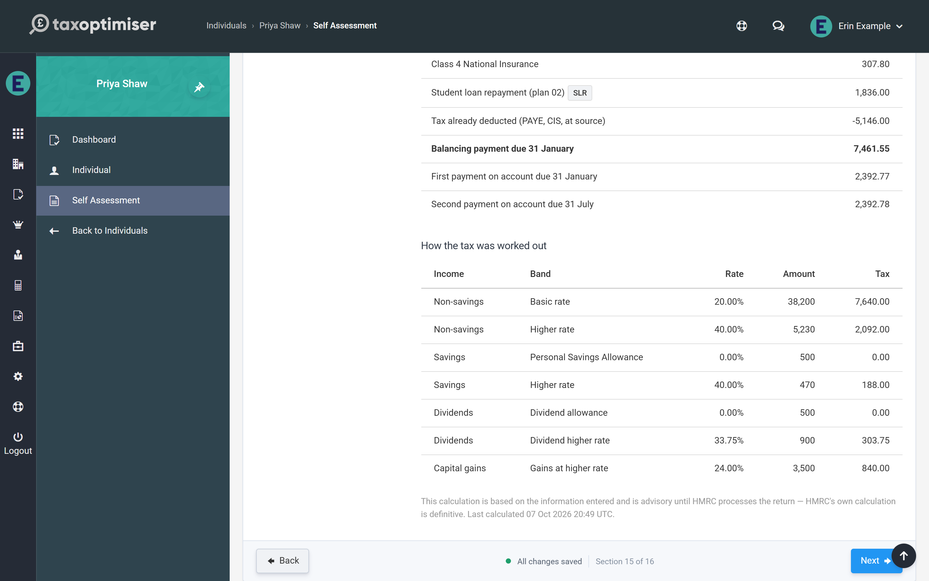

Warnings: informational and blocking
The calculation flags anything it wants you to know about. Informational notes explain a treatment (for example how a state pension lump sum was taxed). Blocking warnings, shown in red, mean the return cannot be filed online through Tax Optimiser — typically because it uses one of the specialist boxes the calculation does not yet cover. The section menu shows a red count beside Calculation while any are outstanding. A blocked return fails the pre-flight checks on the Submission screen, so nothing incomplete can reach HMRC by accident.

The SA302 PDF
Download SA302 PDF produces the tax-calculation document clients are asked for by mortgage lenders: the full statement, the band breakdown and the payments on account, over the client’s name and UTR. The PDF is recalculated from the saved figures at the moment you download it, and carries a draft banner until HMRC has accepted the return. As with any software calculation, it is advisory until HMRC processes the return — HMRC’s own figure is definitive.

7. Submitting the return to HMRC
Filing a prepared return: the pre-flight checks and their fix links, the declaration, what happens during submission, and reading the submission history.
IN SHORT
- Every pre-flight check must pass - and is re-checked server-side at filing
- A failed check links straight to the section that fixes it
- One click builds, signs, submits and polls HMRC for the outcome
- Acceptance locks the year; rejection shows HMRC's errors verbatim
- The correlation ID in the history is the reference for any HMRC query
- Re-poll chases an in-flight submission without resubmitting

The Submission section takes the return from prepared to filed: pre-flight checks, the declaration, the submission itself, and a history of every attempt.

Pre-flight checks
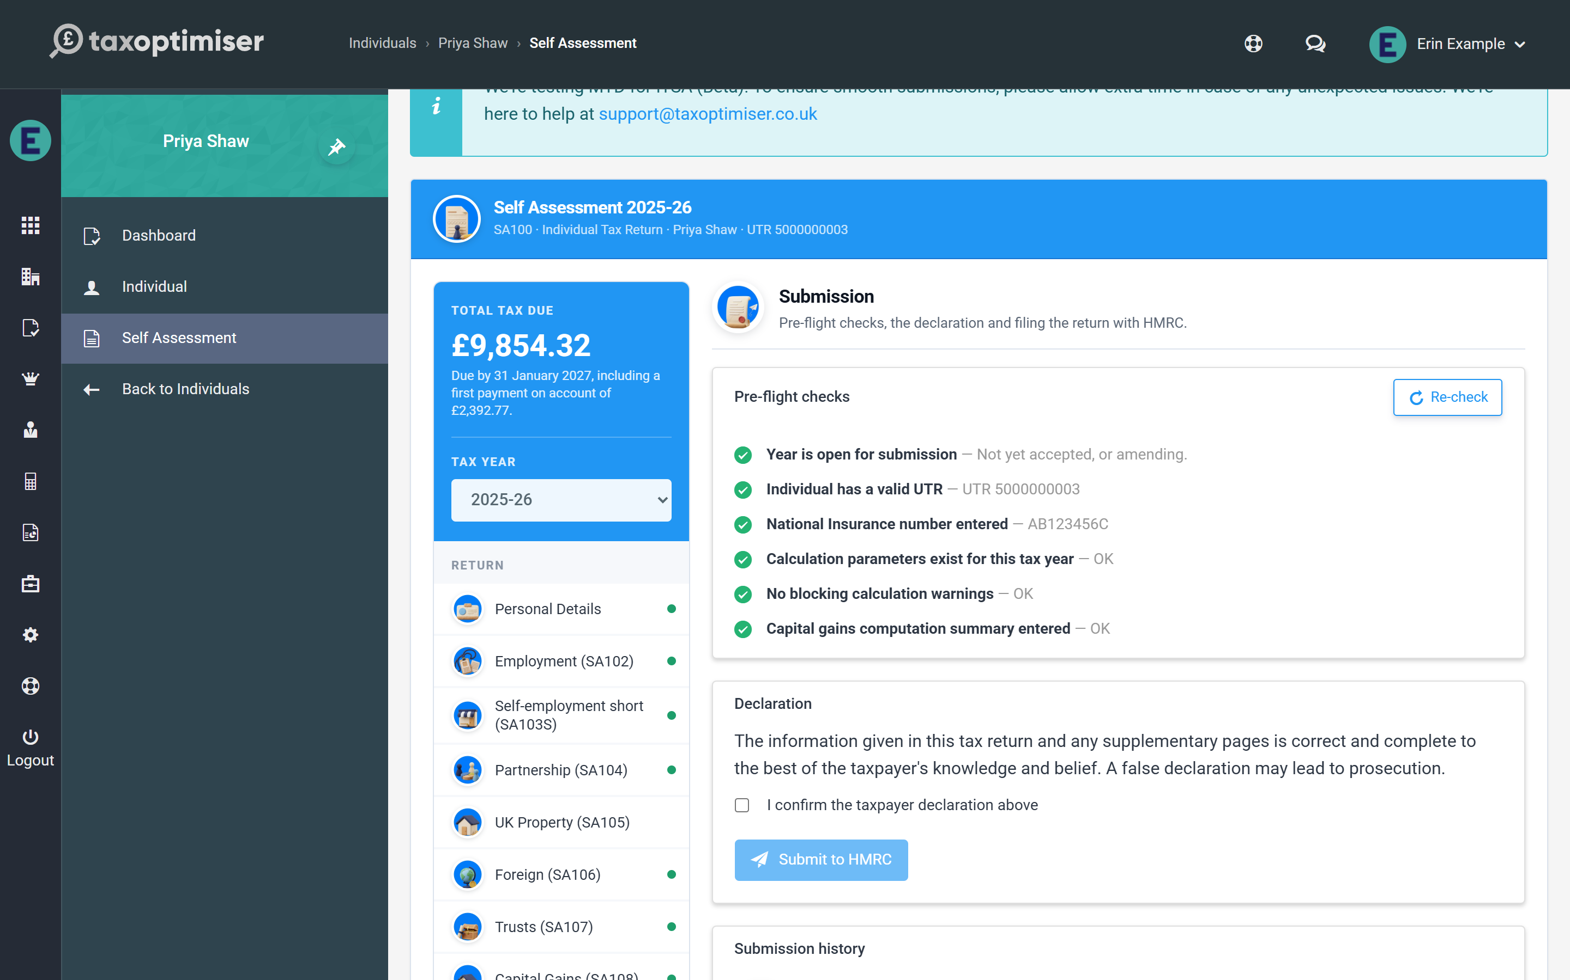
Every check must pass before the Submit button unlocks, and every one is re-verified on the server at the moment of filing:
- the year is open for submission (not already accepted, unless amending)
- the client has a valid UTR on their record (it is checked against HMRC’s check-digit algorithm, not just for presence)
- a National Insurance number is entered in Personal Details
- calculation support exists for the tax year
- there are no blocking calculation warnings
- where the return has a Capital Gains page, the computation summary is entered in its box 54 — HMRC rejects an SA108 without one
Anything failing shows in red with what to fix. Where the fix is on another section of the return, a Go to link beside the check takes you straight there; come back to Submission afterwards and the list is checked again, or press Re-check to run it at any time.
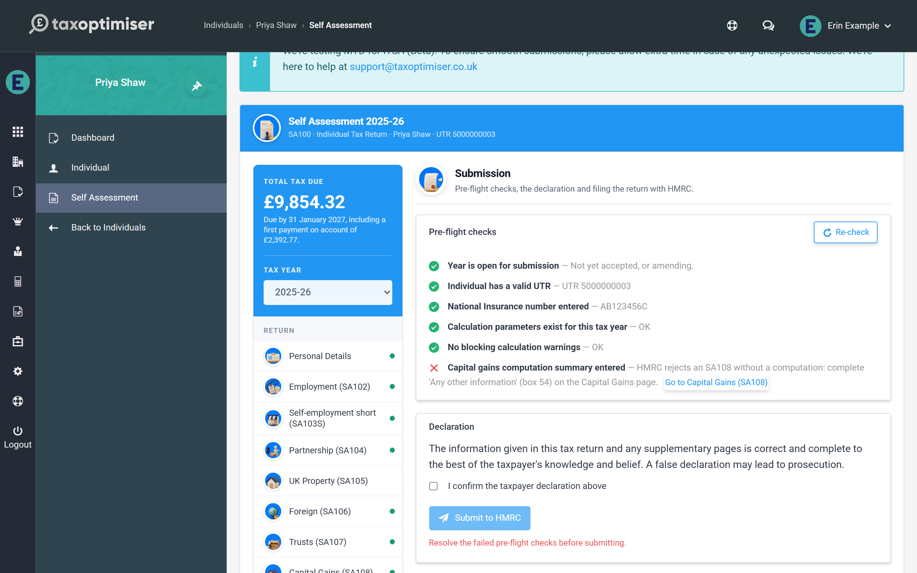

Declaration and submit
Tick the declaration — the standard Self Assessment wording that the return is correct and complete to the best of the taxpayer’s knowledge — and press Submit to HMRC. Tax Optimiser builds the return in HMRC’s required format, signs it with the tamper-evident IRmark, sends it, and polls HMRC for the response, all in one step. The section shows a progress panel while this happens — it can take a minute — and then the outcome: Return accepted by HMRC, or the problem HMRC reported. On success the year moves to Accepted and locks against accidental edits; if HMRC rejects the return, their errors are shown in full and the year reopens for correction as soon as you edit it.

The submission history
Every attempt is recorded with its date, status (Waiting for HMRC, Accepted or Rejected), whether it was an amended return, and its HMRC correlation ID — the reference to quote if you ever need to speak to HMRC (or to support@taxoptimiser.co.uk) about a filing. If a submission is still showing Waiting for HMRC — for example after a connection drop mid-poll — the Re-poll button asks HMRC for the outcome again without resubmitting anything. Tax Optimiser also chases stuck submissions automatically in the background every fifteen minutes, so a return interrupted mid-poll usually resolves itself without any action from you.

8. Amending an accepted return
Accepted years lock; Reopen for amendment files a replacement return. The amendment deadline, rejections, and chasing stuck submissions.
IN SHORT
- Accepted years lock read-only automatically
- Amendments can be filed until 12 months after the 31 January deadline
- Reopen for amendment - the next filing replaces the original at HMRC
- Rejections reopen on edit; Re-poll chases interrupted submissions
- Quote the correlation ID to support for any filing query

Once HMRC accepts a return, the year locks: every section shows read-only so the filed position cannot drift by accident. The banner across the top shows the amendment deadline — Self Assessment returns can be amended up to 12 months after the 31 January filing deadline (for 2025-26, until 31 January 2028).
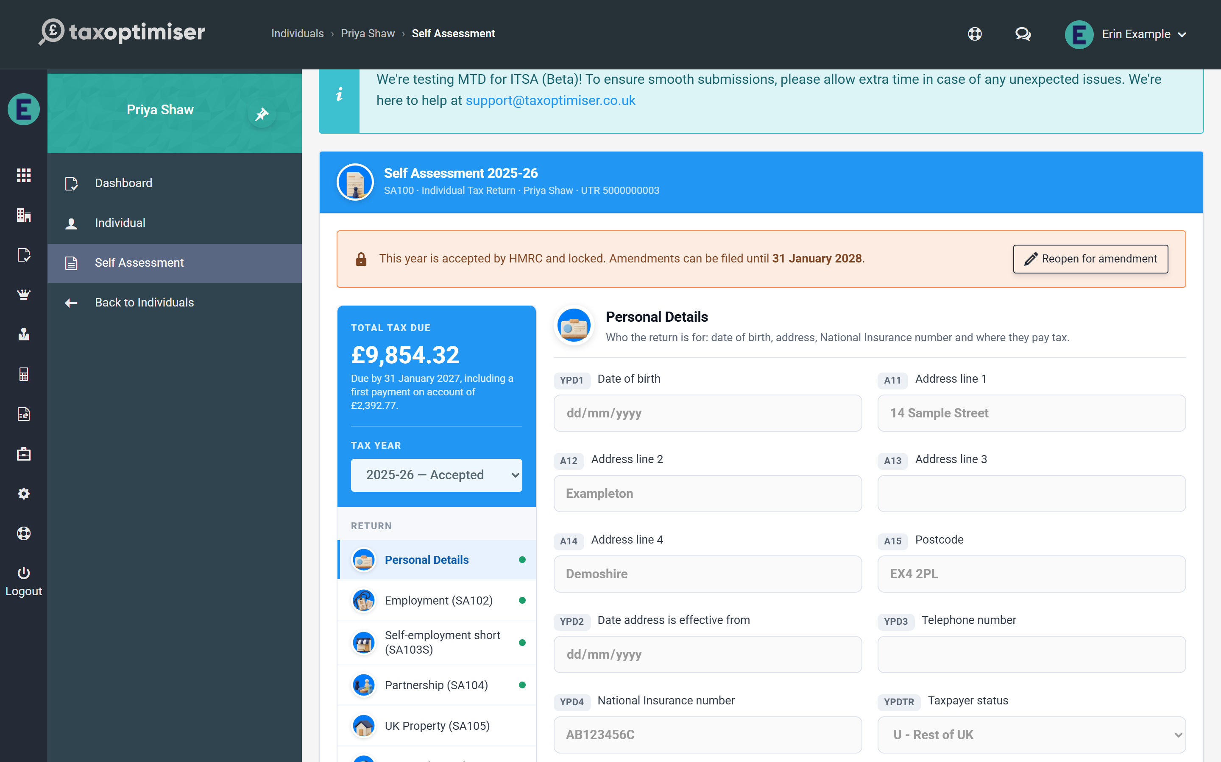

Reopening for amendment
Press Reopen for amendment and the year unlocks with an amendment banner: from this point the next submission is filed as an amended return, which HMRC treats as replacing the original. Edit whatever needs correcting — the calculation re-runs as usual — then submit again from the Submission section exactly as before. The declaration step makes clear an amended return is being filed.
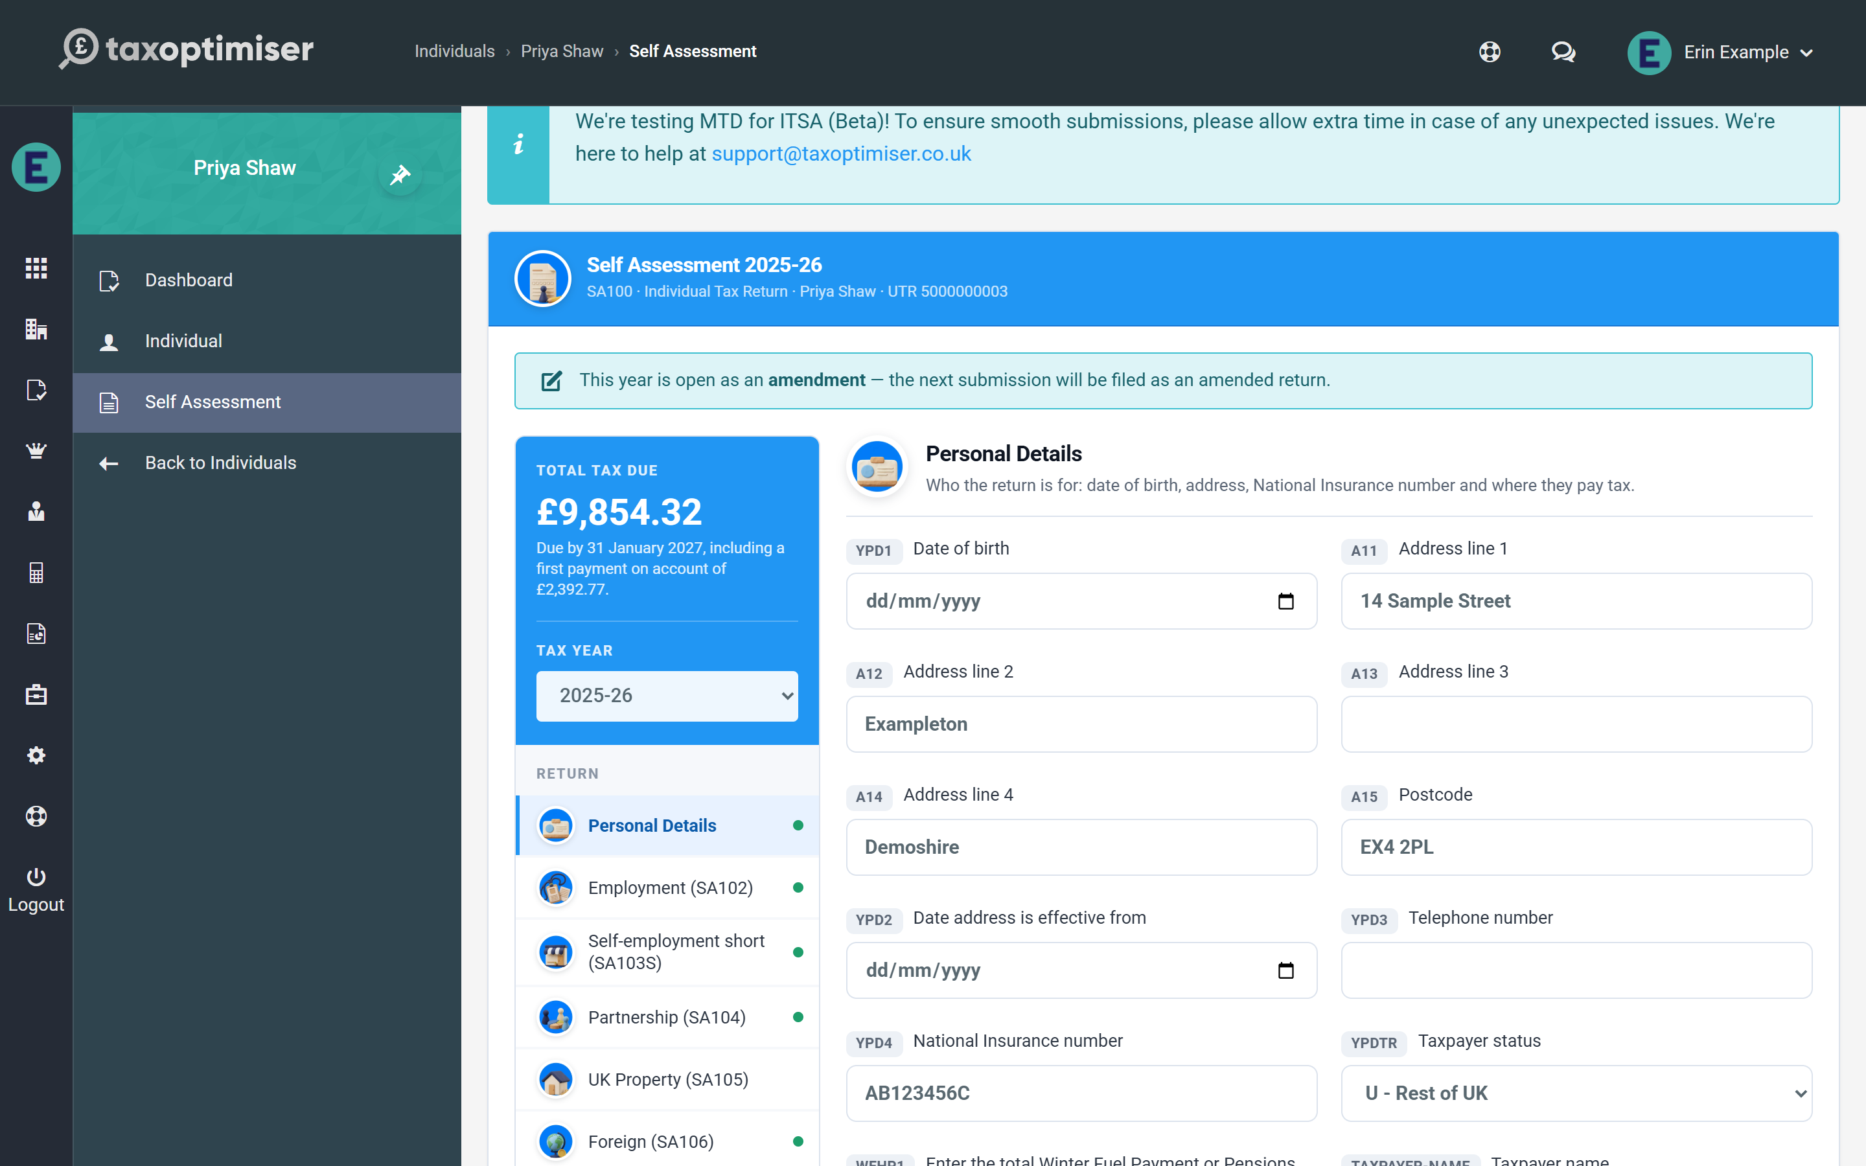

Rejections and stuck submissions
A rejection never locks anything: HMRC’s errors are shown on the Submission screen, and the year returns to open the moment you edit a section — fix the issue and submit again. If a submission was interrupted mid-flight and the year shows submitted without an outcome, the same Reopen action unlocks it (without the amendment flag, since nothing was accepted), and Re-poll on the Submission screen can chase HMRC for the original outcome first.

During the beta
While Self Assessment is in beta, the team at support@taxoptimiser.co.uk is the fastest route for anything unexpected around filing and amendments — include the submission’s correlation ID from the history and they can trace it end to end with HMRC.

