SA800 Partnership Returns
User Guide (beta)
Preparing and filing the Partnership Tax Return in Tax Optimiser — creating a partnership period, the details and declarations, trading income, the balance sheet, the Partnership Statement, supplementary pages, and submitting to HMRC.
Beta feature — Partnership (SA800) returns are currently in beta and are switched on for one accountant firm at a time. To gain access for your firm, email support@taxoptimiser.co.uk and the team will enable it and help you get started.
taxoptimiser.co.uk · 7 October 2026

Contents
- Partnership (SA800) returns in Tax Optimiser (beta) — Prepare and file SA800 Partnership Tax Returns for LLP and partnership clients: a six-step wizard, self-calculating boxes, the official form as a PDF, and direct HMRC filing.
- Getting started with SA800 returns — Where the LLP (SA800) menu appears, what the returns list shows, what New Partnership Period prefills for you, and what a return costs to file.
- SA800 details, declarations and the page 2 questions — The Details step: partnership name and live-checked UTR, boxes 3.1/3.2, period and start/cessation dates, the accounting basis and declarations, the page 2 questions and box 3.116.
- SA800 trading income and expenses — The full SA800 income and expenses page: entering income and expense totals, the capital allowance pools, an optional breakdown of disallowables, and how the calculated boxes 3.65 and 3.73 drive the rest of the return.
- The SA800 balance sheet — Boxes 3.99 to 3.115: assets, liabilities and the partners' accounts, with all three totals calculated and a built-in way to check the sheet balances.
- The Partnership Statement: partners and profit shares — Adding partners, boxes 6-12, entering each partner's share, and the live checks: the allocation-vs-return warning and the UTR check that prevents error 8205.
- SA800 supplementary pages (SA801-SA804) — Land & Property, Foreign, Chargeable Assets and Savings on one screen - each page files only when it carries figures, and the totals calculate themselves.
- Reviewing, printing and submitting the SA800 — The checks that block a return HMRC would reject (each linked to its step), the page 8 declaration, the review summary, printing the official SA800 form and its schedule, what Submit really does, and what happens afterwards.

1. Partnership (SA800) returns in Tax Optimiser (beta)
Prepare and file SA800 Partnership Tax Returns for LLP and partnership clients: a six-step wizard, self-calculating boxes, the official form as a PDF, and direct HMRC filing.
IN SHORT
- SA800 returns for LLP and partnership clients, in a six-step wizard
- Calculated boxes (3.65, 3.73, balance sheet totals) are derived automatically
- SA801/SA802/SA803/SA804 supplementary pages included
- Print the official SA800 form and file directly to HMRC
- BETA: email support@taxoptimiser.co.uk to enable it for your firm

Tax Optimiser can now prepare and file the SA800 Partnership Tax Return for client partnerships — the annual return every UK partnership must send to HMRC, reporting the business’s income and how the profit was shared between the partners. You enter the return in a six-step wizard, the arithmetic boxes calculate themselves as you type, you can print the official SA800 form at any point, and you submit to HMRC without leaving Tax Optimiser.

Who this is for
The feature applies to client organisations whose structure is a Limited Liability Partnership or an ordinary Partnership — the LLP (SA800) menu section only appears for those organisations. The partnership itself pays no tax on the return: the SA800 reports the results and the Partnership Statement allocates them, and each partner then carries their own share onto the partnership pages of their personal return. If you also prepare the partners’ personal Self Assessment returns, Tax Optimiser’s Self Assessment (beta) feature covers those, including the SA104 partnership pages.

What is supported today
The beta supports the 2025-26 return with:
- The full trading income & expenses page (boxes 3.29–3.73) — also valid below the £90,000 three-line-accounts threshold, so one screen serves every size of partnership — with the capital allowance pools, an optional breakdown of disallowable expenses, and the start and cessation dates of the business
- Partnerships with no trade — property or investment partnerships file without the trading pages at all
- The summary balance sheet (boxes 3.99–3.115)
- The Partnership Statement — any number of partners, with each share checked against the return
- The supplementary pages: Land & Property (SA801) with its expense and tax-adjustment boxes and residential finance costs, Foreign (SA802) savings and dividends, Chargeable Assets (SA803) listed asset by asset, and Savings (SA804) interest, dividends and other income
- Partner and agent declarations, provisional figures and the rest of page 8, and amended returns
- A populated, printable copy of the official SA800 form, with a schedule for everything the printed form has no box for
- Direct filing to HMRC over their online channel, with the return checked before it is sent, signed, and tracked until HMRC answers
Not yet supported: more than one trade or accounting period on a return, foreign property and offshore funds on SA802, and returns for years other than 2025-26.
Every calculated box on the form — net profit (3.65), net business profit for tax (3.73), the balance sheet totals, the partners’ closing balance — is derived for you and shown read-only, so the return can never disagree with its own arithmetic.
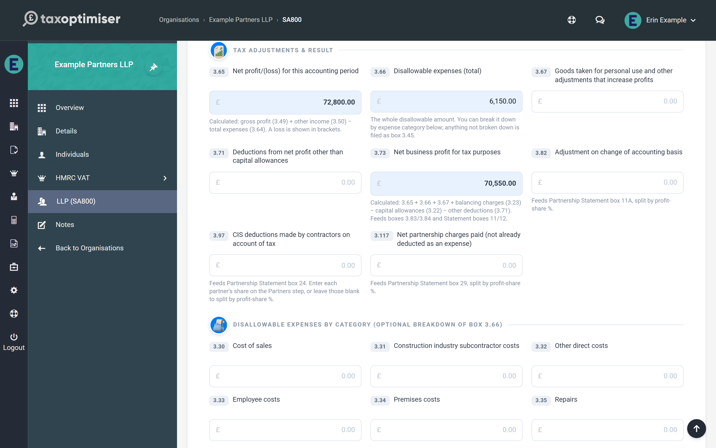

How the return comes together
The wizard walks the form in the order an accountant naturally works: partnership details, trading income, balance sheet, partners, supplementary pages, then a review step that summarises the whole return before anything is sent. Each step’s bubble gains a green tick once that step has what the return needs from it, and a red count whenever something on it would stop the return being filed, so you can see at a glance where there is still work to do.
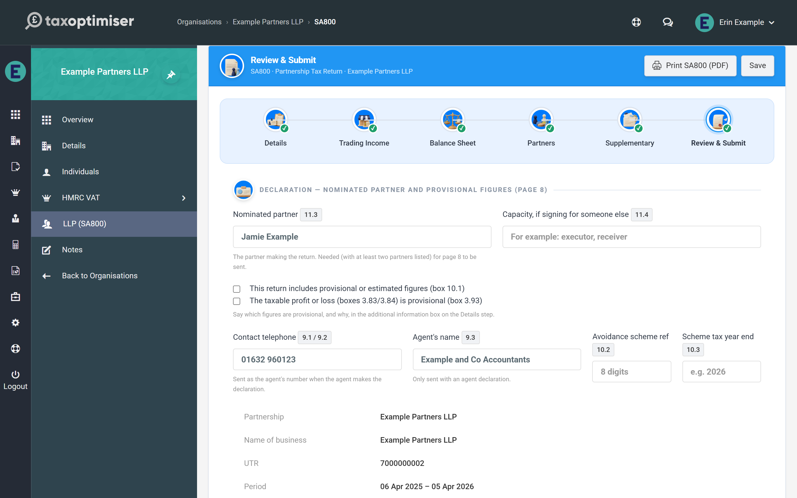

2. Getting started with SA800 returns
Where the LLP (SA800) menu appears, what the returns list shows, what New Partnership Period prefills for you, and what a return costs to file.
IN SHORT
- LLP (SA800) menu appears only for partnership-structured organisations
- Statuses: Ready to start, Preparing, Submitted, Complete
- One 2025-26 return per partnership; the due date is 31 January 2027
- Firms use one credit per return; direct customers pay the standard fee once
- BETA: email support@taxoptimiser.co.uk to enable it for your firm

SA800 returns hang off a partnership period — the partnership’s equivalent of an accounting period, created and managed from the LLP (SA800) menu.

Before you start: the organisation must be a partnership
The LLP (SA800) menu section only appears when the selected organisation’s company structure is Limited Liability Partnership or Partnership. If you can’t see it for a client, check the structure type on the organisation’s details first — and remember the feature is in beta, so it also needs to be enabled for your firm (email support@taxoptimiser.co.uk).

The returns list
Selecting LLP (SA800) opens the partnership’s returns list: one row per period showing the partnership name, period start and end, how many partners are on the statement, and the period’s status.
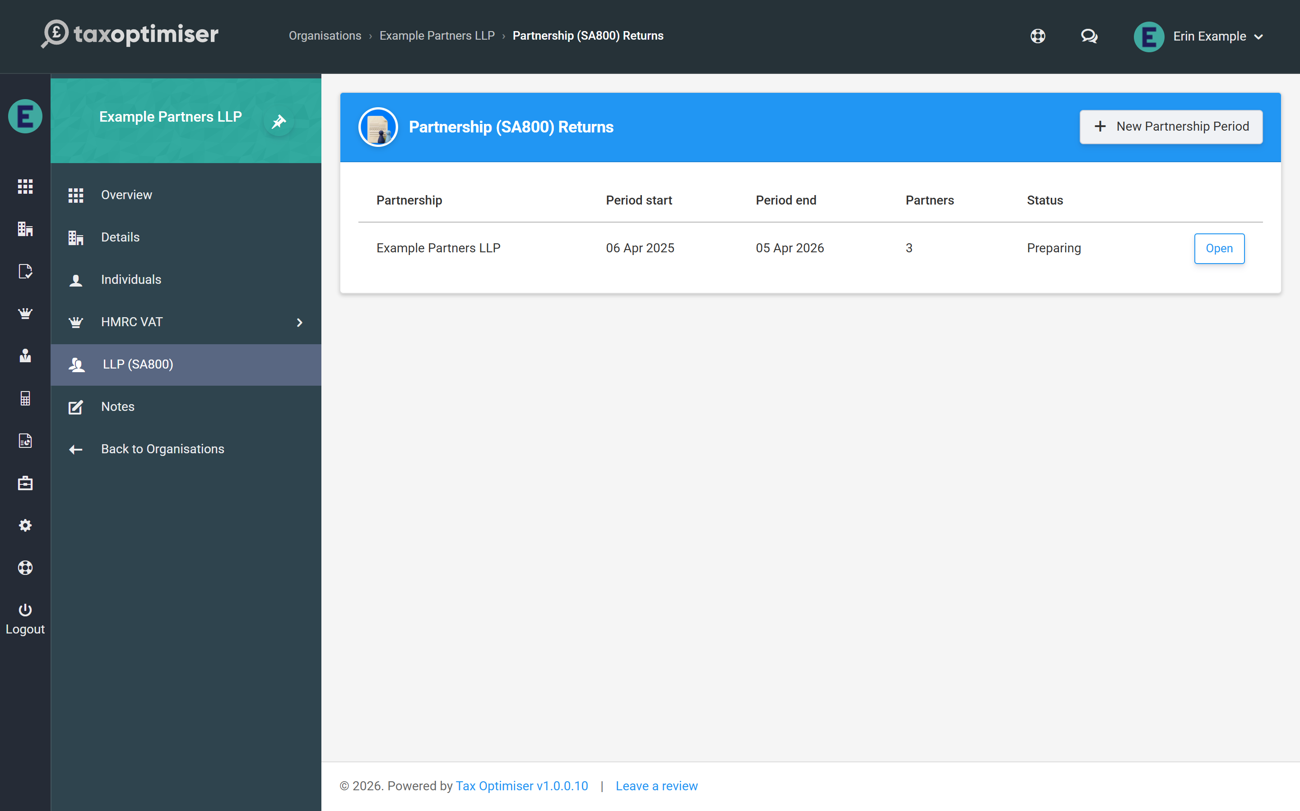
A period moves through the statuses Ready to start → Preparing → Submitted (the return is with HMRC) → Complete (HMRC has accepted it). A return that is Submitted or Complete is locked — see reviewing, printing and submitting for how to reopen one.

Creating a period
Click New Partnership Period. Tax Optimiser creates the 2025-26 return and opens the wizard straight away, prefilled with sensible defaults:
- Period dates of 6 April 2025 to 5 April 2026 — change them if the partnership’s accounts are drawn to a different date ending in that tax year
- The partnership name is taken from the organisation
- The UTR is prefilled from the tax reference held on the organisation’s details, if there is one
- Traditional accounting (box 3.9) starts ticked, because accounts prepared by an accountant are normally on the accruals basis and an LLP cannot use the cash basis — untick it on the Details step for a cash-basis partnership
There is one return per partnership for the year: if the 2025-26 return already exists, New Partnership Period simply opens it rather than creating a second.
The filing due date is set to 31 January 2027, the deadline for a 2025-26 return filed online.

Working in the wizard
The return is a six-step wizard: Details, Trading Income, Balance Sheet, Partners, Supplementary and Review & Submit. Move between steps with Previous and Next, or click a step’s bubble to jump straight to it. A bubble gains a green tick when its step has what the return needs, and a red count when something on it would stop the return being filed.
Nothing is stored until you click Save in the header. The footer shows whether there are unsaved changes, and if you try to leave the page with changes unsaved the browser asks you to confirm first. Print SA800 (PDF) sits in the header too, and is available whenever the return is saved.

What it costs
Preparing a return is free; you pay when you submit, once per return, and that covers any amended return for the same year too.
- Accountant firms use one credit per partnership return — the same credits you already buy for accounts and CT600 filing. If the firm has none left, the Submit step says so and links to Buy credits; nothing is sent until a credit is available.
- Organisations without an accountant firm pay the standard submission fee of £10 plus VAT by card when they first submit, and are then brought straight back to the return to send it.

3. SA800 details, declarations and the page 2 questions
The Details step: partnership name and live-checked UTR, boxes 3.1/3.2, period and start/cessation dates, the accounting basis and declarations, the page 2 questions and box 3.116.
IN SHORT
- UTR is checked as you type; fix failures before submitting (HMRC error 8205)
- Enter boxes 3.7 / 3.8 only if the business started or ceased in the year
- Tick "no trade" for a property or investment partnership
- The page 8 declaration is completed on the Review & Submit step
- BETA: email support@taxoptimiser.co.uk to enable it for your firm

The first step of the wizard captures the partnership’s identity and the whole-return declarations — everything on the front of the SA800 plus the yes/no questions from page 2.

The partnership’s identity
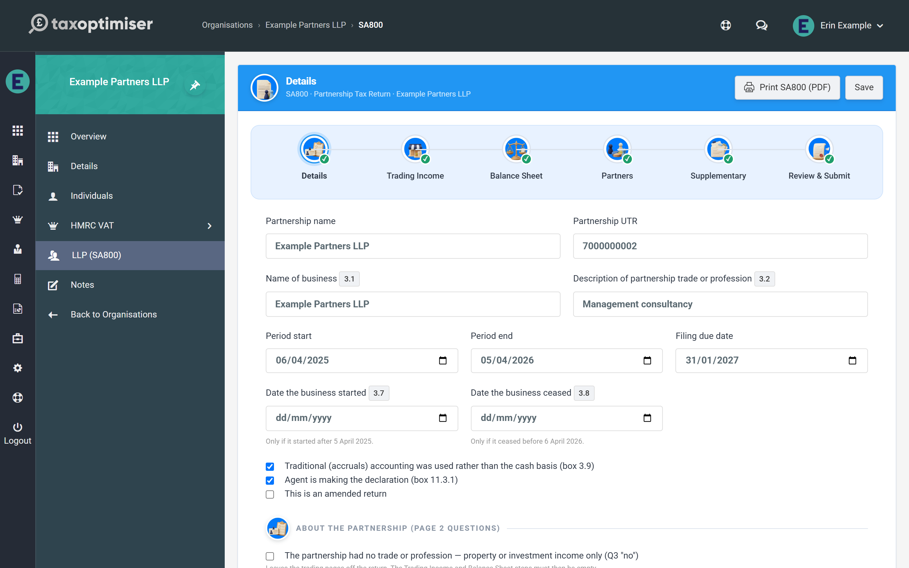
- Partnership name and Partnership UTR — the UTR is checked as you type against HMRC’s own check-digit rule. A UTR that fails the check turns the field red immediately: HMRC rejects a return carrying a bad UTR outright (error 8205), so it is worth fixing here rather than at submission.
- Name of business (box 3.1) and Description of partnership trade or profession (box 3.2) — box 3.1 falls back to the partnership name if left blank.
- Period start / end and the filing due date. The period must end in the 2025-26 tax year.
- Date the business started (box 3.7) and date it ceased (box 3.8) — fill these in only when the business started or ceased during 2025-26. Entering a date answers the form’s “did the partnership start / cease” question “yes”; leaving it blank answers “no”.

Accounting basis and declarations
Three checkboxes sit under the dates:
- Traditional (accruals) accounting was used rather than the cash basis (box 3.9) — ticked on new returns. Untick it only for a partnership that really is on the cash basis; an LLP cannot be.
- Agent is making the declaration (box 11.3.1) — tick this when your firm declares on the partnership’s behalf; leave it clear for a partner declaration.
- This is an amended return — ticked for you when you reopen a return HMRC has already accepted; the submission is flagged as an amendment and replaces the original.

The page 2 questions
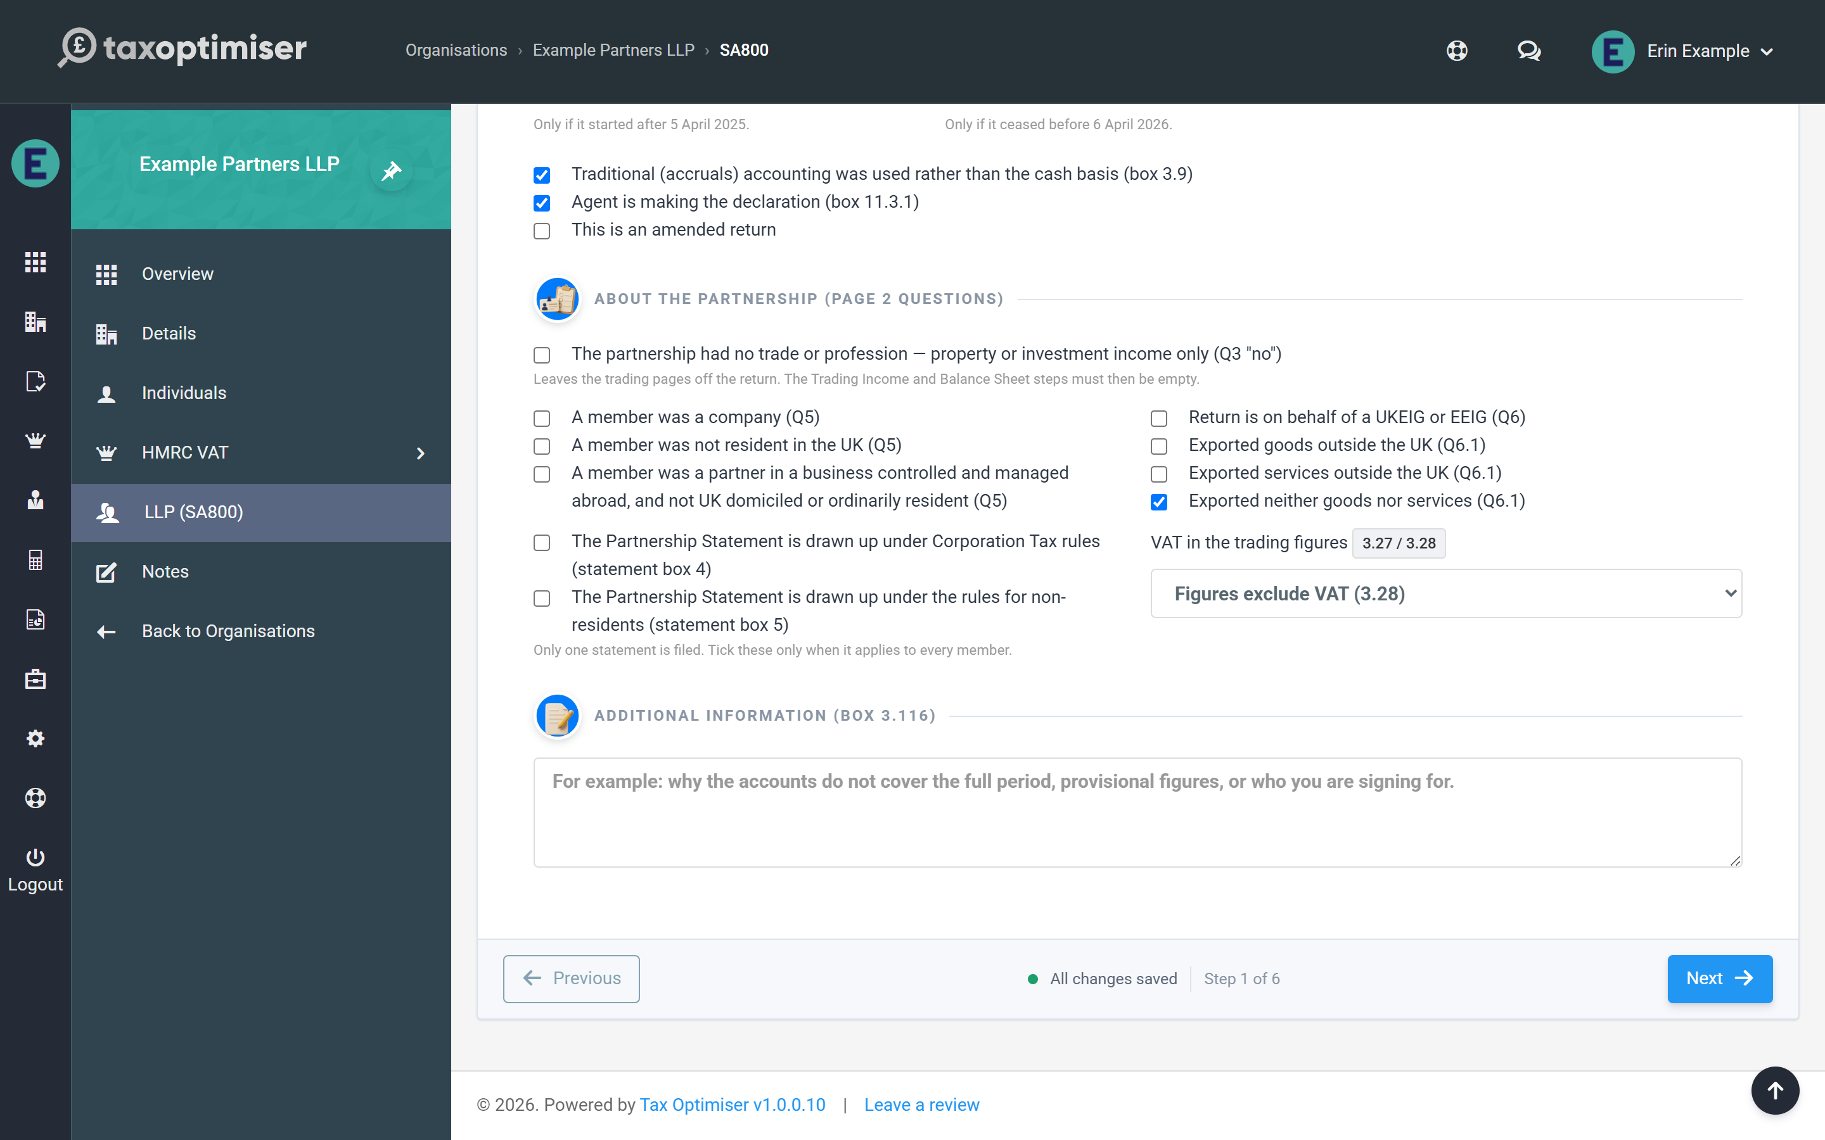
- The partnership had no trade or profession (Q3 “no”) — for a property or investment partnership. The trading pages are left off the return altogether: the Trading Income and Balance Sheet steps become read-only (each shows a Change on Details button to bring you back here), and the supplementary pages and the Partnership Statement carry the whole return.
- Questions 5, 6 and 6.1 — whether any member was a company, was not UK resident, or was a partner in a business controlled and managed abroad; whether the return is on behalf of a UKEIG or EEIG; and whether the partnership exported goods, services or neither. (Questions 1, 2 and 4 are answered for you from the supplementary pages you complete.)
- The Partnership Statement is drawn up under Corporation Tax rules / the rules for non-residents (statement boxes 4 and 5) — tick only when it applies to every member, because one statement is filed.
- VAT in the trading figures (boxes 3.27 / 3.28) — say whether the figures include or exclude VAT, for a VAT-registered partnership.
Additional information (box 3.116) is the free-text box HMRC reads for anything that needs explaining — for example why the accounts don’t cover the full period, which figures are provisional and why, or who you are signing for.
The declaration itself — the nominated partner, the provisional-figure ticks, contact telephone, agent’s name and any tax avoidance scheme reference (page 8) — is completed on the Review & Submit step, beside the Submit button.

4. SA800 trading income and expenses
The full SA800 income and expenses page: entering income and expense totals, the capital allowance pools, an optional breakdown of disallowables, and how the calculated boxes 3.65 and 3.73 drive the rest of the return.
IN SHORT
- One full income & expenses page for every partnership, any size
- Enter expenses gross; add back disallowables in box 3.66 (at least the depreciation)
- Capital allowance pools 3.13A to 3.21; totals 3.22 / 3.23 are calculated
- 3.73 feeds boxes 3.83/3.84 and the partner allocation
- BETA: email support@taxoptimiser.co.uk to enable it for your firm

The Trading Income step is the heart of the return: the SA800’s full income & expenses page (boxes 3.29–3.73). Tax Optimiser implements the full page for every partnership — it is also valid below the £90,000 three-line-accounts threshold, so there is one screen to learn regardless of the client’s size.

Entering the figures
Every money box works the same way: type the amount (the £ sign, commas and spaces are all tolerated), and boxes that can go negative accept brackets — (1,500) means minus 1,500, matching how the form itself shows losses. Boxes with a grey tint are calculated and read-only; each one explains its own arithmetic underneath.
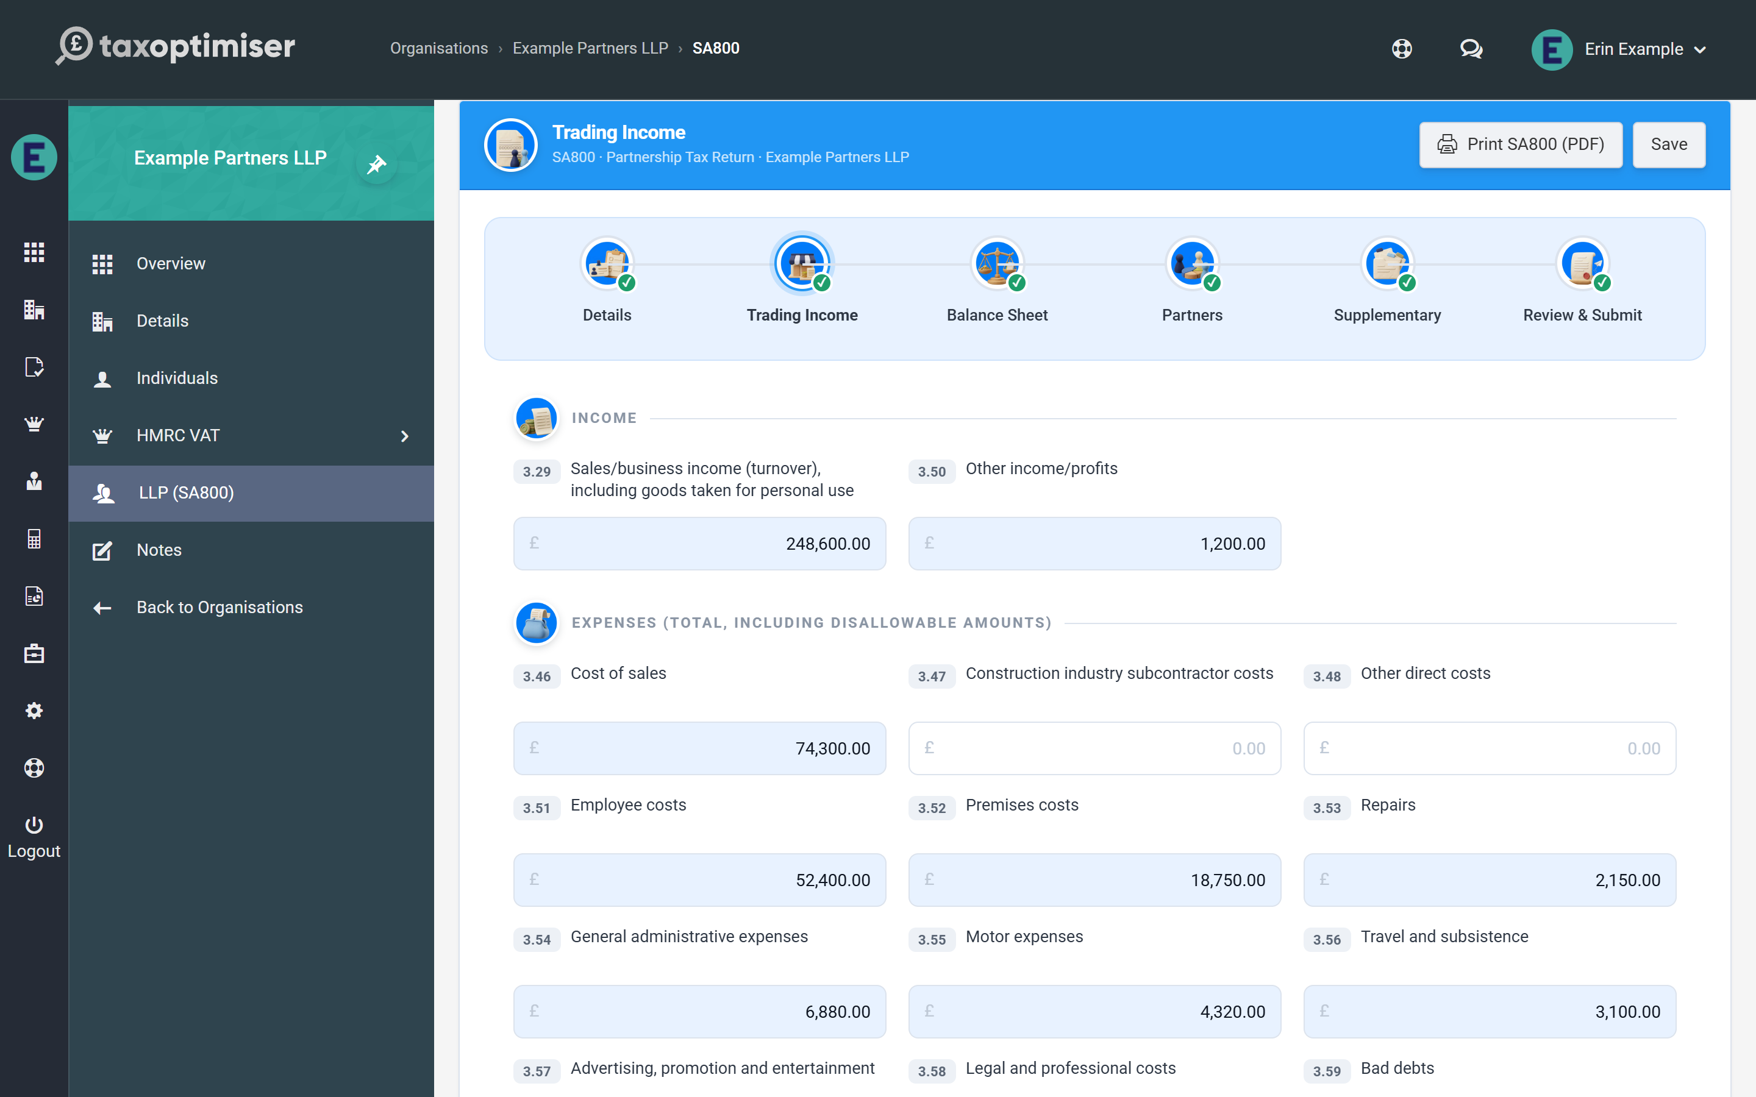

Income and expenses
- Income: sales/business income (box 3.29, including goods taken for personal use) and other income/profits (3.50).
- Expenses (boxes 3.46–3.63): entered at their full amounts including any disallowable part — cost of sales, subcontractor costs, employee costs, premises, repairs, admin, motor, travel, advertising, legal, bad debts, interest and finance charges, depreciation, and other expenses. The disallowable total is added back separately in box 3.66.
If “no trade or profession” is ticked on the Details step, this step and the Balance Sheet step show a notice and must be left empty — nothing on them is sent to HMRC.

Capital allowances and balancing charges
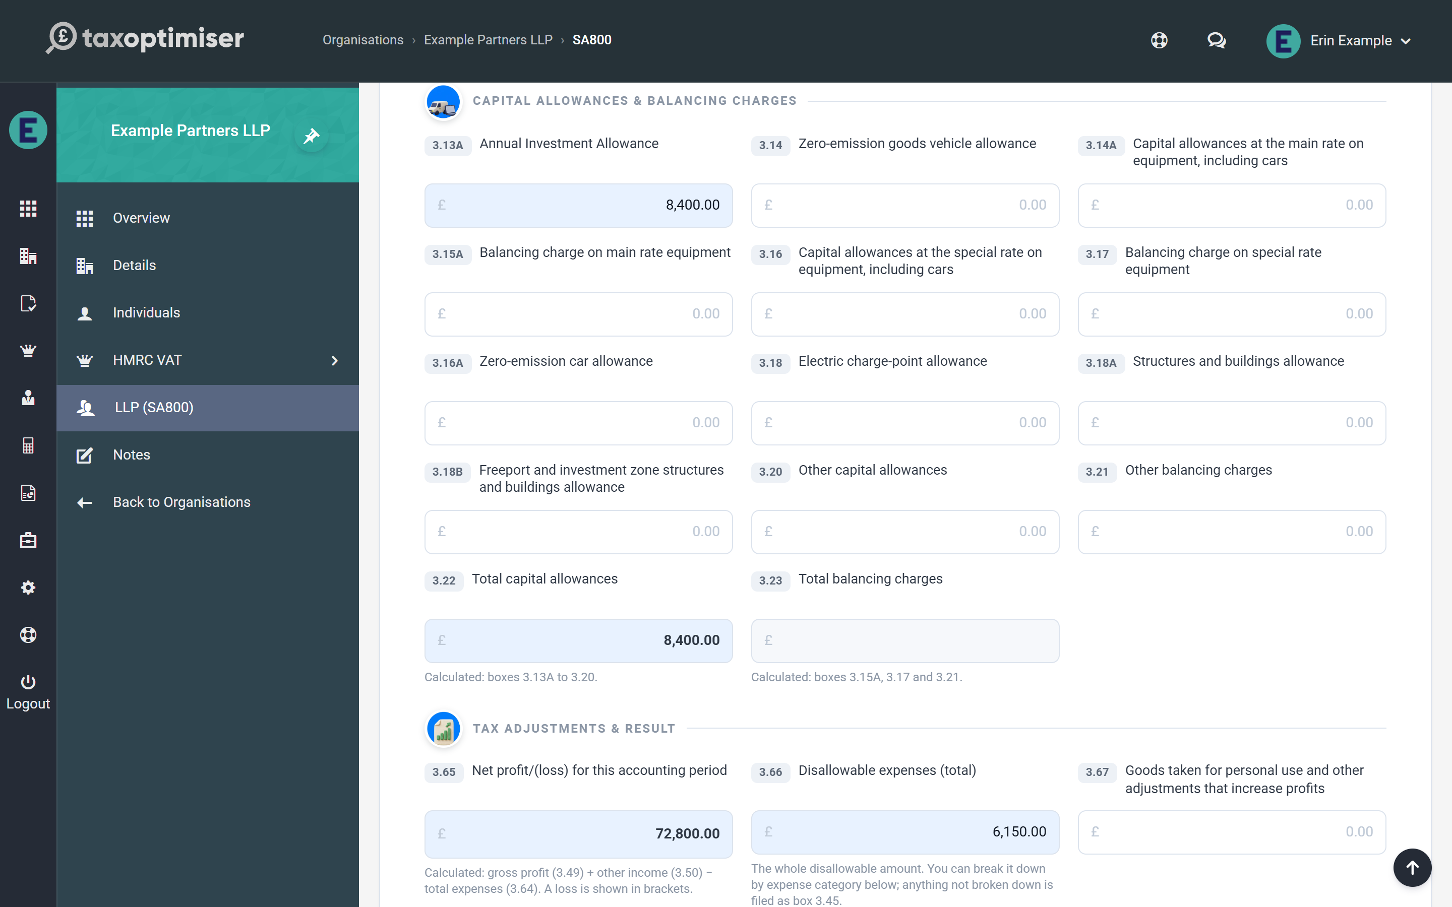
Each kind of allowance has its own box, as on the form: the Annual Investment Allowance (3.13A), the zero-emission goods vehicle allowance (3.14), main rate (3.14A) and special rate (3.16) allowances on equipment and cars, the zero-emission car allowance (3.16A), electric charge-points (3.18), structures and buildings (3.18A, and 3.18B for freeports and investment zones), and other capital allowances (3.20). Balancing charges go beside the pool they belong to (3.15A, 3.17) or in other balancing charges (3.21). Total capital allowances (3.22) and total balancing charges (3.23) are calculated.

Tax adjustments and the calculated result
- Net profit/(loss) (3.65) — calculated: gross profit (3.49) + other income (3.50) − total expenses (3.64).
- Disallowable expenses (3.66) and goods taken for personal use (3.67) add back to profit. Depreciation (box 3.62) is never allowable, so box 3.66 must be at least the depreciation figure — the Review step tells you if it isn’t.
- Deductions from net profit other than capital allowances (3.71).
- Net business profit for tax purposes (3.73) — calculated: 3.65 + 3.66 + 3.67 + balancing charges (3.23) − capital allowances (3.22) − other deductions (3.71). This figure drives the whole return: a positive result becomes the taxable profit (3.83) and a negative one the allowable loss (3.84), and those are exactly what the Partnership Statement must allocate to the partners.
- Adjustment on change of accounting basis (3.82) — carried to box 11A of the Partnership Statement.
- CIS deductions (3.97) for tax deducted by contractors under the Construction Industry Scheme. It flows to box 24 of the Partnership Statement. (Box 3.98 is no longer part of the 2025-26 return.)
- Net partnership charges paid (3.117) — charges not already deducted as an expense; carried to box 29 of the Partnership Statement.

Breaking down the disallowable expenses (optional)
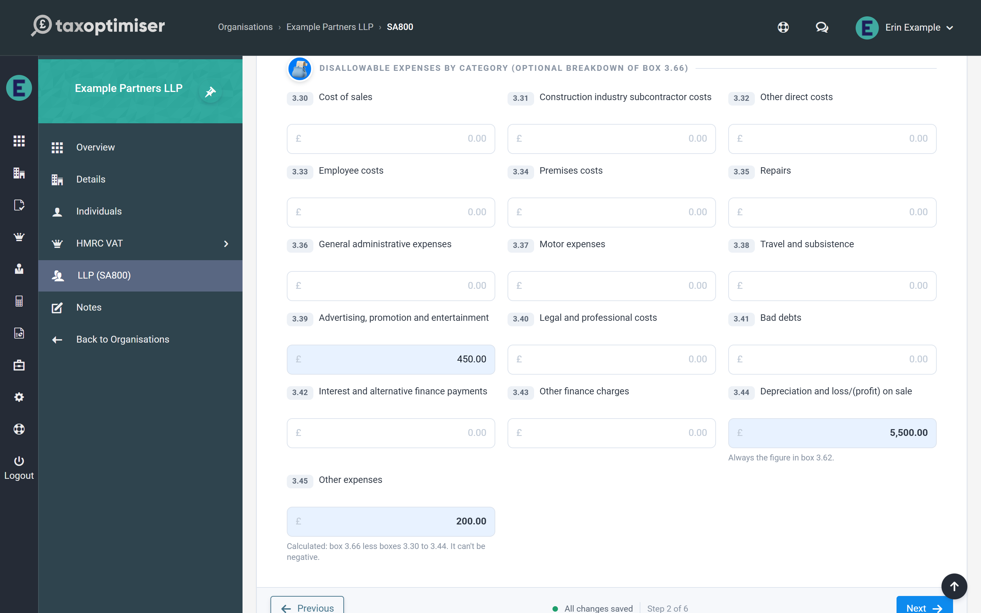
Box 3.66 is the one figure you must enter. If you want the return to show which expenses were disallowed, enter the amounts against their categories in boxes 3.30 to 3.43. Depreciation is always filed as box 3.44, and whatever is left of box 3.66 is filed as other expenses (3.45), shown calculated at the bottom of the group. The itemised amounts cannot add up to more than box 3.66.

5. The SA800 balance sheet
Boxes 3.99 to 3.115: assets, liabilities and the partners' accounts, with all three totals calculated and a built-in way to check the sheet balances.
IN SHORT
- Totals 3.105/3.109/3.110/3.115 are calculated for you
- 3.112 mirrors box 3.65 automatically
- Brackets mean negative, matching the paper form
- Check 3.115 = 3.110 to prove the sheet balances
- BETA: email support@taxoptimiser.co.uk to enable it for your firm

The Balance Sheet step covers the SA800’s summary balance sheet (boxes 3.99–3.115) — a condensed snapshot of the partnership’s position at the period end, with all three totals calculated for you.

Assets and liabilities
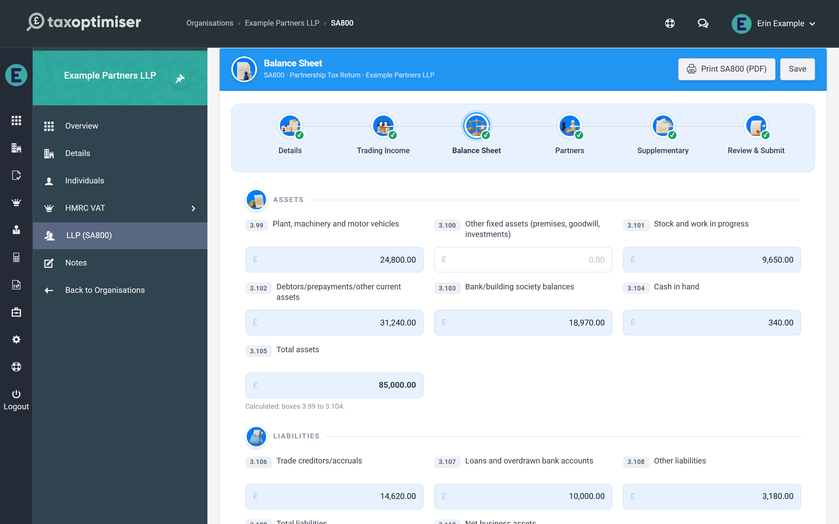
- Assets (3.99–3.104): plant, machinery and vehicles; other fixed assets; stock and work in progress; debtors and prepayments; bank balances; cash. Total assets (3.105) is calculated.
- Liabilities (3.106–3.108): trade creditors and accruals; loans and overdrawn bank accounts; other liabilities. Total liabilities (3.109) is calculated.
- Net business assets (3.110) — calculated as 3.105 minus 3.109; net liabilities show in brackets.

Partners’ current and capital accounts
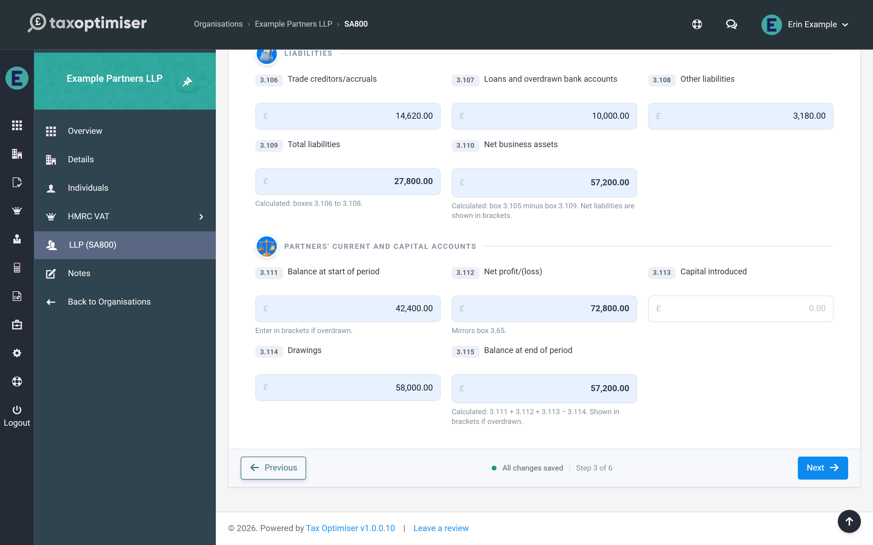
The final group reconciles the partners’ combined accounts across the period:
- Balance at start of period (3.111) — enter in brackets if overdrawn
- Net profit/(loss) (3.112) — mirrors box 3.65 from the Trading Income step automatically
- Capital introduced (3.113) and drawings (3.114)
- Balance at end of period (3.115) — calculated: 3.111 + 3.112 + 3.113 − 3.114
A useful cross-check before moving on: on a balance sheet that balances, the closing balance in 3.115 equals net business assets in 3.110. If the two disagree, an asset, liability or drawings figure is missing or mistyped.

6. The Partnership Statement: partners and profit shares
Adding partners, boxes 6-12, entering each partner's share, and the live checks: the allocation-vs-return warning and the UTR check that prevents error 8205.
IN SHORT
- One row per partner: boxes 6, 8, 10, 11, 12 plus address and dates 7/9
- Enter trading shares directly; the percentage column splits everything else and must total 100%
- Shares must total 3.83 (profit) and 3.84 (loss) - submission blocked if not
- A single bad partner UTR = whole return rejected (8205)
- BETA: email support@taxoptimiser.co.uk to enable it for your firm

The Partners step is the SA800’s Partnership Statement — the schedule that tells HMRC who the partners were and how the period’s result was divided between them. Each partner takes their share from here onto their own personal return.

Adding partners
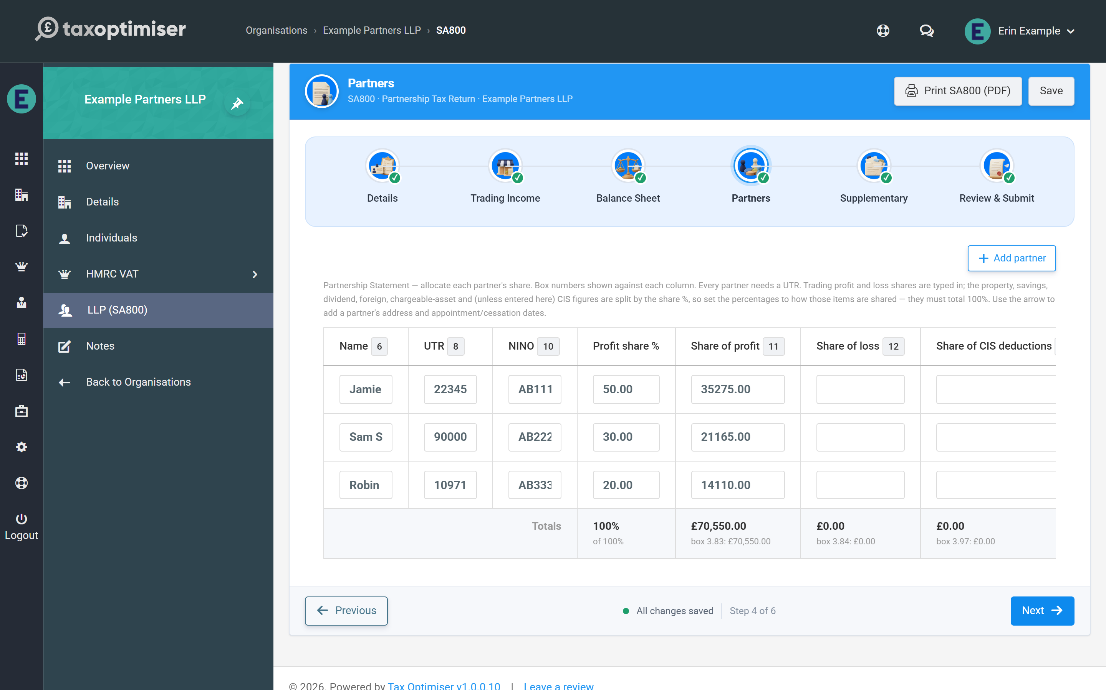
Click Add partner for each partner. The table columns carry the statement’s box numbers: name (box 6), the partner’s own UTR (box 8), National Insurance number (box 10), and the shares of profit (box 11) and loss (box 12). The arrow at the end of each row opens the partner’s detail panel for their address and, where relevant, date appointed (box 7) or date ceased (box 9) — only enter those dates if they fall during 2024-25 or 2025-26.
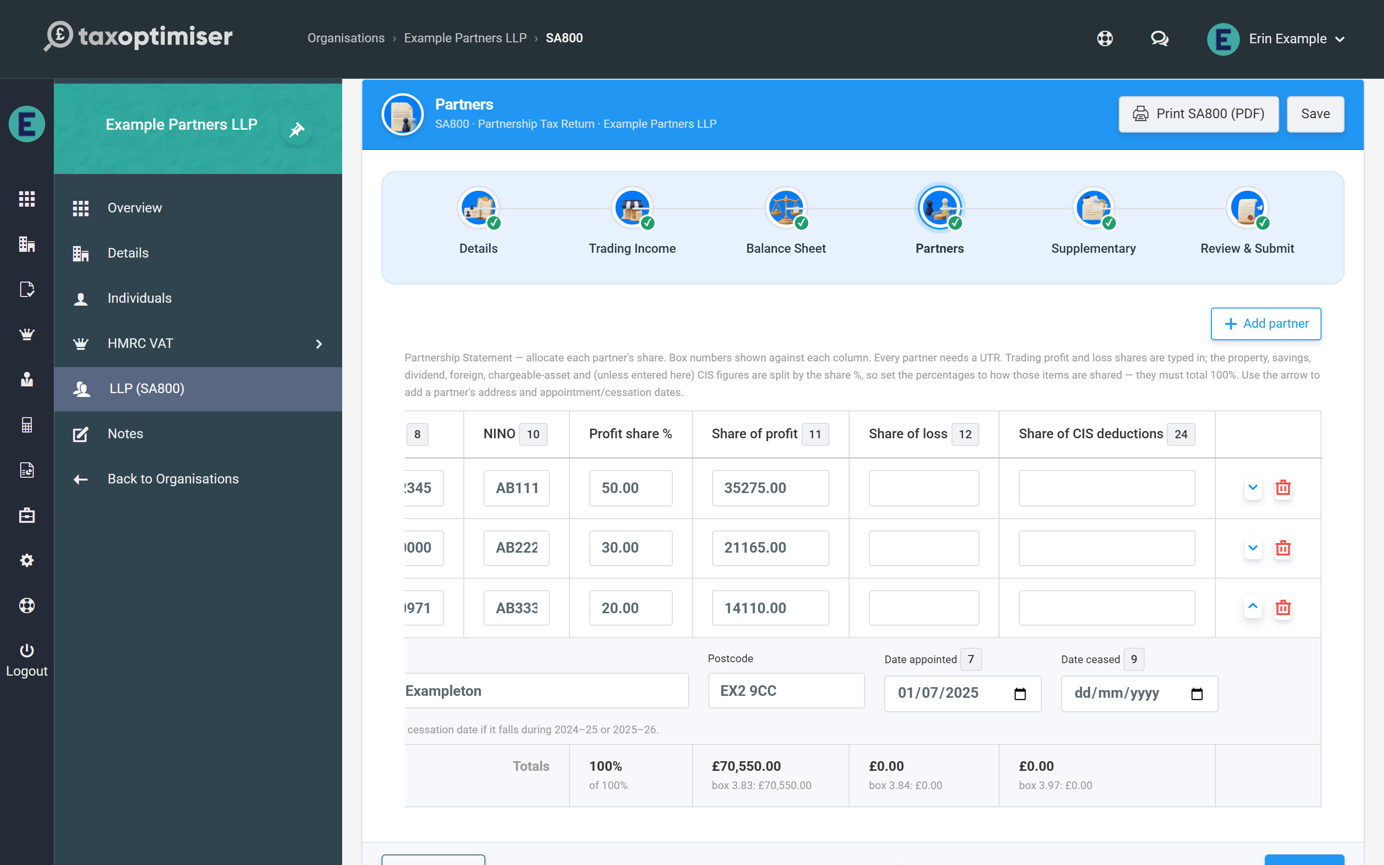

Allocating profit shares
Enter each partner’s share of the trading result directly in the profit and loss columns, so agreements with fixed shares, salaries or interest on capital can be entered exactly as computed. The rule the statement must obey is simple: the partners’ shares must add up to the return — box 11 shares to the taxable profit (3.83), box 12 shares to the allowable loss (3.84).
The profit share % column does a different job: it is how everything else on the statement is divided — property income, interest, dividends, foreign income and tax, disposal proceeds, residential finance costs, partnership charges, and CIS deductions unless you type each partner’s CIS share in the last column. Set the percentages to how those items are actually shared; they must total 100% whenever the return has any of them. Each share is rounded to the penny and the last partner takes any odd penny, so the partners always add back to the total.
A totals row under the table adds up the percentages and the profit, loss and CIS shares as you type, and shows each against the figure it must match — 100%, box 3.83, box 3.84 and box 3.97 — turning red where they differ. A warning above the table quotes the gap as well. Neither blocks saving — you can leave the allocation half-done and come back — but the return cannot be submitted until the shares match boxes 3.83/3.84 exactly.
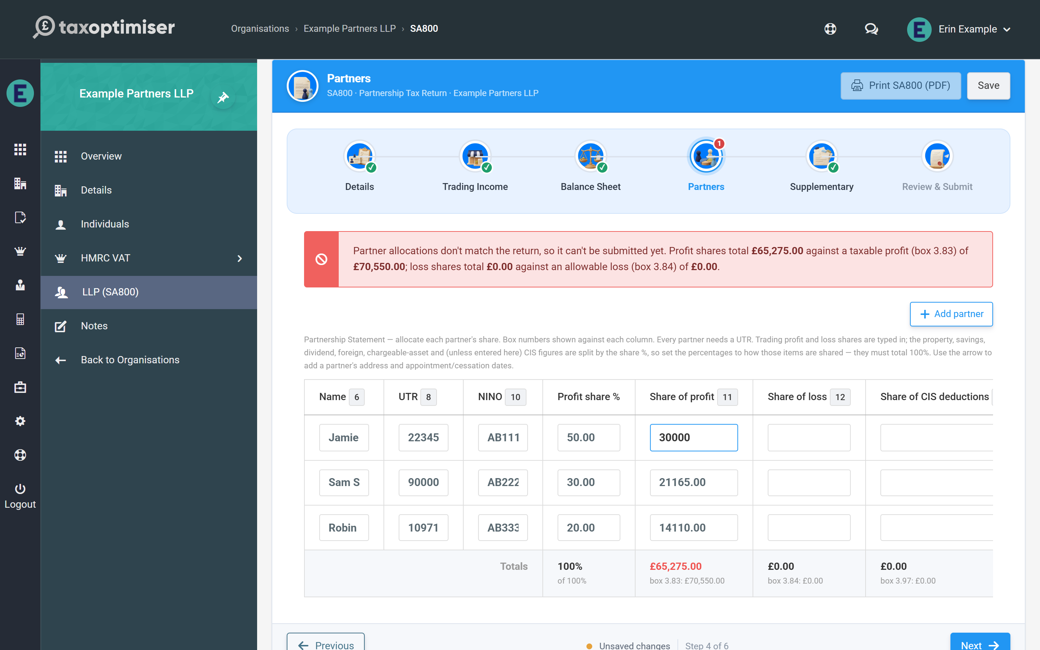

The checks that stop an HMRC rejection
Two per-partner checks run as you type:
- Partner UTR — required for every partner, and validated against the same HMRC check-digit rule as the partnership’s own UTR. A blank UTR is flagged and blocks submission; one bad partner UTR causes HMRC to reject the whole return (error 8205), so the field turns red immediately.
- NINO — optional, but if you enter one it must be in the standard format (two letters, six digits and an optional final letter); spaces and lower case are tidied up for you. A malformed NINO blocks submission. No NINO is sent for a partner that is a company.
A partner who left before they joined (a date ceased earlier than the date appointed) is refused too, as HMRC would reject it.

7. SA800 supplementary pages (SA801-SA804)
Land & Property, Foreign, Chargeable Assets and Savings on one screen - each page files only when it carries figures, and the totals calculate themselves.
IN SHORT
- All four supplementary pages on one step
- Pages with no figures are simply not filed - nothing to toggle
- Residential finance costs go in box 1.40, not in expenses
- SA803 is proceeds-only: list each asset, partners compute their own gains
- BETA: email support@taxoptimiser.co.uk to enable it for your firm

Partnerships with income beyond the trade report it on the SA800’s supplementary pages. The Supplementary step gathers all four on one screen; a page is only included in the submission when it actually carries figures, and the Review step lists which pages will go (“Supplementary pages with data”).
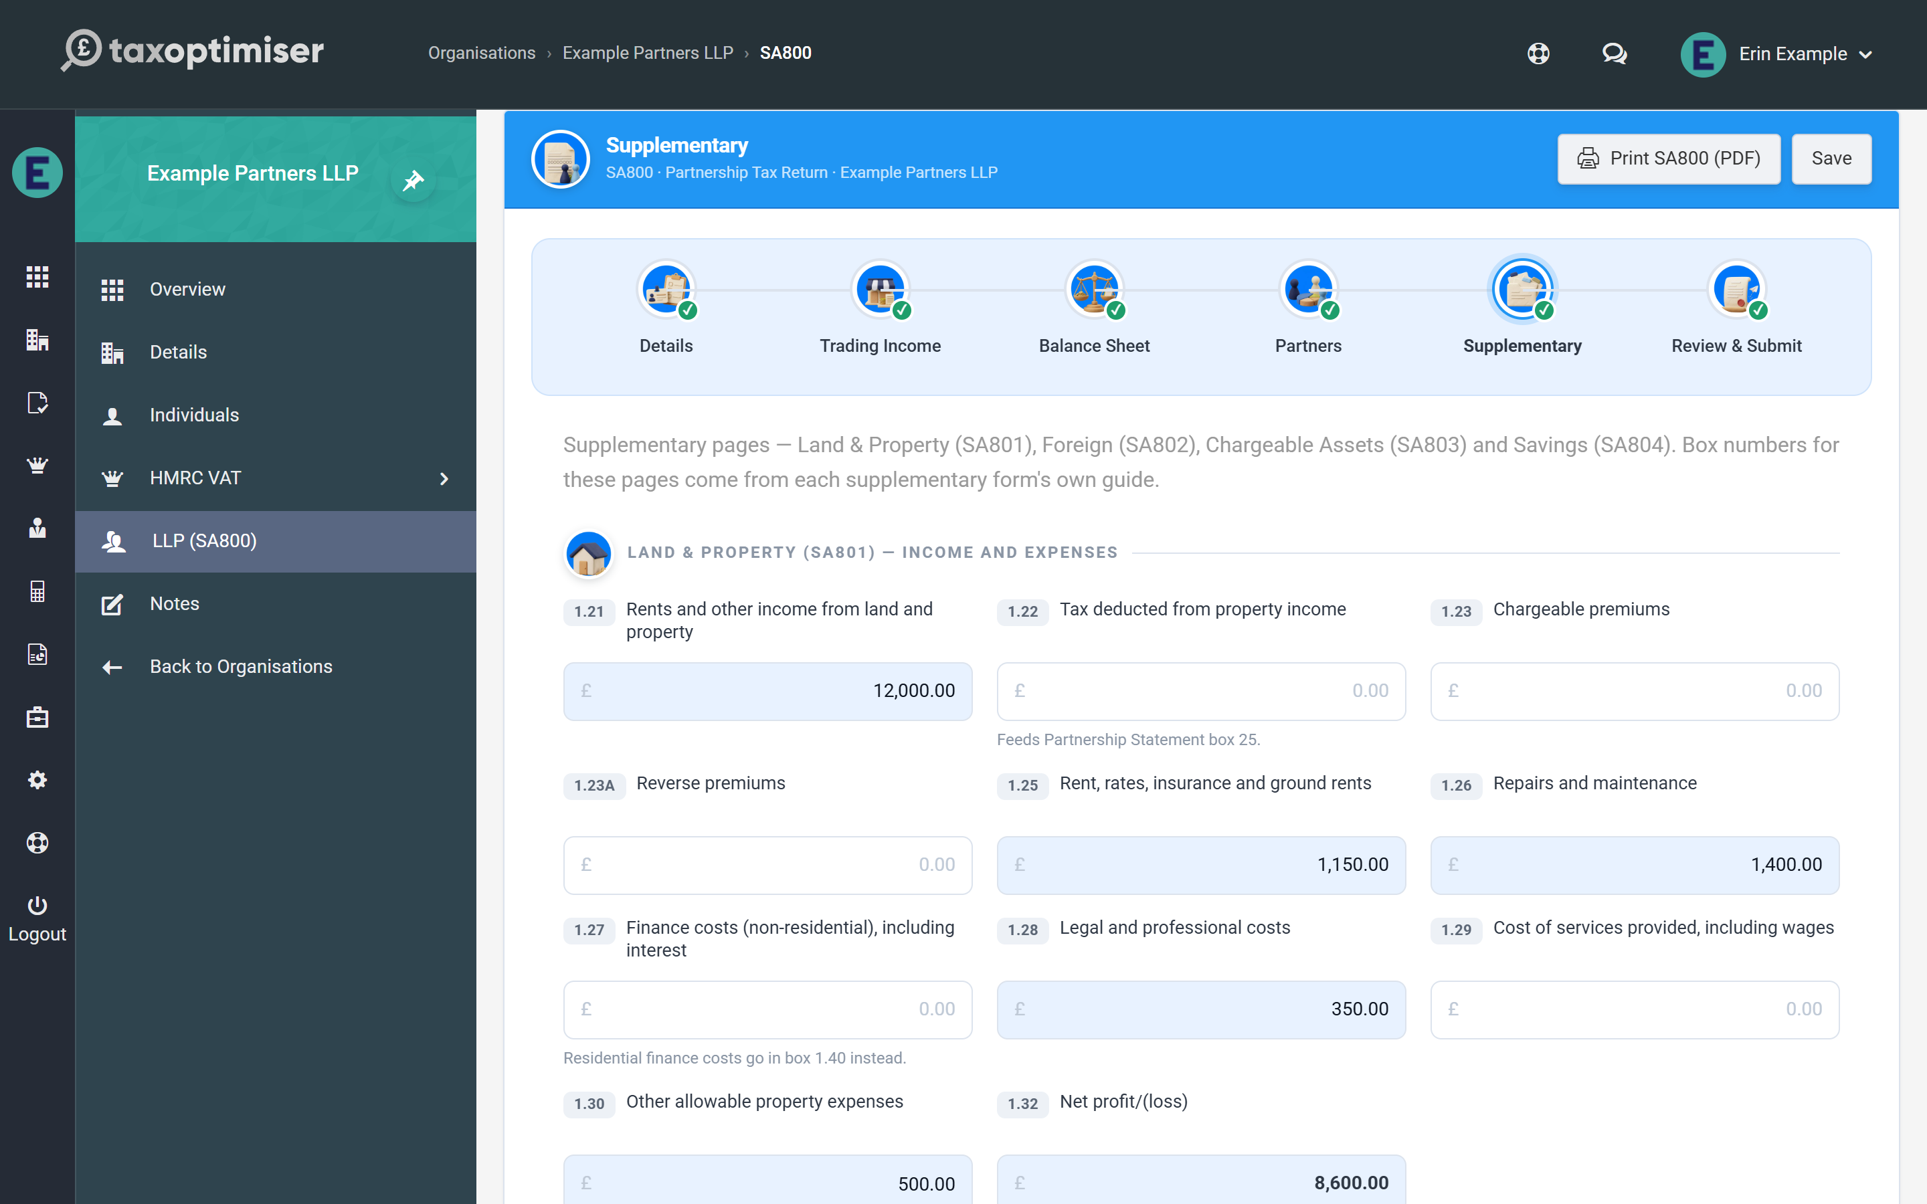
Every figure on these pages is carried to the Partnership Statement and shared between the partners by their profit share % on the Partners step — each box’s hint says which statement box it feeds.

Land & Property (SA801)
- Income: rents and other income (1.21), any tax deducted from it (1.22), chargeable premiums (1.23) and reverse premiums (1.23A).
- Expenses (1.25–1.30): rent, rates and insurance; repairs and maintenance; non-residential finance costs; legal and professional costs; cost of services provided; and other allowable expenses. Net profit/(loss) (1.32) is calculated.
- Tax adjustments: private use (1.33) and balancing charges (1.34) add back; the Annual Investment Allowance (1.35A), the other allowances (1.35B–1.36) and the cost of replacing domestic items (1.37) deduct. Profit/(loss) for the return period (1.39) is calculated from them and feeds statement box 19.
- Residential finance costs (1.40) — mortgage interest and similar costs on residential lets are not an expense. Enter them here and each partner receives their share in statement box 26 to claim the basic-rate tax reduction on their own return.
Under the grid, tick traditional (accruals) accounting (box 1.22A) if the property income is not on the cash basis — the Annual Investment Allowance on property can only be claimed with it.

Foreign (SA802)
Foreign savings income (box 2.6) and foreign dividends (box 2.6A), each before foreign tax, with the foreign tax paid on each and, under the grid, the country each came from. Foreign tax cannot be entered without the income it was paid on. Foreign property income and offshore funds are not supported yet.

Chargeable Assets (SA803)
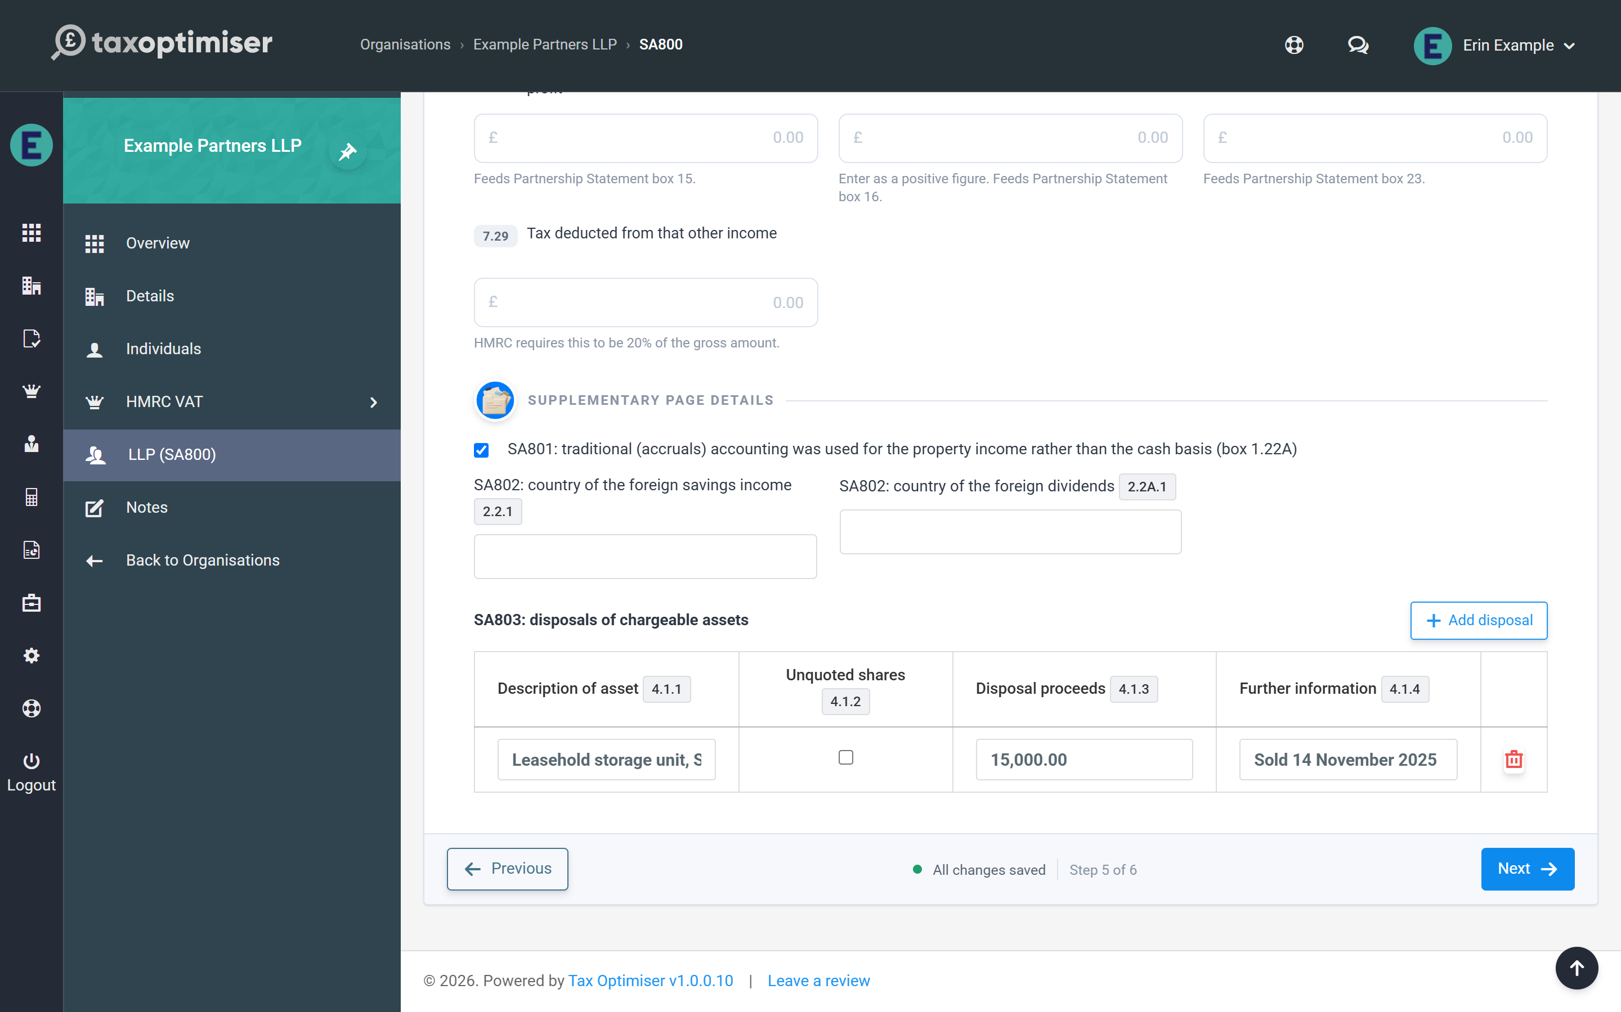
The partnership reports only the disposal proceeds from chargeable assets sold in the period. That is deliberate — a partnership isn’t itself chargeable to capital gains tax, so each partner computes their own gain or loss on their share via their personal return.
You can type a single total in box 4.1, or click Add disposal to list each asset with a description, a tick for unquoted shares, its proceeds and any further information (up to 50 rows, 80 characters each). Once disposals are listed, box 4.1 becomes their calculated total.

Savings (SA804)
- UK bank and building society interest (gross) — filed as untaxed interest unless you also enter tax deducted, in which case it is filed as taxed interest. HMRC requires the tax to be 20% of the gross, to within £1.
- National Savings & Investments interest (7.4).
- Dividends from UK companies and unit trusts, stock dividends and bonus issues (7.19–7.22).
- Other income: without tax deducted, as a profit (7.26) or a loss (7.27) but not both; or with tax deducted (7.30 gross and 7.29 tax, again 20%).
Like the main pages, anything the form derives is calculated read-only, and leaving a page untouched simply leaves it out of the filing — there is nothing to switch on or off.

8. Reviewing, printing and submitting the SA800
The checks that block a return HMRC would reject (each linked to its step), the page 8 declaration, the review summary, printing the official SA800 form and its schedule, what Submit really does, and what happens afterwards.
IN SHORT
- Submit is disabled until every listed problem is fixed; each has a Go to link
- The page 8 declaration lives on this step
- The printed PDF uses saved figures; the button waits for a save
- Submit = save, pay once, build, IRmark sign, send, poll for the outcome
- Amend an accepted return with Reopen as amended return
- BETA: email support@taxoptimiser.co.uk to enable it for your firm

The final step pulls the whole return together: the checks, the declaration, a summary to review, the official form to print, and the submission itself.

The final checks
The summary shows the partnership, business name, UTR, period, the headline figures (net profit 3.65, taxable profit 3.83, allowable loss 3.84), the partner count against the totals actually allocated, which supplementary pages carry data, and the declaration type.
Above it, Tax Optimiser lists everything that would make HMRC reject the return, checked against HMRC’s own rules as you type. While anything is listed, Submit to HMRC stays disabled. The usual ones are:
- A UTR missing or failing the check digit — the partnership’s, or any partner’s (every partner needs one)
- An allocation mismatch — the partners’ shares don’t add up to boxes 3.83/3.84, or the profit share percentages don’t total 100% when the return has property, savings or other shared items
- Depreciation not added back — box 3.66 is less than the depreciation in box 3.62
- Tax deducted that isn’t 20% of the gross interest, or a negative figure in a box that can’t be negative
- A period that doesn’t end in 2025-26, or a name or description longer than HMRC allows
Each problem carries a Go to… link to the step that owns it, and that step’s bubble shows a red count of its outstanding problems, so there is no hunting for the box to fix.
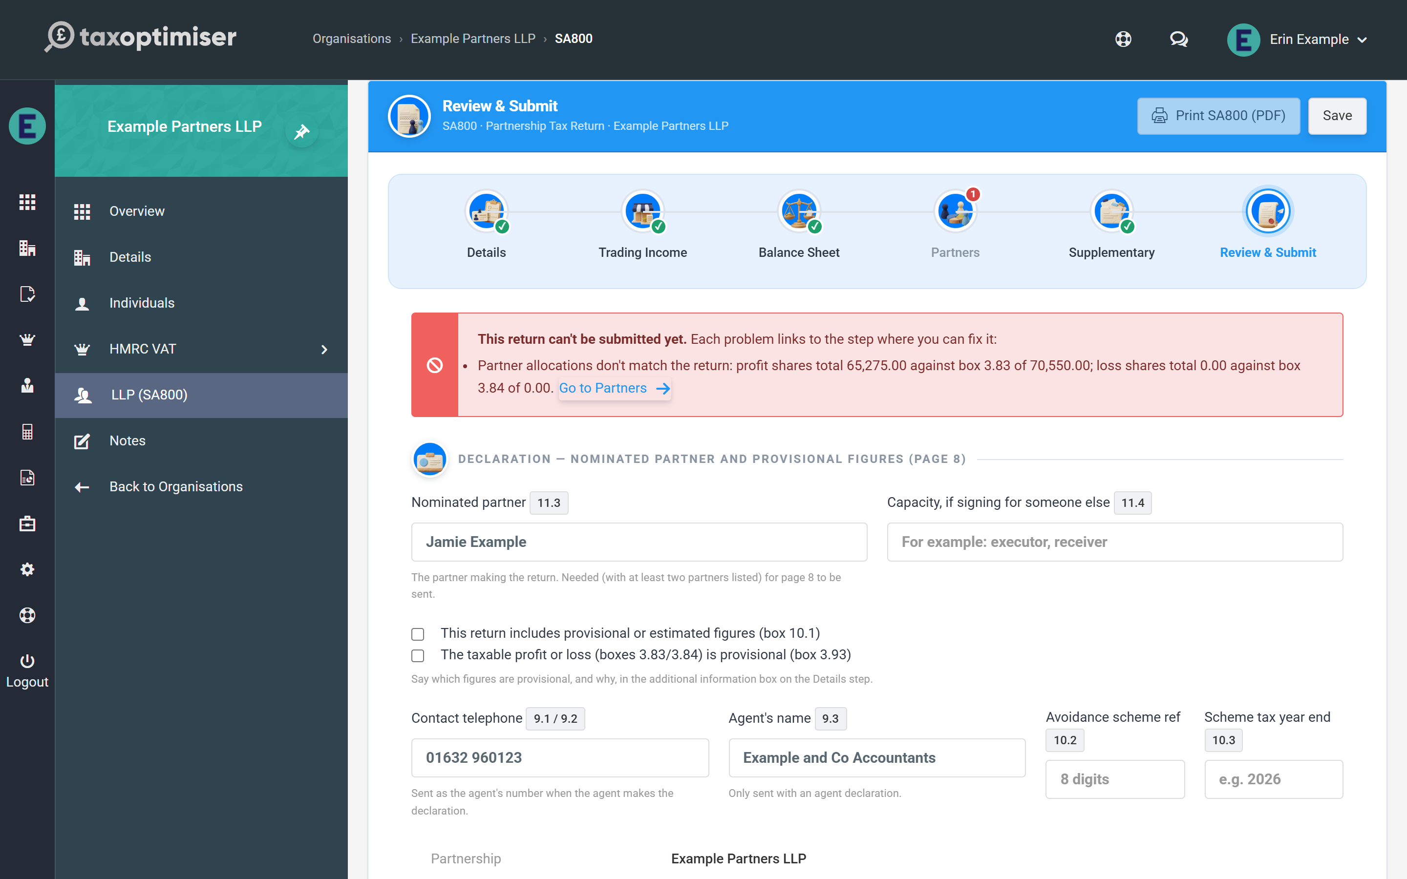

The declaration (page 8)
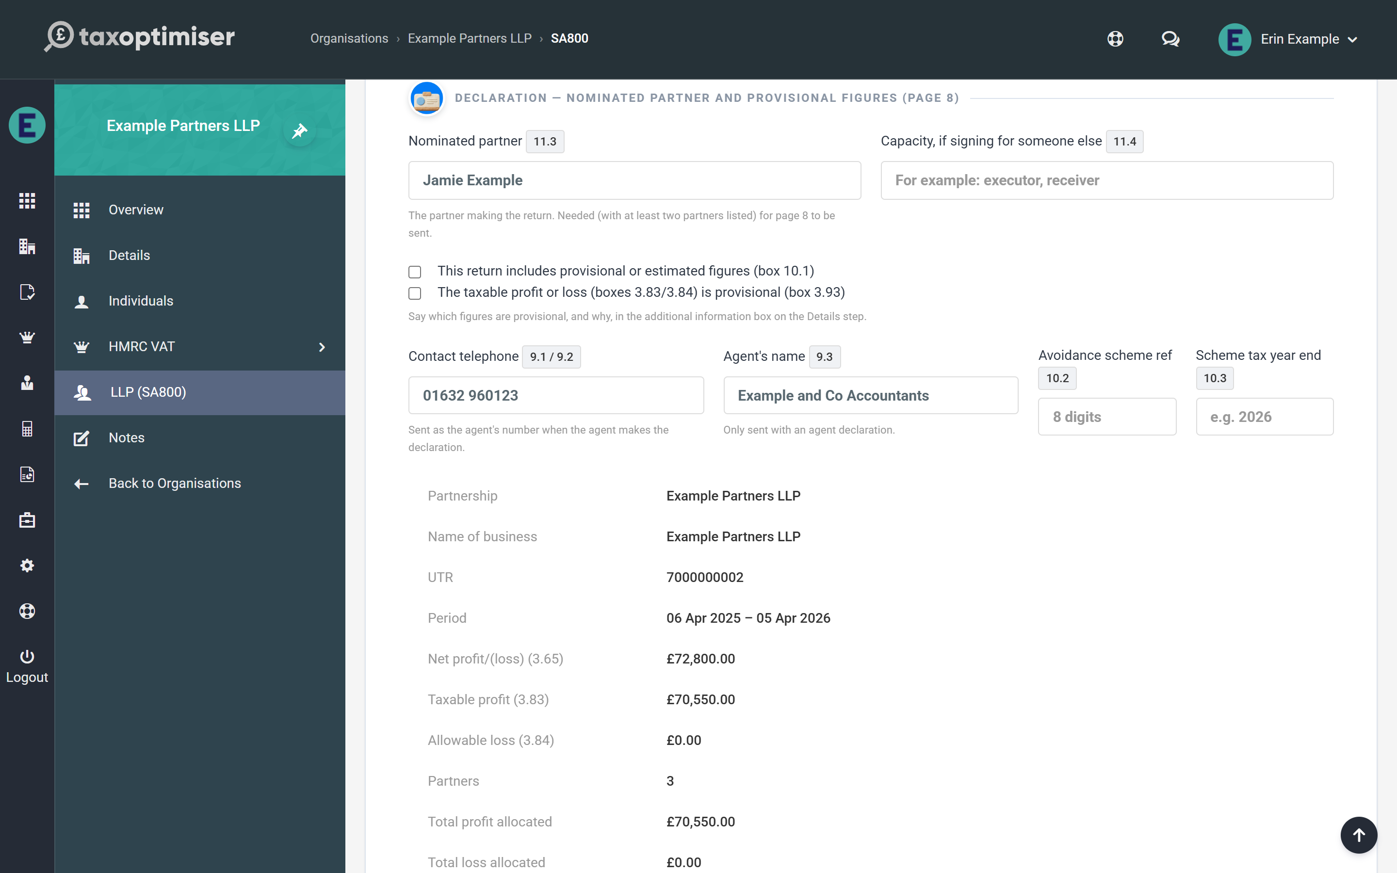
- Nominated partner (box 11.3) and, if someone is signing for them, the capacity (box 11.4). HMRC only accepts page 8 with a nominated partner and at least two partners listed, so enter the name whenever you use anything else in this group.
- This return includes provisional or estimated figures (box 10.1), and separately the taxable profit or loss is provisional (box 3.93). Say which figures are provisional, and why, in the additional information box on the Details step.
- Contact telephone (boxes 9.1 / 9.2) — digits and spaces only. It is sent as the agent’s number, with the agent’s name (box 9.3), when the agent makes the declaration (ticked on the Details step).
- Tax avoidance scheme — the 8-digit scheme reference (box 10.2) and the year the tax year ends (box 10.3), for a disclosed scheme.

Printing the official form
Print SA800 (PDF) renders the partnership’s figures onto the official HMRC SA800 form — ideal for a review file or for the client’s records. The button appears in the wizard header throughout. The PDF is built from saved figures, so while you have unsaved changes it is greyed out until you click Save.
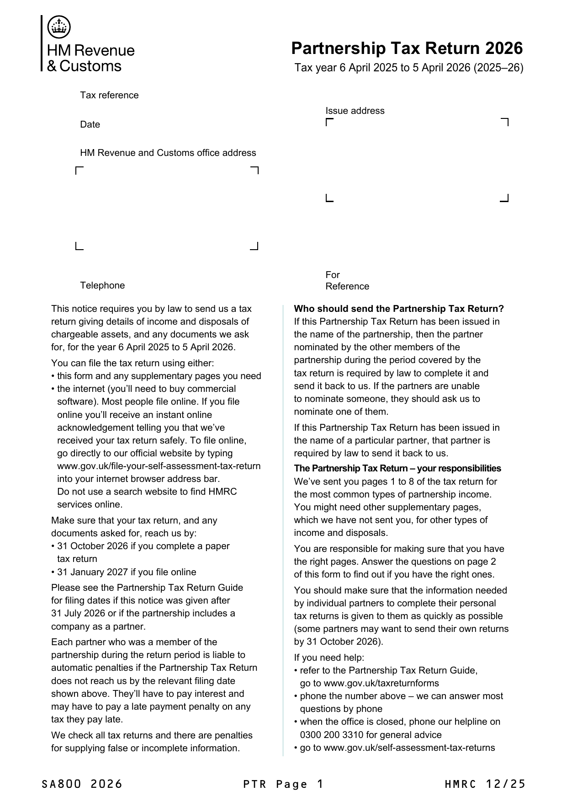
The printed form carries the short Partnership Statement and three partners. Anything it has no box for — a fourth partner onwards, the full statement’s lines, and the figures from the supplementary pages — is listed, exactly as filed, on a schedule after page 8.
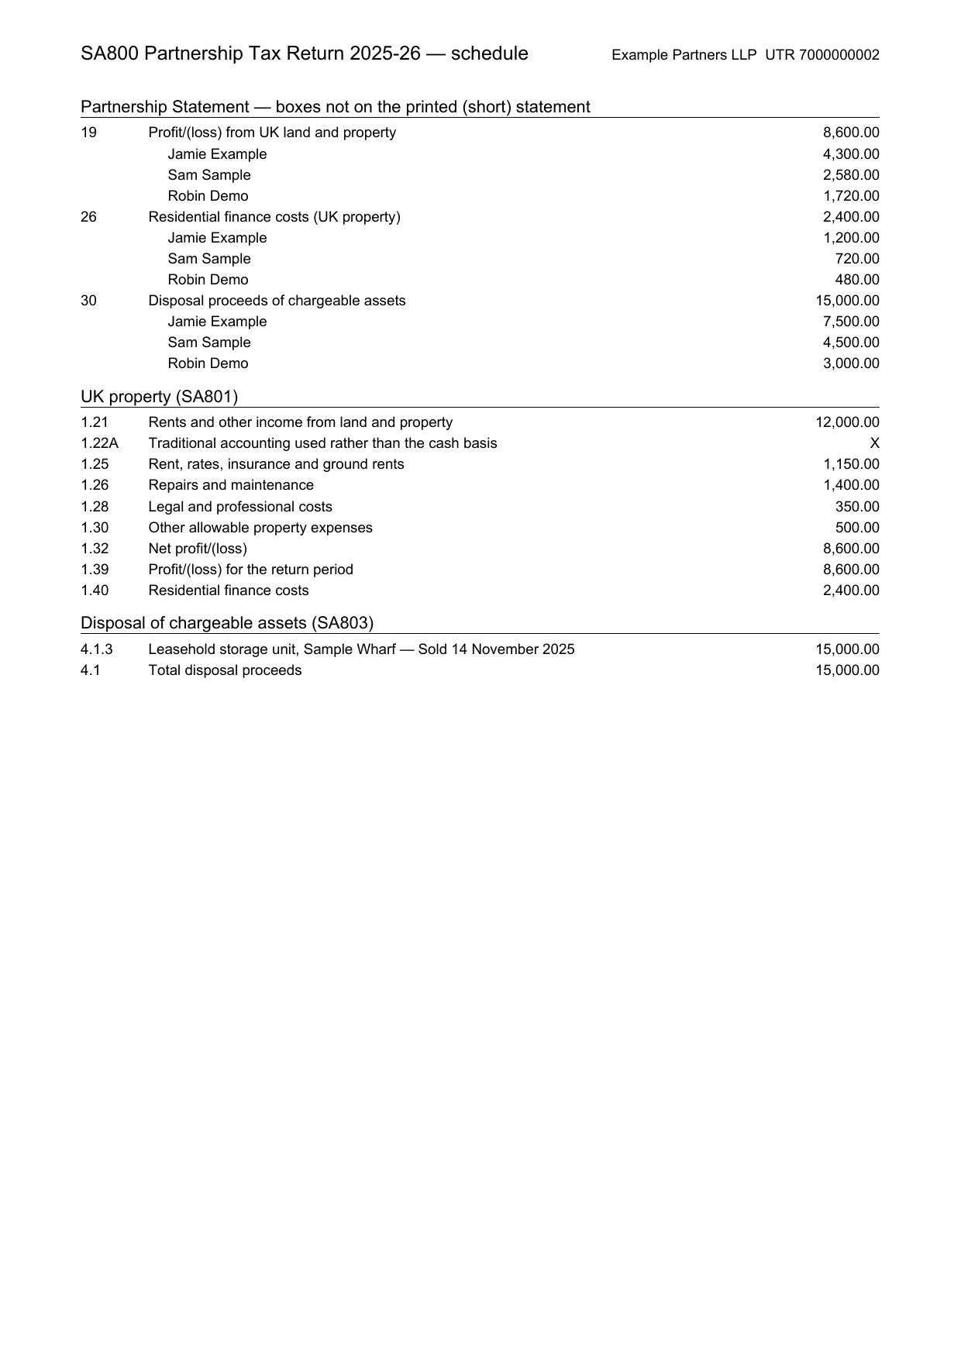

What Submit to HMRC actually does
Clicking Submit to HMRC saves your changes and takes payment for the return if it hasn’t been paid for — one credit for an accountant firm, or the standard submission fee by card for an organisation without one (see getting started). It then builds the SA800 from the saved return, signs it with an IRmark (the tamper-evident signature HMRC requires), sends it over HMRC’s online channel, and polls until HMRC confirms the outcome. On success the screen confirms “SA800 submitted to HMRC” and the return becomes Complete.

After you submit
The Review step keeps a list of Submissions to HMRC: when each was sent, its status, the IRmark, HMRC’s correlation ID and, for one that was not accepted, HMRC’s reason.
- HMRC is slow to answer — the submission shows “With HMRC — awaiting their response” and the return is locked so it cannot be sent twice. Tax Optimiser checks again automatically every 15 minutes; Check status asks straight away.
- HMRC rejects the return — the reason is shown, the return unlocks, and you fix it and submit again at no further charge.
- HMRC accepts the return — it is locked. To change it, click Reopen as amended return: the return unlocks with the amended-return flag set, and the next submission replaces the original.
Every submission’s full exchange with HMRC is logged, so if anything looks wrong, email support@taxoptimiser.co.uk and the team can trace the filing end to end.

