Accountant Workflow
User Guide
Filing for clients from Tax Optimiser — firm credentials and credits, creating client organisations, the firm-vs-organisation rules, and sending accounts and Corporation Tax.
taxoptimiser.co.uk · 4 October 2026

Contents
- The accountant workflow: from firm setup to filed accounts and CT600 — The map of the journey: set your firm's filing credentials once, then create each client and file accounts and Corporation Tax through the two wizards.
- Firm settings for filing: Presenter ID and Government Gateway — Where the firm's Presenter ID and Government Gateway login live, what each one is, and how to obtain a Presenter ID.
- Adding a client organisation — Four ways to add a client: the Companies House lookup, by name, from QuickBooks or Xero, or the full details form. Then what to complete before you file.
- Whose credentials file what: firm vs organisation — The Gateway login is firm-wide with a per-client override; the Presenter ID is firm-only for firm-managed clients. Here are the rules, the override, and the errors.
- Preparing the period: trial balance, accounts and the Corporation Tax computation — Every period follows the same three stages before you can file: get the trial balance in, build and review the accounts, and build the Corporation Tax computation. Here's the map.
- Sending statutory accounts to Companies House — Filing a client's accounts as a firm: credits instead of per-period fees, the firm's presenter credentials, and the pre-flight checks before the wizard sends.
- Sending the CT600 to HMRC — Filing the CT600 for a client: the UTR and Gateway login it needs, what the warnings mean, and the final confirmations before sending.

1. The accountant workflow: from firm setup to filed accounts and CT600
The map of the journey: set your firm's filing credentials once, then create each client and file accounts and Corporation Tax through the two wizards.
IN SHORT
- Set the Presenter ID and Government Gateway login once, at firm level
- Firms pay for filings with credits - one credit per period covers both filings
- Create clients from the Companies House register or by name
- The period checklist tracks everything still needed before filing

Filing for clients from Tax Optimiser splits neatly in two: things you set up once for your firm, and things you do per client. Get the firm side right first and every subsequent filing — statutory accounts to Companies House, the CT600 to HMRC — reuses it automatically.

Once per firm
- Companies House Presenter ID and password — your firm’s software-filing account with Companies House, entered on the Companies House tab of Firm Settings.
- HMRC Sender Id and password — your firm’s Government Gateway login, entered on the HMRC tab. Once saved, it files Corporation Tax for every client as their agent.
- Credits — firms pay for filings with credits rather than a per-period fee; one credit covers a period’s filings to both Companies House and HMRC.
The detail, including how to obtain a Presenter ID, is in Firm settings for filing.

Once per client
- Create the organisation — either straight from the Companies House register by searching the company name, or by name only (sole traders, partnerships, or companies you’ll complete manually). See Adding a client organisation.
- Complete the company record — Companies House number, authentication code and Corporation Tax UTR. The period’s Setup Process Checklist tracks what’s still missing.
- Prepare the period — trial balance, accounts and the Corporation Tax computation. See Preparing the period for the map through all three stages.
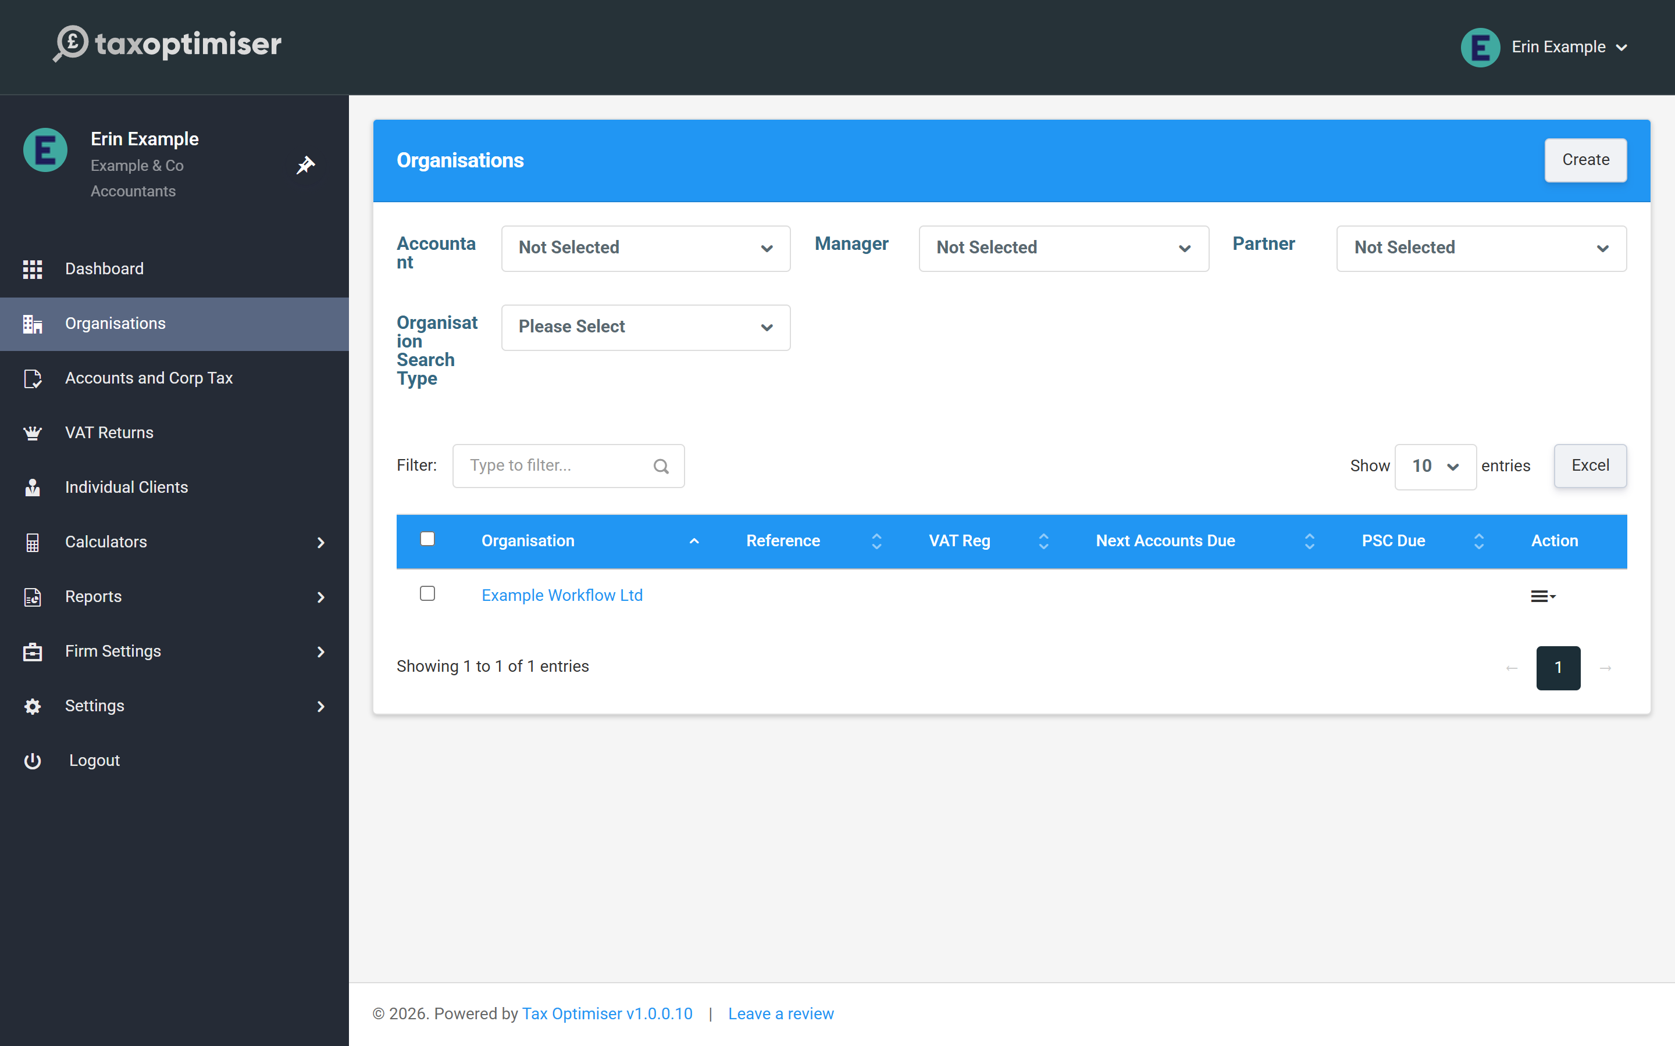

Then, for every period
Two guided wizards do the filing: accounts to Companies House and the CT600 to HMRC. Both check the same pre-flight list — credentials, authentication code, signed accounts — and both draw on your firm-level settings, unless a client has their own (see Whose credentials file what).

2. Firm settings for filing: Presenter ID and Government Gateway
Where the firm's Presenter ID and Government Gateway login live, what each one is, and how to obtain a Presenter ID.
IN SHORT
- Presenter ID = your firm's Companies House software-filing account; apply once on gov.uk
- The presenter authentication value is issued alongside the Presenter ID
- HMRC Sender Id = the firm's 12-character Government Gateway user ID
- Set at firm level, both are used for every client automatically
- HMRC sees firm-filed returns as filed by an agent

Everything in this article lives in one place: Firm Settings → Firm, which opens the Accountant Firm Settings page. Two of its tabs carry your filing credentials — set them once and they are used for every client your firm manages.

The Companies House tab: your Presenter ID
A Presenter ID is your firm’s account for filing accounts by software — it is not the same thing as a WebFiling login, and each company’s authentication code is separate again (that one belongs to the client; see Adding a client organisation).
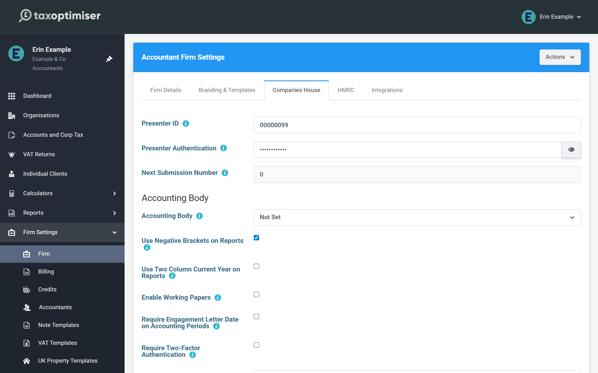
If your firm doesn’t have one yet, the application is a one-off form on gov.uk: apply to file with Companies House using software. Companies House issues the Presenter ID together with a presenter authentication value — that pair is exactly what the two fields on this tab want.
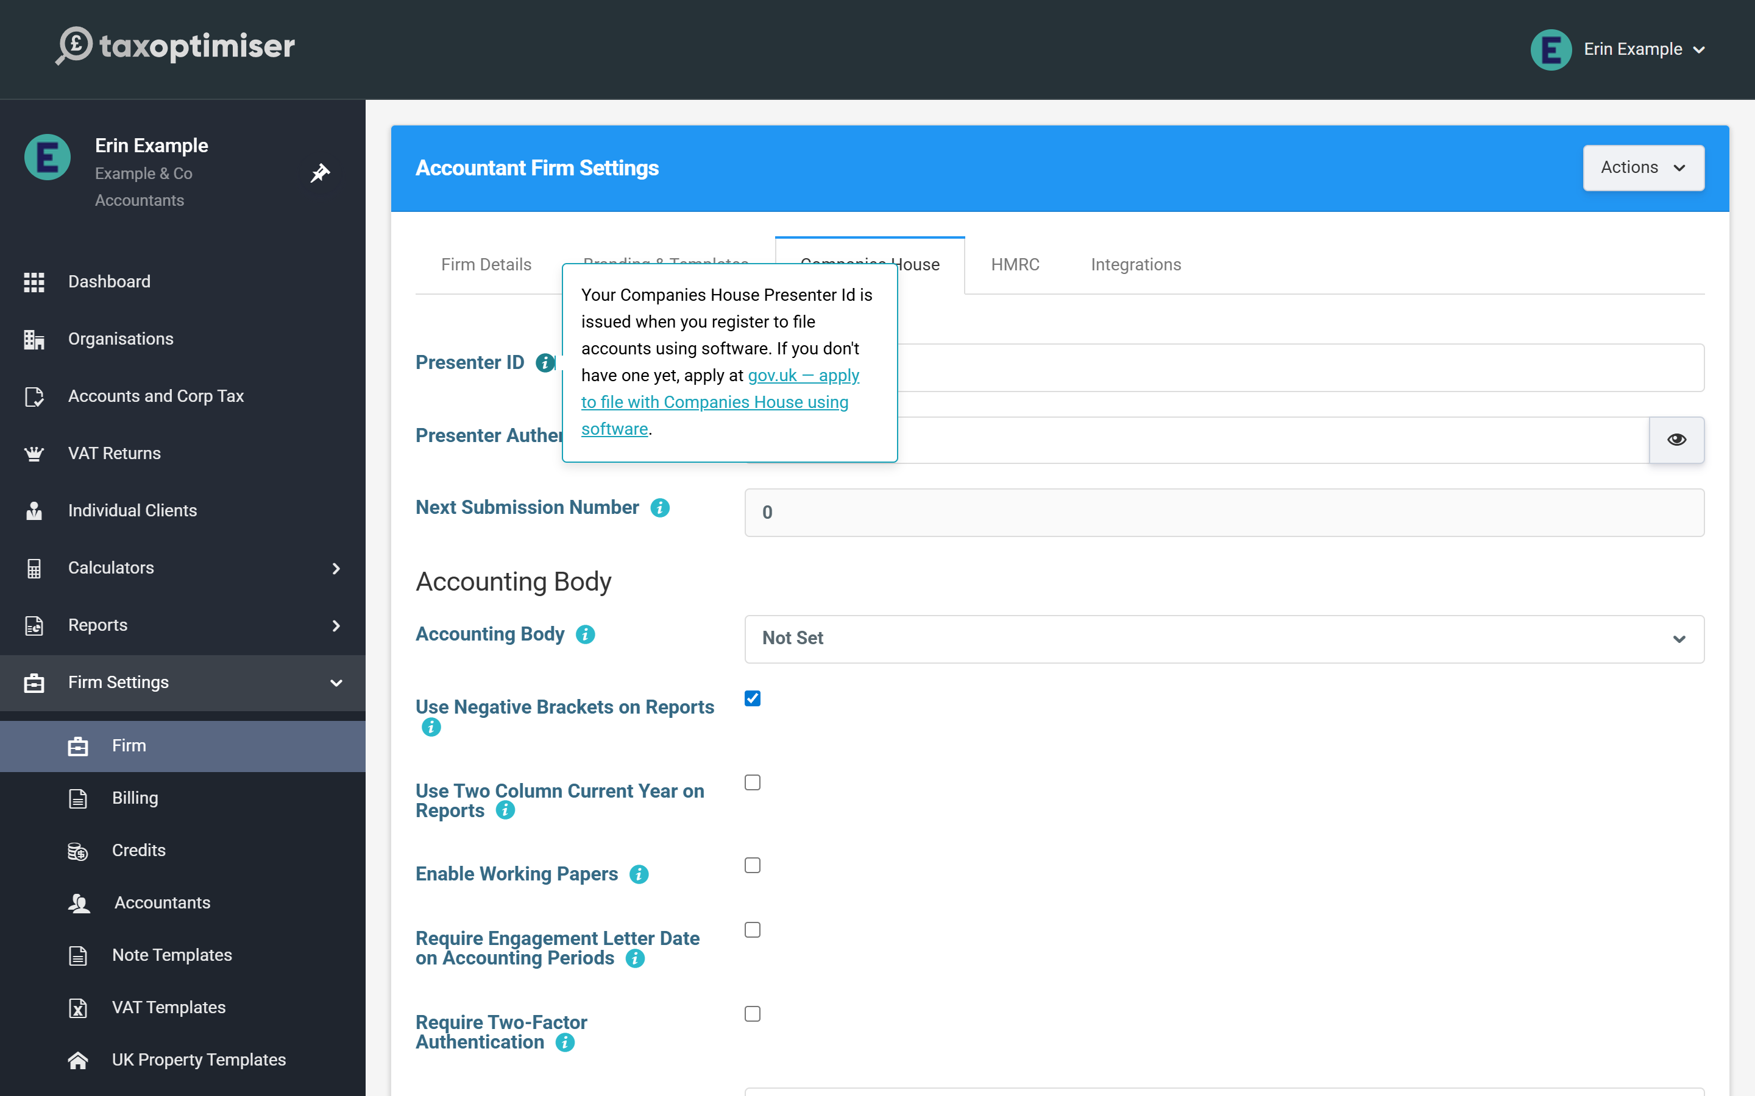
Next Submission Number is read-only housekeeping: every electronic filing your firm sends carries a sequence number, and Tax Optimiser increments it automatically. You’d only resync it (via the button at the foot of the tab) if filings had also been sent outside Tax Optimiser under the same Presenter ID.

The HMRC tab: your Government Gateway login
HMRC Sender Id is your firm’s Government Gateway user ID — the 12-character ID for the account your firm uses to file Corporation Tax — with its password alongside.
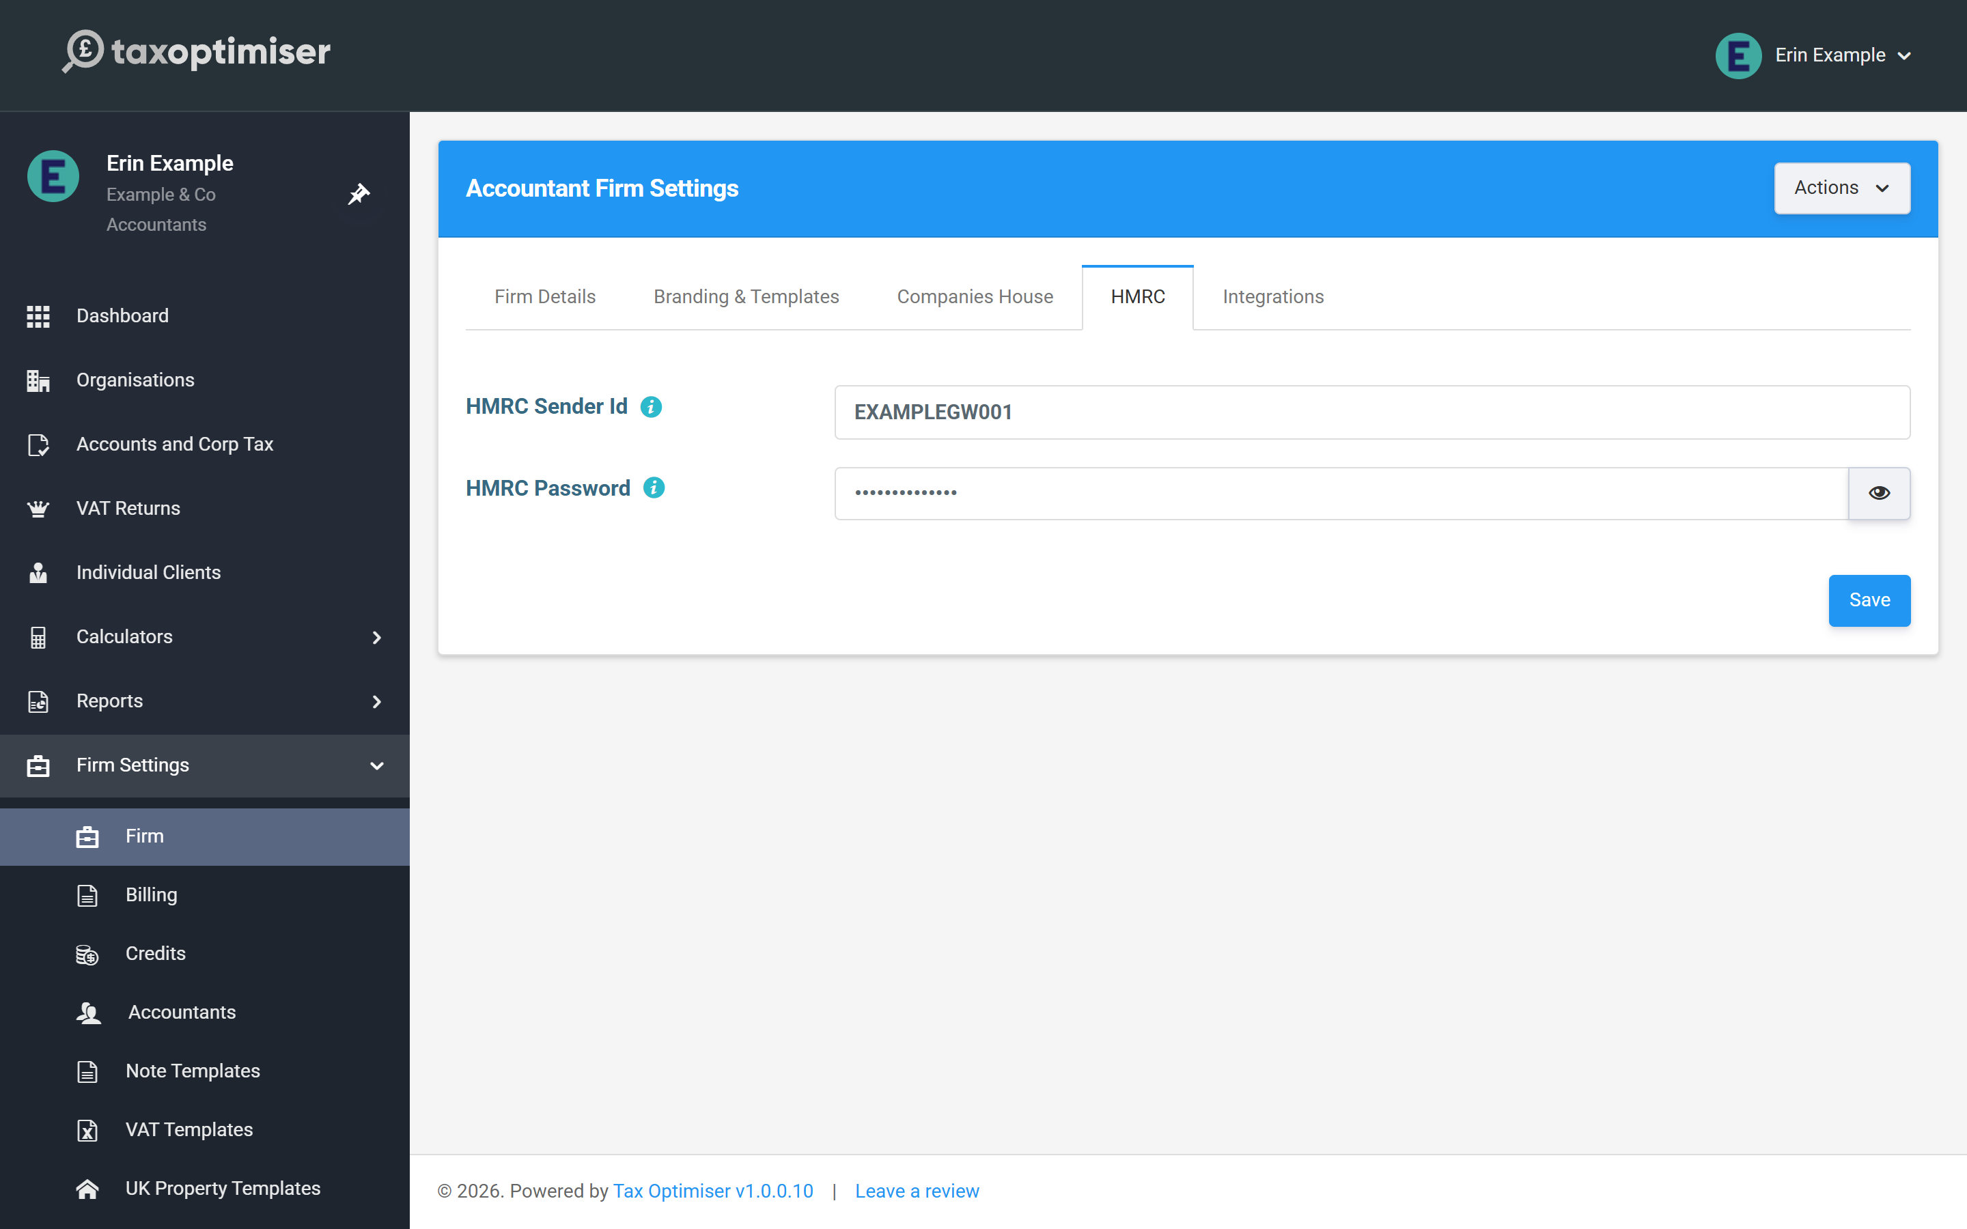
Entered here, it is used for every client’s CT600, and HMRC sees the return as filed by an agent. If one client needs to file under their own Government Gateway account instead, you can override it on that client’s record — the rules are in Whose credentials file what.

Worth doing while you’re here
The Firm Details tab (name, address, contact details) feeds the client portal and report headers, and the Branding & Templates tab dresses the generated accounts PDFs. Neither blocks filing, but both make the output look like yours.

3. Adding a client organisation
Four ways to add a client: the Companies House lookup, by name, from QuickBooks or Xero, or the full details form. Then what to complete before you file.
IN SHORT
- Start from Organisations, then Create
- The lookup needs 3+ characters and searches the live register as you type
- Lookup-created companies get registered details and their first period automatically
- By-name creation fetches nothing: set the structure, then enter the company number
- The Companies House tab only appears once the structure is Limited Company
- A matching name or company number brings up a Possible duplicate warning you can override

Every client you work on in Tax Optimiser is an organisation in your firm’s list. There are four ways to add one: search Companies House, type a name, connect QuickBooks or Xero, or fill in the full details form. This article walks through each, and what to finish off afterwards.

Where to start
Click Organisations in the left-hand menu to see your client list, then Create at the top right.
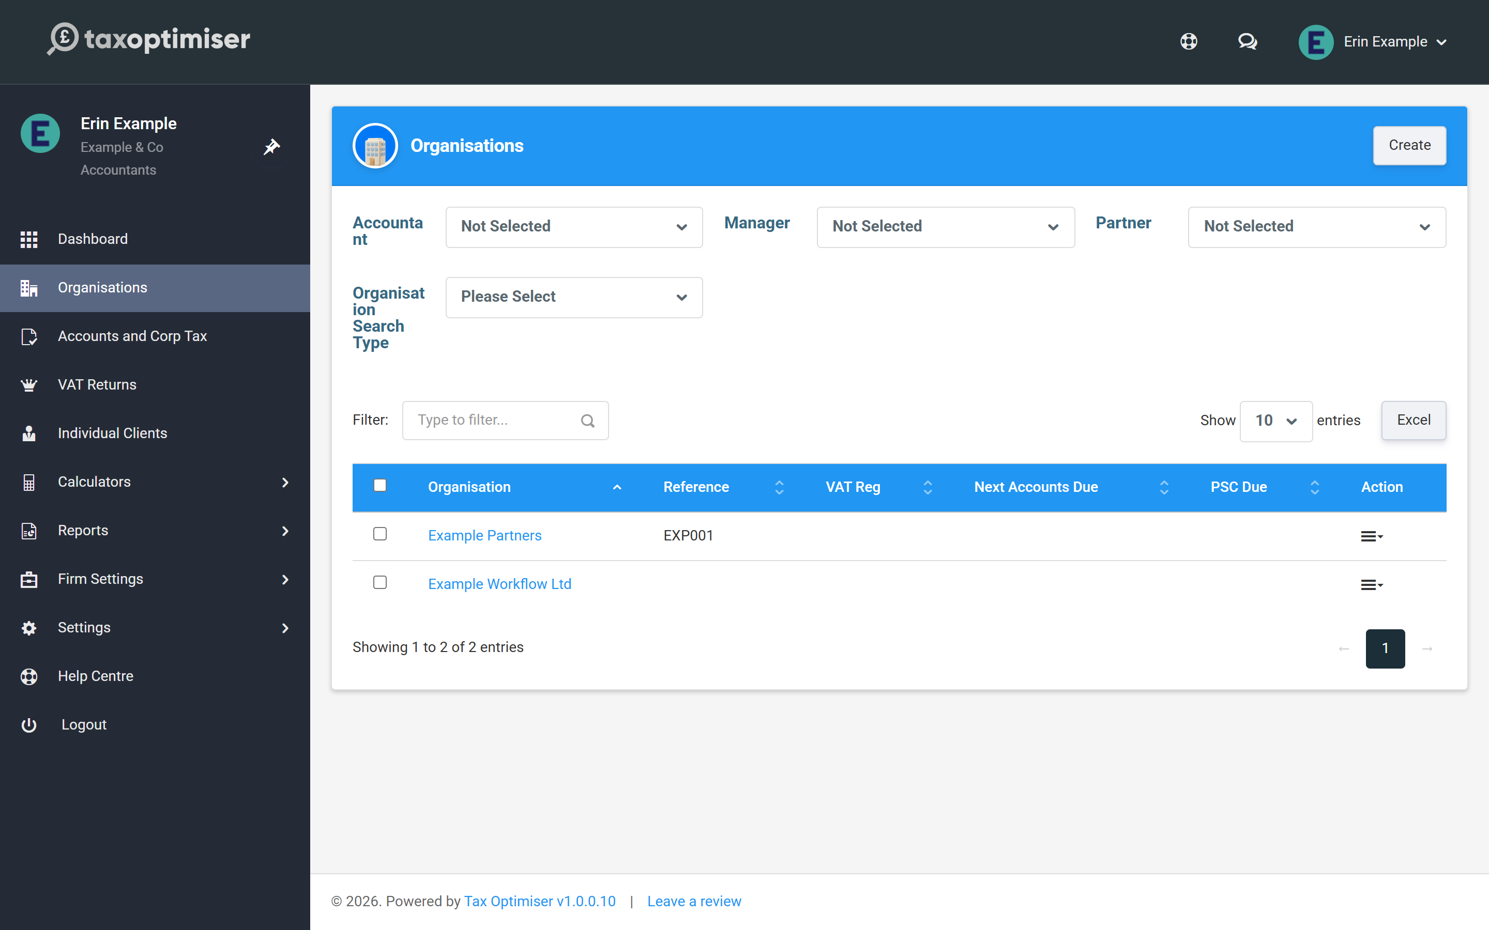
Create opens one page with the three quick ways of adding a client. Use one of them, then press Next.
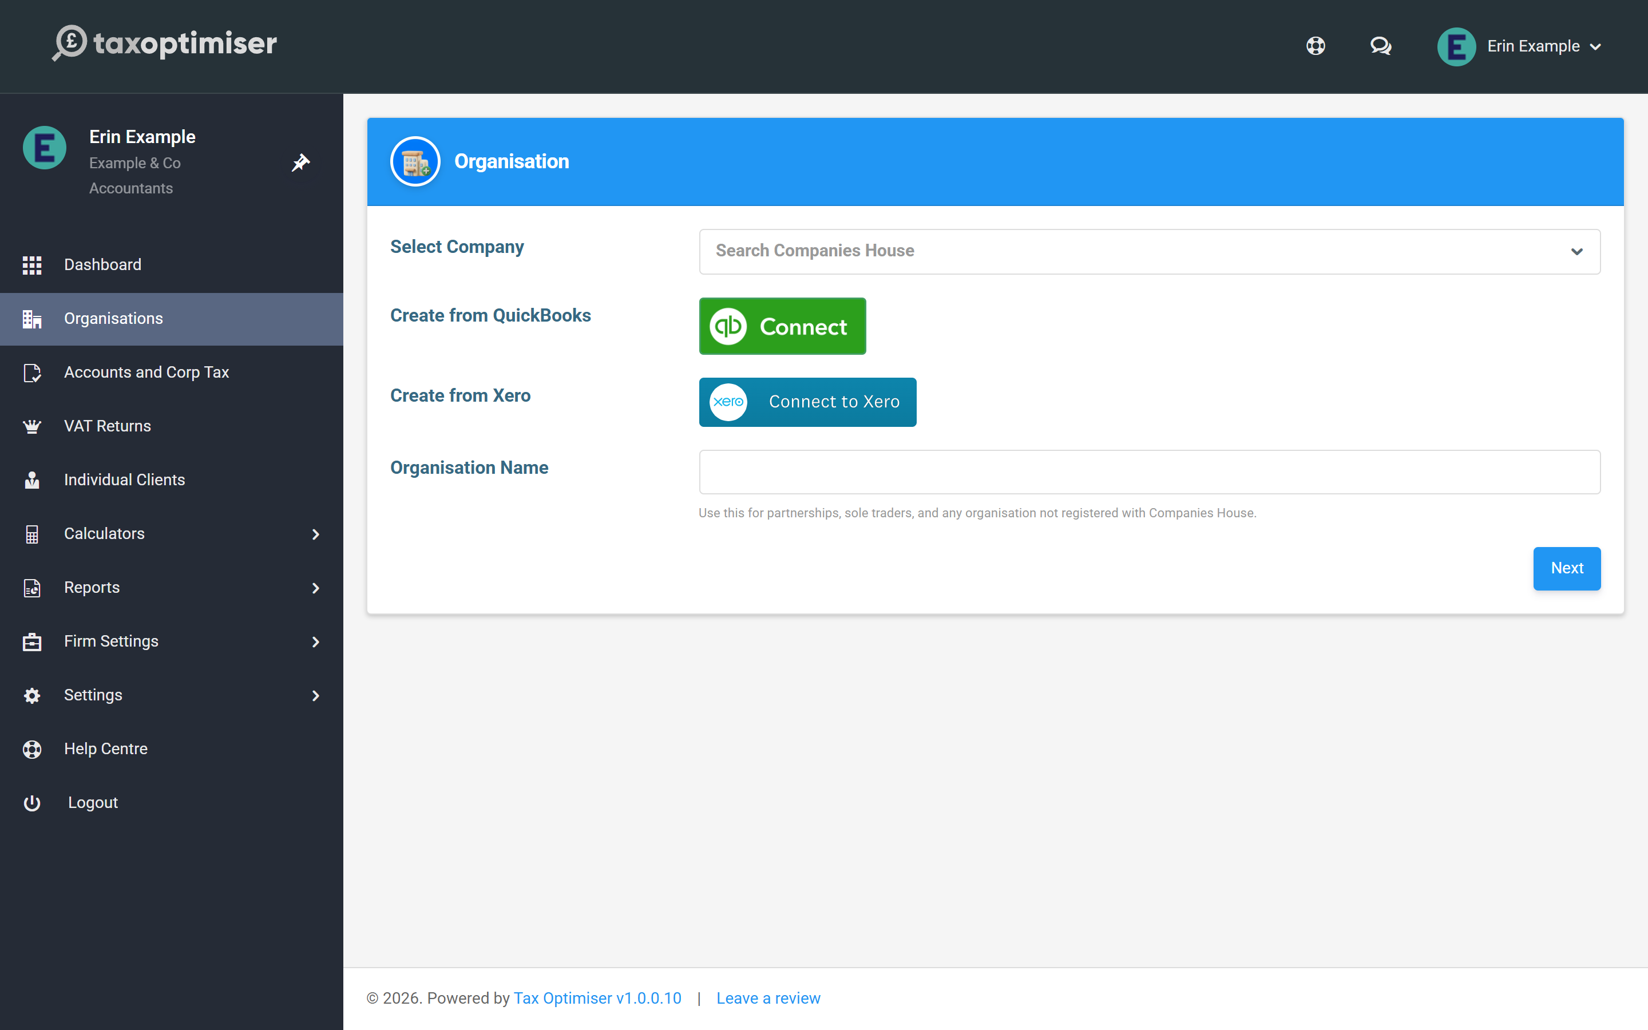

The quick way: the Companies House lookup
Use this for any company on the Companies House register.
- Click Select Company and type three or more characters of the company’s name. The live register is searched as you type, and each result shows the registered name and company number.
- Pick the company. Check the number, because many companies have similar names.
- Press Next.
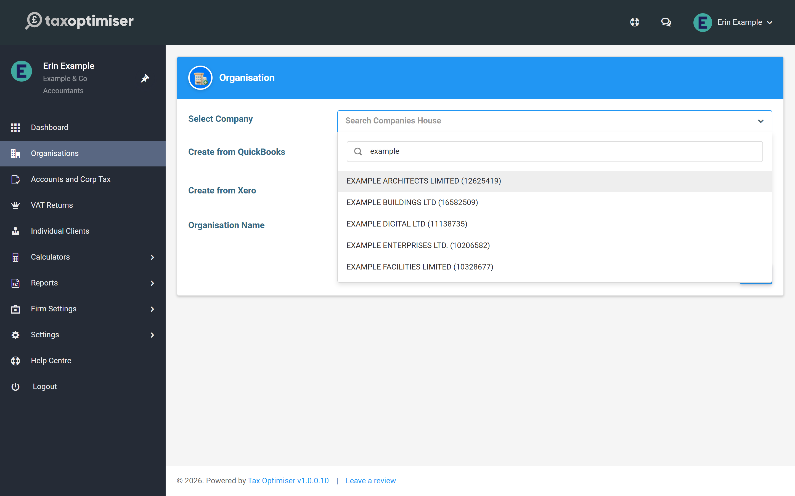
Tax Optimiser then does the setup for you. It creates a limited company with the registered name, company number, registered office address and incorporation date from the register, and builds the first accounting period from the company’s filing dates. What it can’t fetch is the authentication code, the six-character code Companies House posts to the registered office. Add that to the client’s record before you file.

The manual way: by name
Type a name into Organisation Name instead and press Next. This creates an empty organisation with that name. It is the right path for partnerships, sole traders and anything else not on the Companies House register, and it works for a limited company you would rather set up by hand.
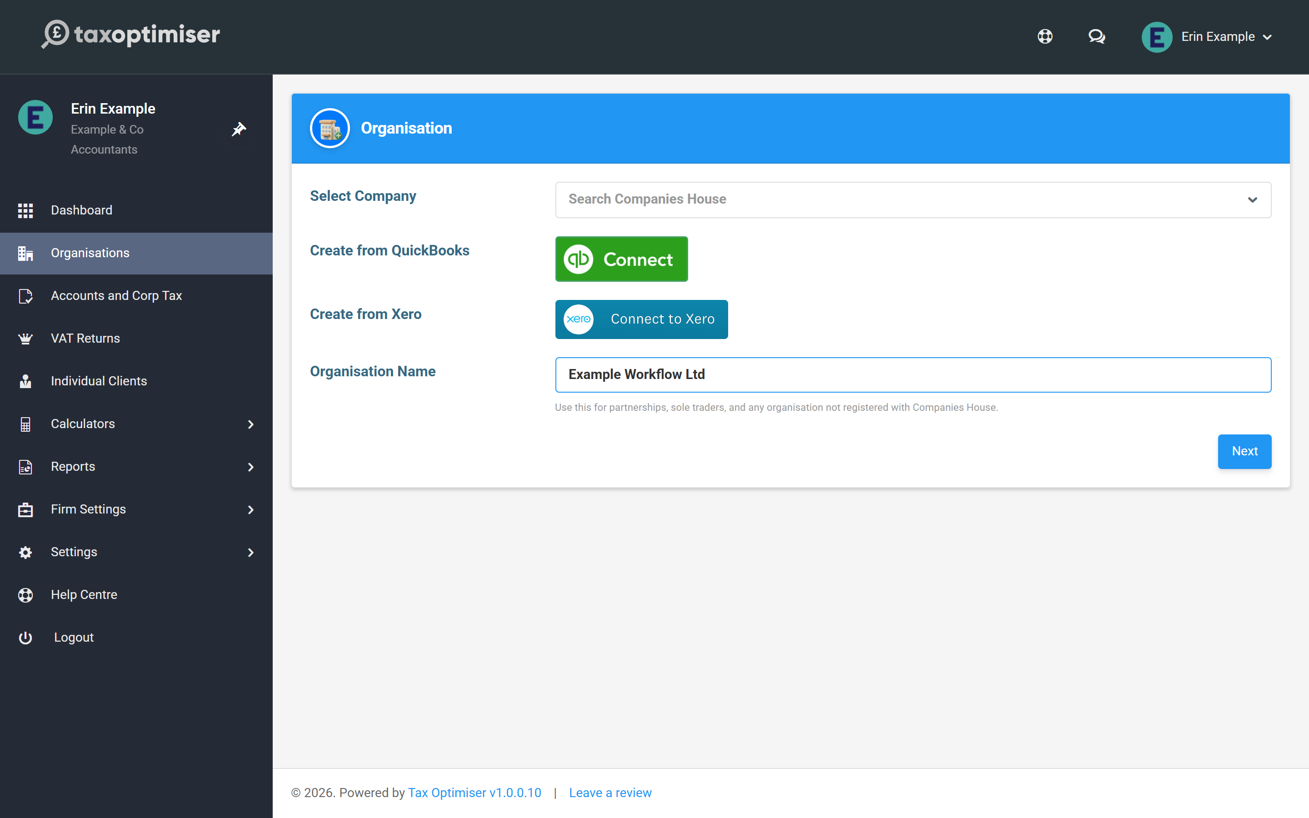
Nothing is fetched for you on this path, so the new organisation opens with only its name filled in.

From QuickBooks or Xero
The Create from QuickBooks and Create from Xero buttons create the organisation by signing in to the client’s accounting software. The company details come from that connection, and so does the trial balance later. The Companies House number and authentication code still need entering by hand, the same as the by-name path.

After you press Next: finish the details
Whichever way you create it, you land on the new client’s Details page. The client’s own menu (Overview, Details, Individuals and so on) replaces the firm menu, and Back to Organisations returns you to your client list.
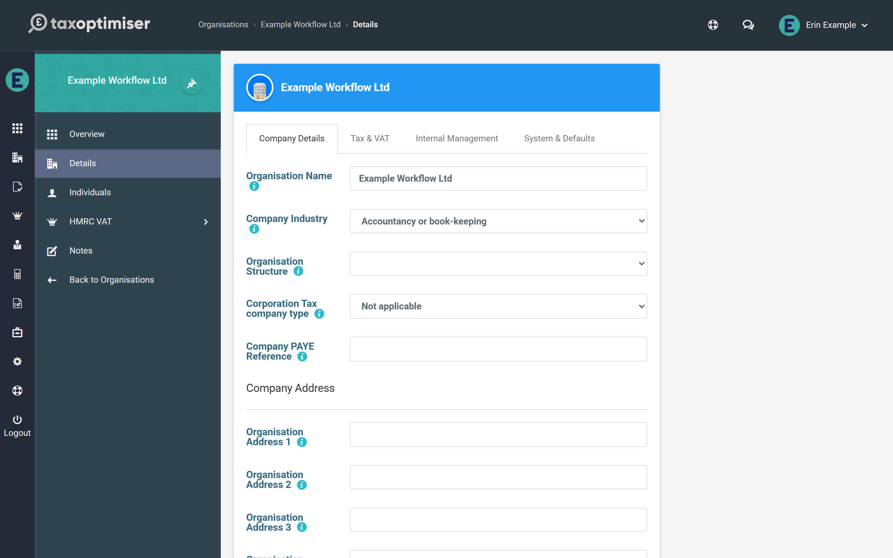
For a client created by name:
- On Company Details, choose the Organisation Structure (Limited Company, Partnership, Sole Trader and so on) and add the address. Click Save.
- For a limited company, a Companies House tab now appears. Enter the Companies House No there. It is 6 to 8 characters, and you include the leading letters for registrations outside England and Wales. The Companies House Authentication Code goes on the same tab.
- On Tax & VAT, enter the Corporation Tax UTR and any VAT registration number.
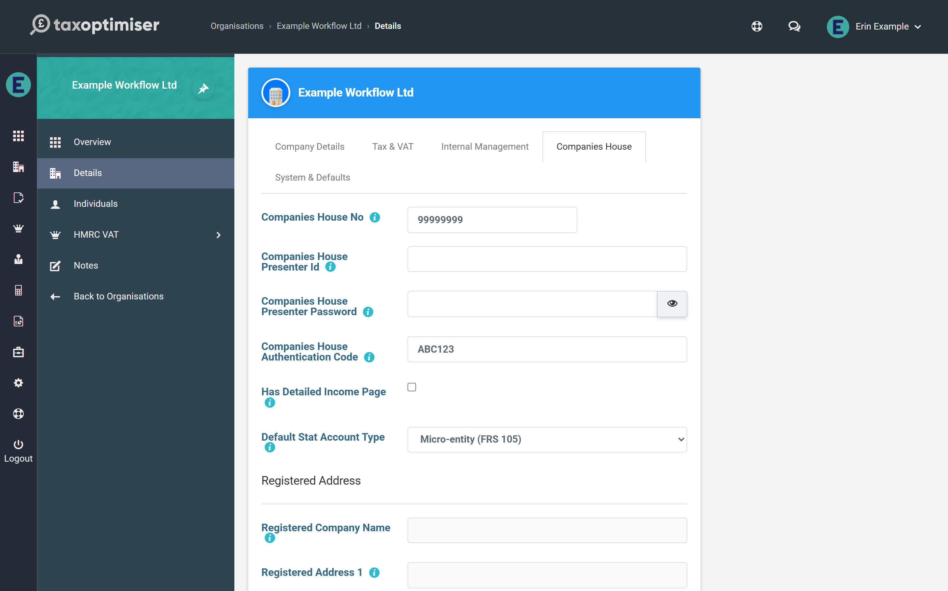
You cannot file accounts for a limited company until its company number is saved. Once the number is saved and the registered name has synced from the register, the number locks and a Sync button appears beside it. Use that whenever you want to refresh the registered details from Companies House.
The presenter fields on this tab can stay empty. Your firm’s presenter ID is used unless you enter one here: see Whose credentials file what: firm vs organisation.

The full details form
A firm with no clients yet sees Add your first client on its dashboard. The Add a client button there, and the Create your first client organisation step in the setup checklist, open a longer form instead of the quick page.
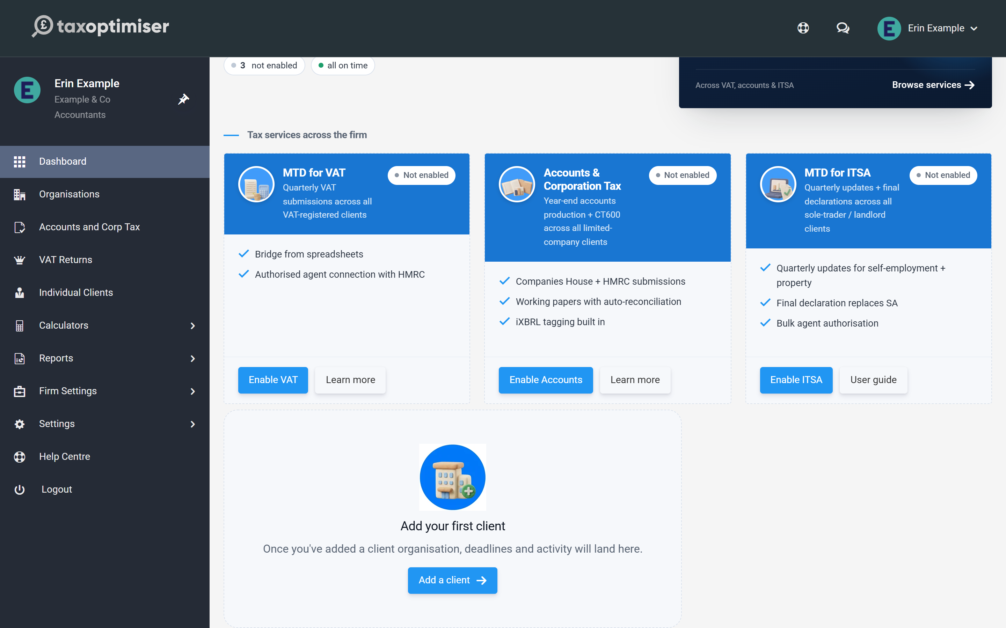
The form takes everything in one go: Organisation Name, Company Industry, Organisation Type, Limited By, the Community Interest Company (CIC) tick box, your own Organisation Reference, the Companies House, VAT, Corporation Tax and PAYE references, the staff responsible (Accountant, Manager, Partner), the incorporation date and both addresses. Only the name is required. Click Save and you land on the same Details page.
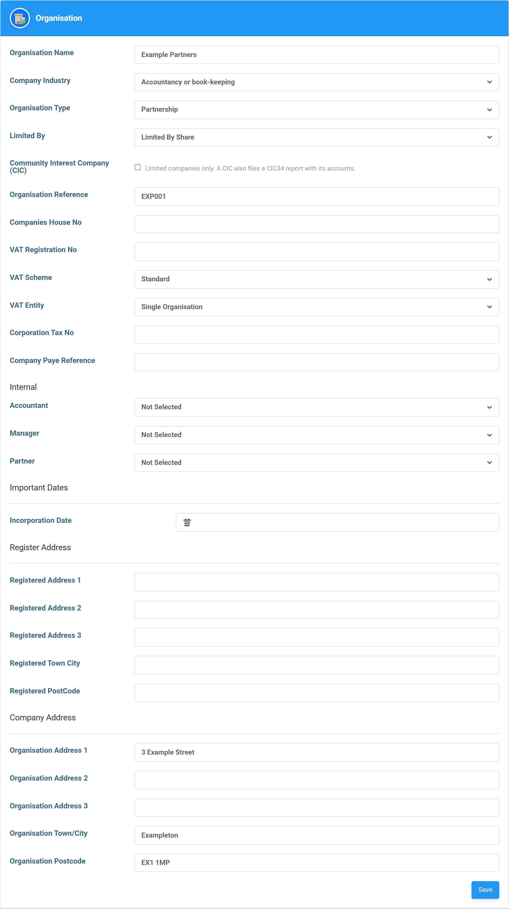
If you type a Companies House number here, check it carefully. This form does not search the register, so nothing confirms the number belongs to the company you meant.

If you see “Possible duplicate”
Before a client is created, Tax Optimiser checks your firm’s clients for the same organisation name or the same Companies House number. If it finds one, the page comes back with a warning instead of creating the client:
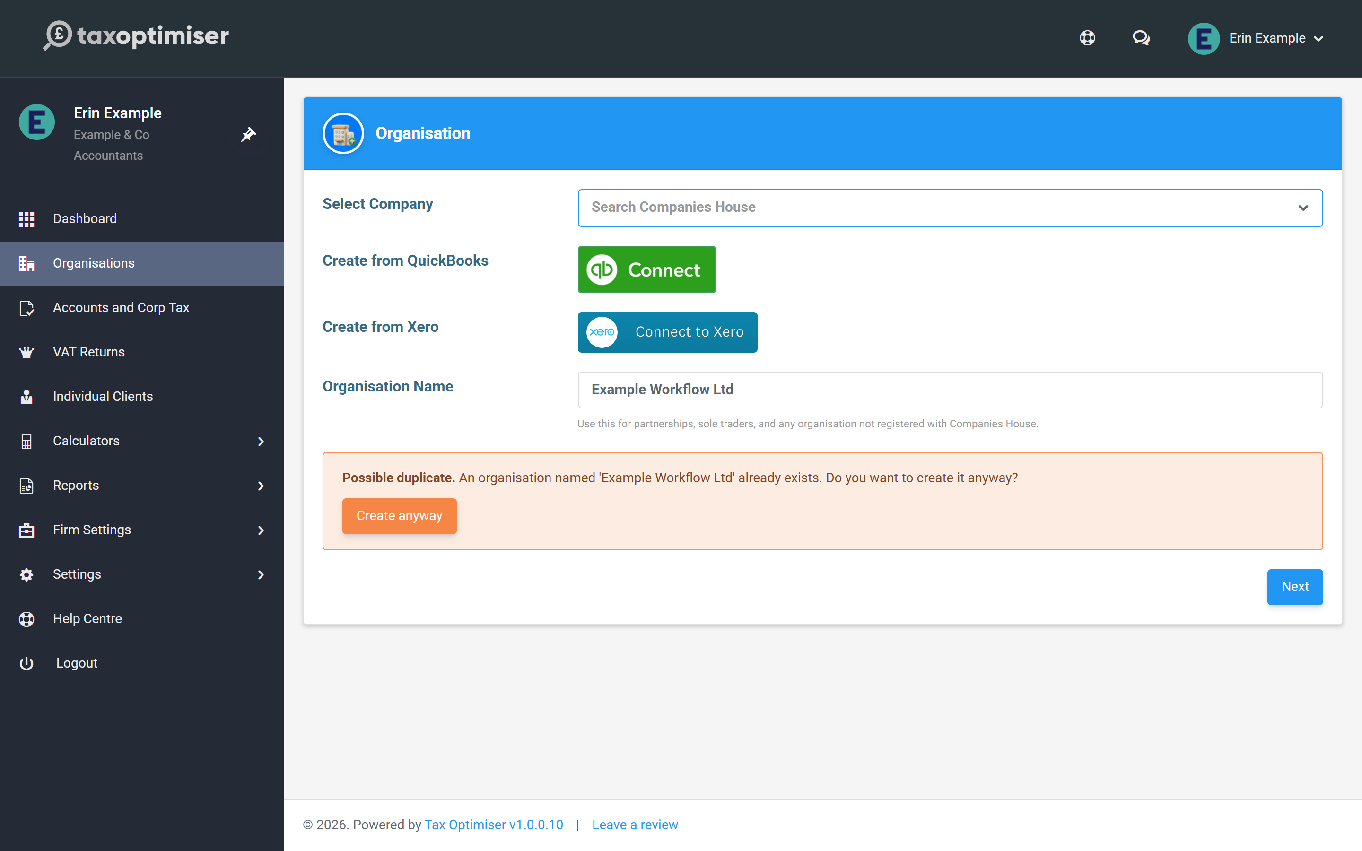
- If the client is already in your list, leave the page and open it from Organisations. Nothing has been created.
- If you do want a second one, for example two clients that trade under the same name, click Create anyway.
The check runs on the Companies House lookup, the by-name box and the full details form. Names are compared ignoring capitals, but must otherwise match exactly. Clients created from QuickBooks or Xero are not checked.

Giving the client a login
A client organisation has no client users until you add one. Open the client, click Individuals in its menu, then Add New, and enter the person’s name and email address. If that email address already has a Tax Optimiser account, you are offered Send invitation instead, and the person accepts it after logging in.

Does it cost anything to add a client?
No. Adding a client organisation is free. Filing for a client uses your firm’s credits, which you buy once and spend across all your clients under Firm Settings.

Can I add a client that is not a limited company?
Yes. Create it by name, then set the Organisation Structure to Partnership, Sole Trader, Limited Liability Partnership, Unincorporated Association or Charitable Incorporated Organisation on the Details page.

Why is there no Companies House tab on my new client?
The tab only appears for limited companies. Set Organisation Structure to Limited Company on Company Details and save, and the tab appears.

Will Tax Optimiser stop me adding the same client twice?
It warns you. If your firm already has a client with the same name or Companies House number, you see a Possible duplicate warning and nothing is created unless you click Create anyway.

I added a client by mistake. How do I remove it?
On the Organisations list, open the menu in the client’s Action column. Archive hides the client and takes it out of your billing from that day; Delete removes it.

4. Whose credentials file what: firm vs organisation
The Gateway login is firm-wide with a per-client override; the Presenter ID is firm-only for firm-managed clients. Here are the rules, the override, and the errors.
IN SHORT
- Gateway: firm-wide by default, per-client override on the Tax & VAT tab
- A client override files the CT600 as the company; the firm login files as agent
- Presenter ID: always the firm's for firm-managed clients
- Presenter credentials belong in Firm Settings, not on the client record
- The checklist and wizard both show exactly which credentials are missing

Two sets of credentials drive the two filings — and they follow different rules. This is the article to come back to when a submission complains about missing credentials.

The rules at a glance
 | Client managed by your firm | Standalone organisation
Government Gateway (CT600 to HMRC) | The firm’s HMRC Sender Id is used and the return files as  agent  —  unless  the organisation record has its own Sender Id, which then takes precedence and the return files as the  company itself  . | The organisation’s own Sender Id and password are used.
Presenter ID (accounts to Companies House) | Always the firm’s  Presenter ID and authentication. The organisation-level presenter fields are not used while the client belongs to a firm. | The organisation’s own presenter fields are used.

In short: the Gateway login is firm-wide with a per-client override; the Presenter ID is firm-only for firm-managed clients. So for your own clients, presenter credentials belong in Firm Settings — entering them on the organisation’s Companies House tab has no effect until an organisation stops being firm-managed.

Overriding the Gateway for one client
Some clients file Corporation Tax under their own Government Gateway account — common when the company already filed for itself before appointing you, or wants returns sent in its own name rather than an agent’s. On the client’s record, open the Tax & VAT tab and fill Corporation Tax Sender Id and Corporation Tax Password:
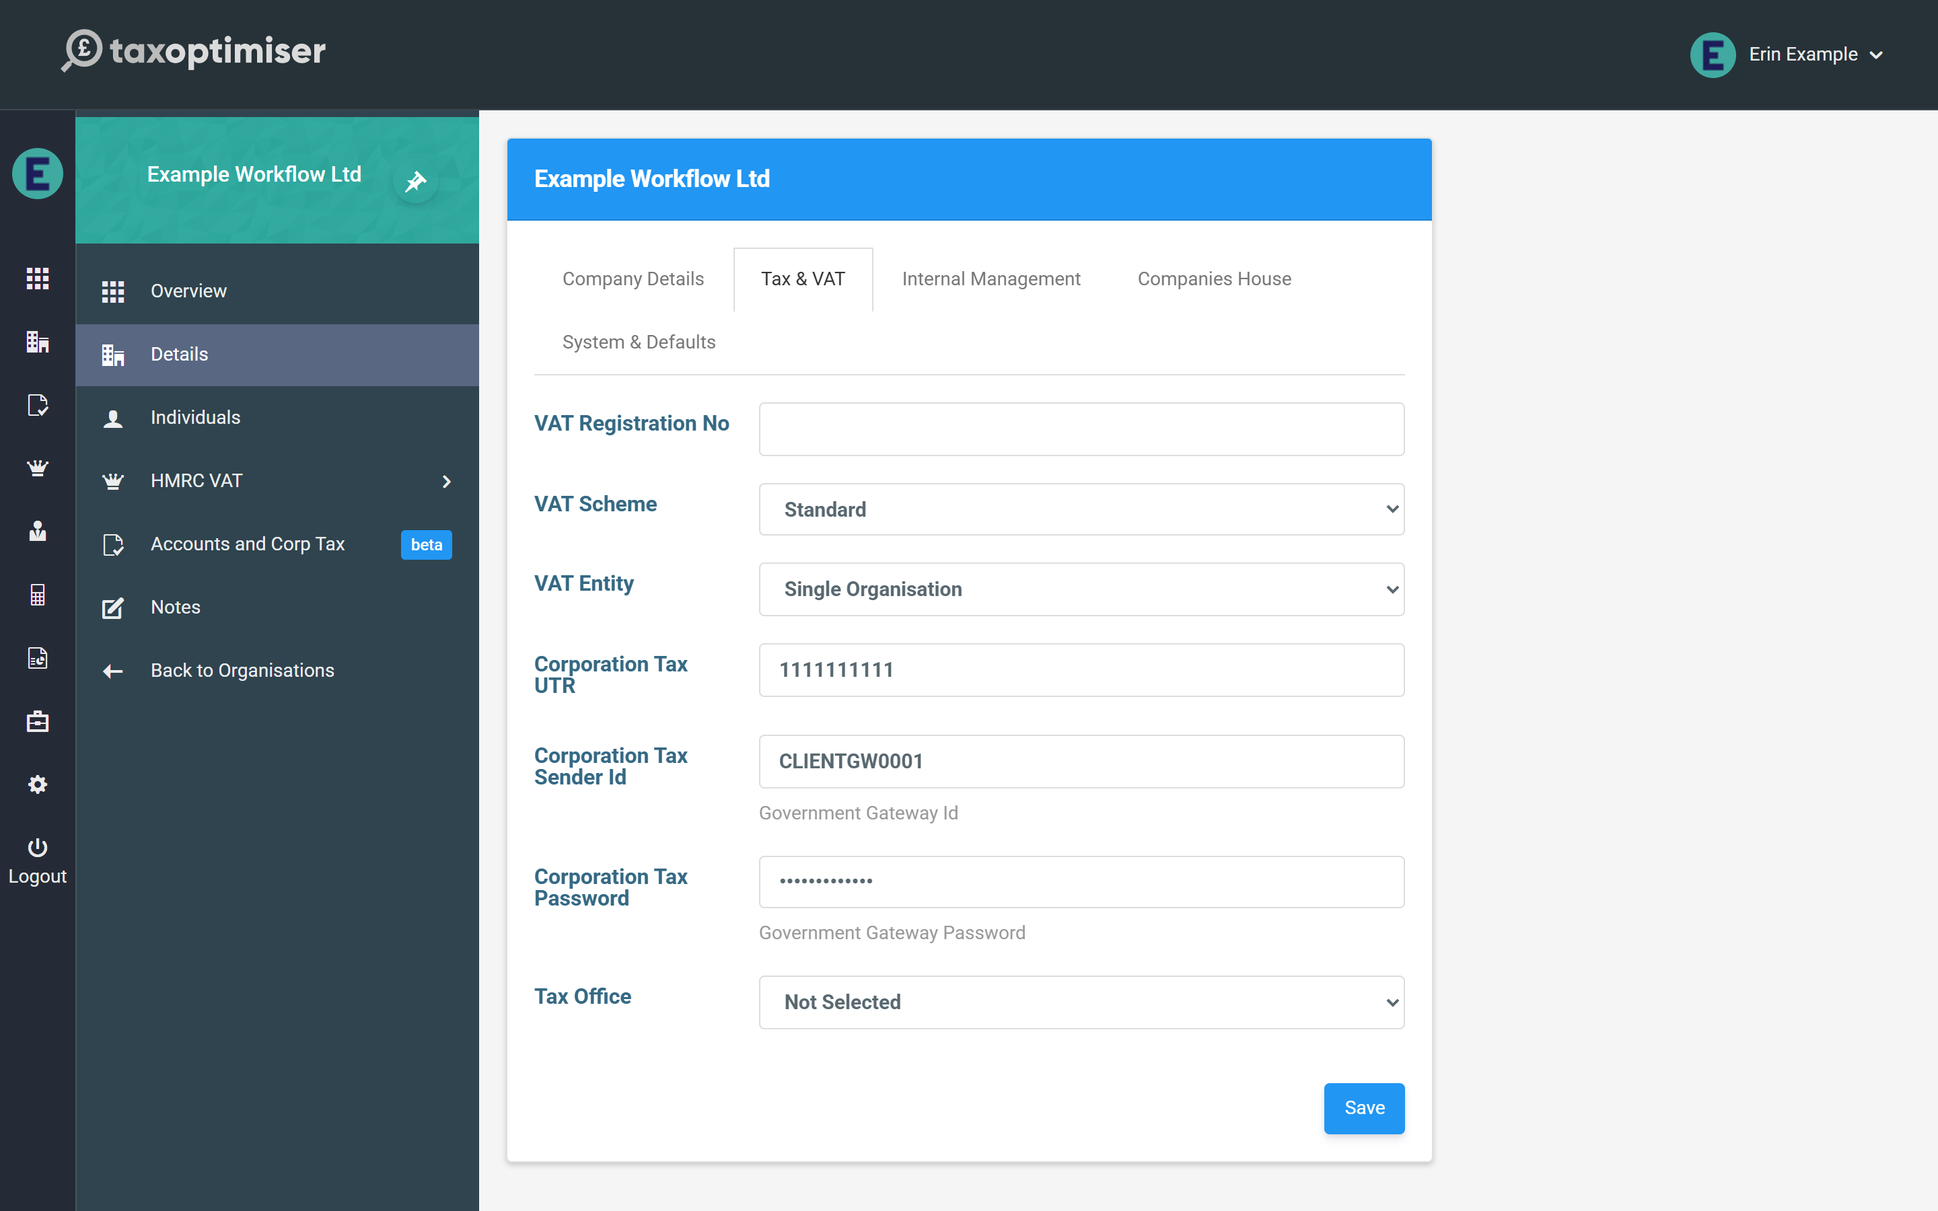
With a value here, this client’s CT600s go to HMRC under their gateway and are marked as filed by the company; every other client carries on using the firm’s. Clear the fields to fall back to the firm login.

The checklist tells you what’s missing
Each period’s Setup Process Checklist evaluates these rules for you. When credentials are missing it says so — and for a firm-managed client, Set Credentials sends you to Firm Settings, the place they actually belong:
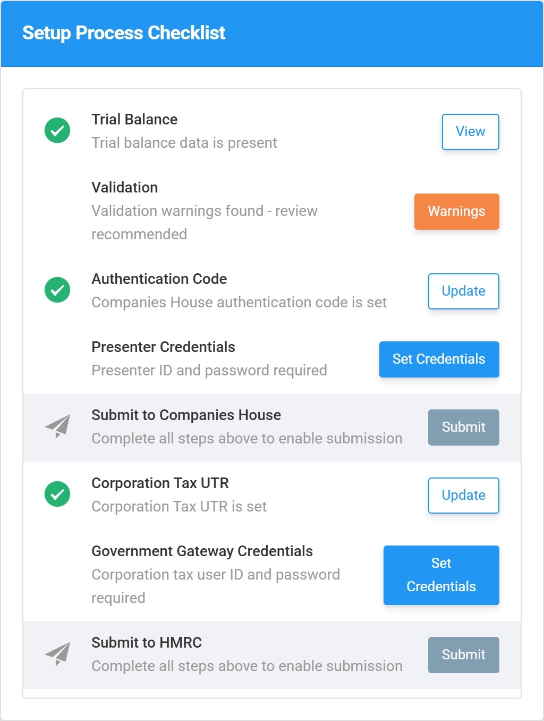
With the firm credentials in place, the same checklist resolves and both submissions unlock:
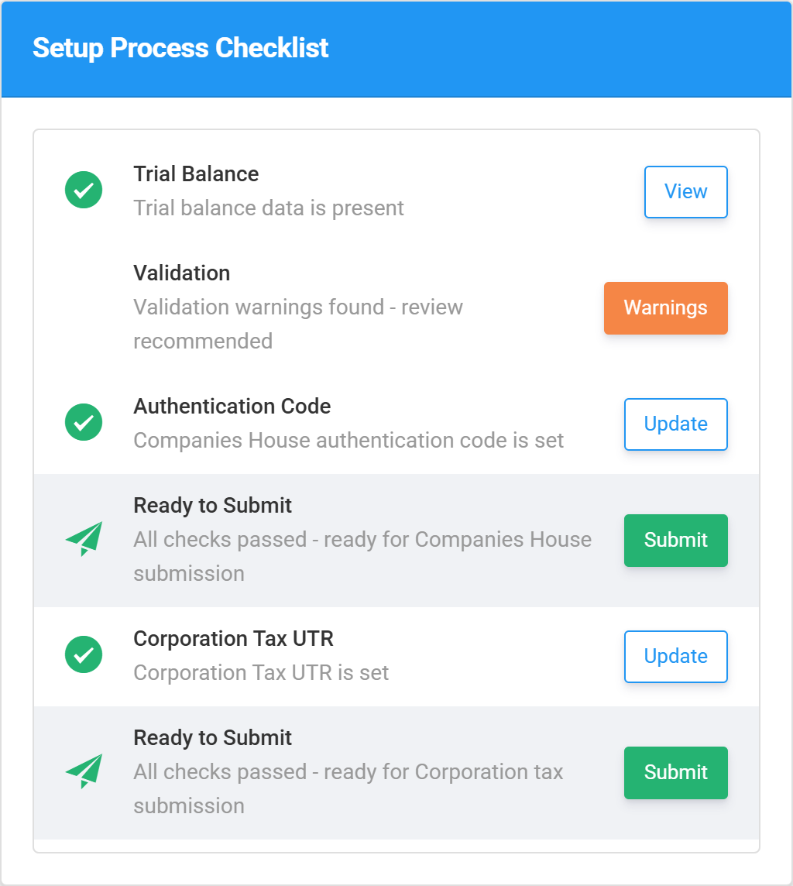

If you try to file anyway
The Companies House wizard’s first step shows the same status against each requirement — Required until it’s set, with a How to apply link for the presenter pair:
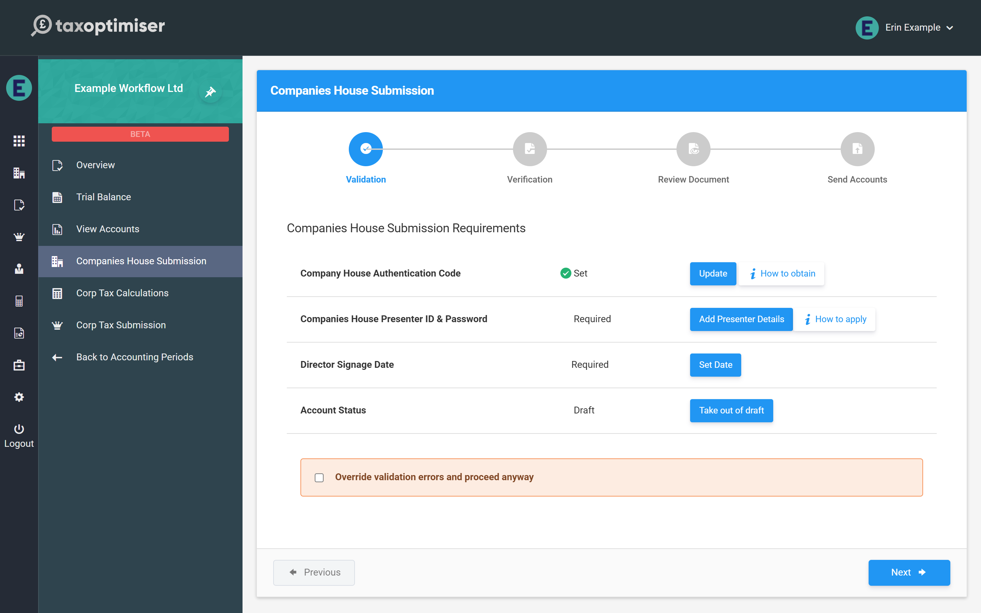
And a send attempted without credentials stops with an error that names the right place to fix it: for a firm-managed client, “Please enter the companies house presenter id in Firm Details”; for a standalone organisation, “Please enter the companies house presenter id in the organisation details”.

5. Preparing the period: trial balance, accounts and the Corporation Tax computation
Every period follows the same three stages before you can file: get the trial balance in, build and review the accounts, and build the Corporation Tax computation. Here's the map.
IN SHORT
- Every period: trial balance, then accounts, then computation - before either wizard
- The trial balance can sync from Xero/QuickBooks, import from a spreadsheet, or be keyed manually, and must balance
- Sign the accounts in View Accounts to take them out of draft - this is what unlocks filing
- The computation covers disallowables, capital allowances and losses, with a combined review step
- The period Setup Process Checklist tracks all three stages

Once the client exists and your firm’s credentials are in place, every accounting period follows the same three stages before either filing wizard will let you send: get the numbers in, build and review the accounts, and build the Corporation Tax computation. None of this is firm-specific — it’s the same work whoever does it — so this article is the map through the three stages, with a link to the full how-to for each. The period’s Setup Process Checklist tracks your progress along the way.

1. Get the numbers in: the trial balance
The trial balance is the foundation for both the accounts and the computation. There are four ways to populate it:
- Sync from Xero or QuickBooks — if the client’s organisation is connected to their accounting platform, pull the trial balance straight from it.
- Import from a spreadsheet — upload an Excel or CSV export from any other bookkeeping system, with templates for Xero, Sage 50 and others and AI-assisted account mapping.
- Enter it manually — key the figures in directly, account by account.
However the figures arrive, the trial balance must balance — total debits equal total credits — and you can post journals to adjust or reclassify before moving on. The full walkthrough is in Getting your numbers in: the trial balance, and the spreadsheet route has its own detailed guide: Import a trial balance from a spreadsheet.

2. Build and review the statutory accounts
Open View Accounts from the period menu to assemble the statutory accounts. The screen is driven by a sidebar — General, Directors, Dates, Addresses, Notes and Policies — with a live preview of the finished document beside it and an Errors/Warnings panel that links straight to whatever needs fixing.
This is where you choose full or filleted accounts (filleted being the abridged version filed at Companies House), complete the notes, and finally sign the accounts — which sets the director signage date and takes them out of draft. Both filing wizards check for exactly that, so signing here is what unlocks them. The complete tour is in Touring the View Accounts screen, and the signing detail is in Validation and signing.

3. Build the Corporation Tax computation
With the trial balance in, open the computation to turn the accounts profit into the tax figure. You work through the disallowable expenses (entertaining, depreciation and the like), other adjustments and donations, capital allowances (the Annual Investment Allowance and the pools), and any losses to carry forward, carry back or set against other profits — Tax Optimiser calculates the liability as you go. The step-by-step is in Building the Corporation Tax computation.
When the computation is done, the review step shows the computation, the accounts and the CT600 together, so you can check the whole return — and validate it against HMRC’s rules — before filing.

Then you’re ready to file
With the trial balance balanced, the accounts signed and the computation reviewed, the period’s Setup Process Checklist clears and both submission wizards unlock. From here it’s the firm-specific filing flow.

6. Sending statutory accounts to Companies House
Filing a client's accounts as a firm: credits instead of per-period fees, the firm's presenter credentials, and the pre-flight checks before the wizard sends.
IN SHORT
- One Active credit per period covers both filings; credits never expire
- An empty credit balance redirects the wizard to the Credits page
- The auth code is the client's; the presenter credentials are the firm's
- Accounts must be signed and out of draft before sending
- The firm's submission sequence number increments automatically

With the period prepared — trial balance in, accounts reviewed, validation clear — filing the accounts is a short guided wizard. Two things are specific to filing as a firm: credits and the firm-level presenter.

Credits: how firms pay for filings
Firms don’t pay the per-period fee that standalone organisations see. Instead your firm holds a balance of credits: opening a period’s submission wizard for the first time consumes one Active credit, and that single credit covers both filings for the period — Companies House and HMRC. Credits are bought in packs (unit price falls with volume), can be added with a redemption code, and never expire. If the balance is empty, the wizard takes you to the Credits page instead:
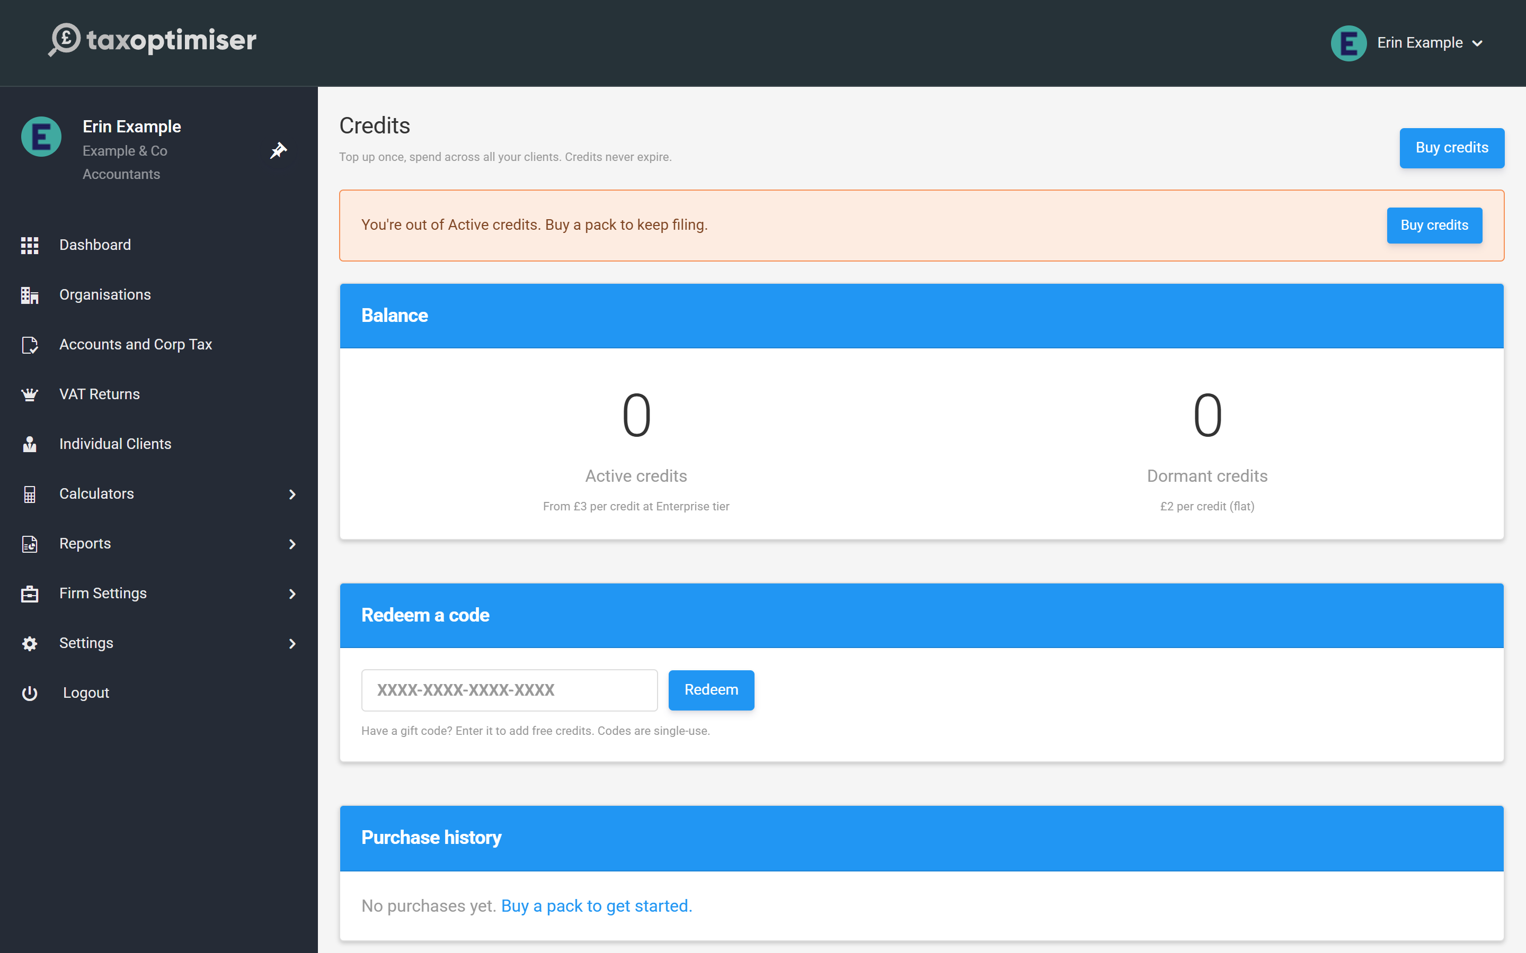

Pre-flight
Open Companies House Submission from the period menu. The first step lists every requirement with its status, so nothing surprises you at the send step:
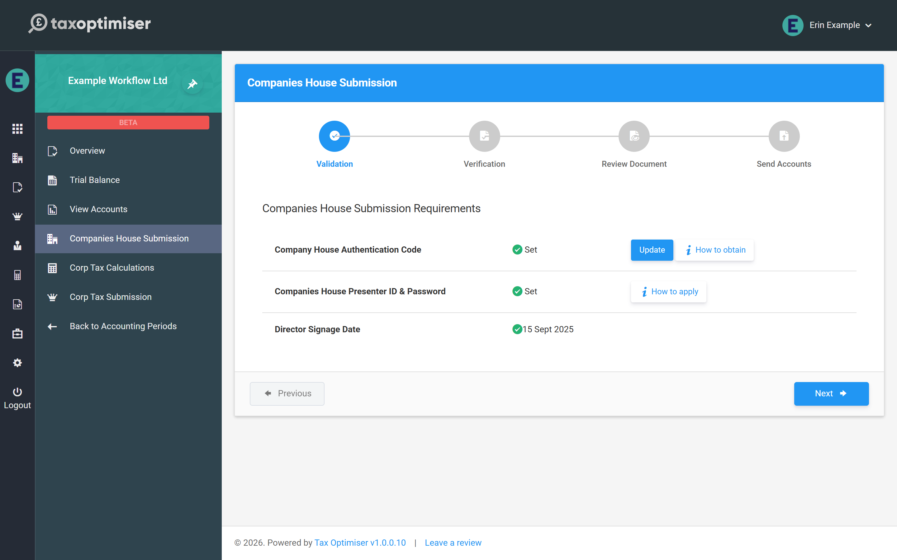
- Authentication code — the client’s 6-character Companies House code (on their organisation record).
- Presenter ID & password — your firm’s, from Firm Settings (see the credentials rules).
- Director signage date and the accounts out of draft — both come from signing the accounts in View Accounts (see Validation and signing).

Through the wizard
From there it’s Verification → Review Document → Send Accounts: confirm the client has approved, give the (usually filleted) document a final read, and send. The step-by-step detail — including choosing full vs filleted at the review step — is in Submitting to HMRC and Companies House.
One firm-specific footnote: every electronic filing carries your firm’s submission sequence number (the read-only counter on the Companies House tab of Firm Settings). It increments by itself; you’ll only ever think about it if filings are also sent under the same Presenter ID outside Tax Optimiser.
After sending, the submission status is tracked on the period until Companies House accepts — electronic filings usually clear in minutes to hours.

7. Sending the CT600 to HMRC
Filing the CT600 for a client: the UTR and Gateway login it needs, what the warnings mean, and the final confirmations before sending.
IN SHORT
- The CT600, full accounts and computation are assembled and sent together
- Needs the client's UTR plus the firm's (or an overriding client) Gateway login
- Warnings are advisory; errors block until fixed or overridden
- Company type and accepting director are confirmed at the send step
- The same period credit covers this filing - nothing extra to pay

The Corporation Tax side files the CT600 with the full iXBRL accounts and the computation attached — Tax Optimiser assembles all three from the period’s data. As a firm you need two things on record before the wizard will send: the client’s Corporation Tax UTR (on their organisation record) and a Government Gateway login — normally your firm’s, filing as agent; a client-level Sender Id overrides it and files as the company (the rules).

The Errors step
Open Corp Tax Submission from the period menu. The wizard opens on anything that needs attention — blocking errors in red, warnings in amber. Warnings are advisory and common ones look like this:
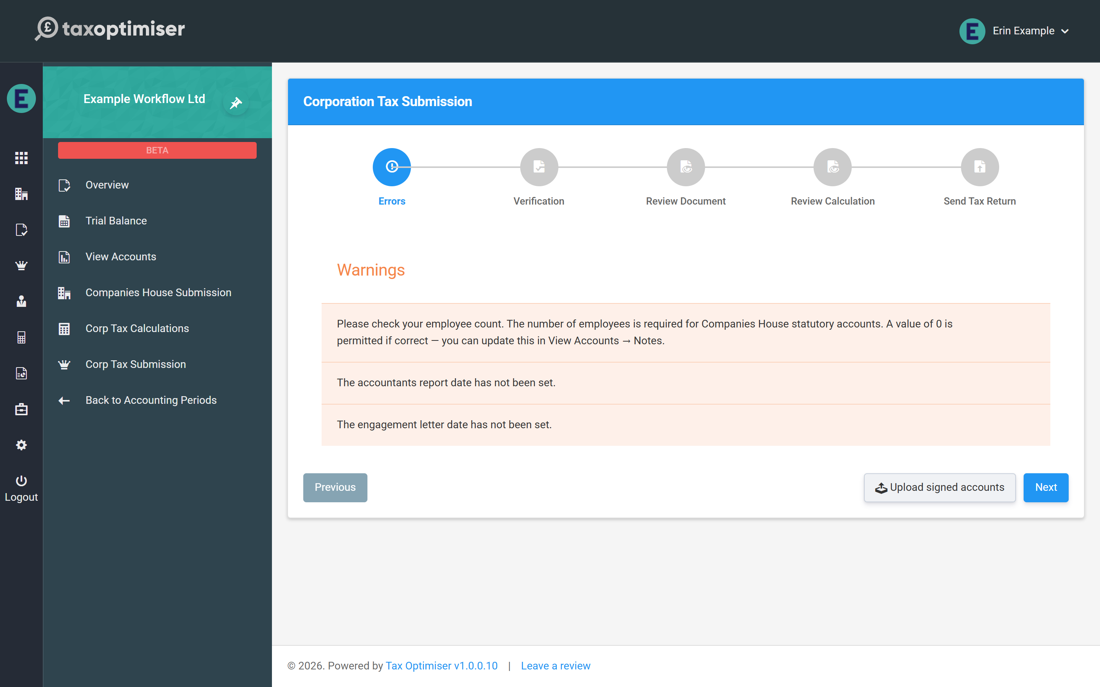
- Employee count — statutory accounts must state the average number of employees; a genuine zero is fine, but confirm it (View Accounts → Notes; see the employee note).
- Accountants report date / engagement letter date — housekeeping dates for the accountants’ report wording in the accounts.
Fixable items offer their fix inline — a missing UTR or signage date can be entered right on this step.

Verify, review, send
The remaining steps mirror the Companies House wizard: confirm the client has approved the accounts, then re-read the full accounts and the computation exactly as HMRC will receive them. The deeper review workflow — what to look for in the computation document — is covered in the Corporation Tax guide’s submission article.
The send step asks for two final confirmations — the company type for the CT600 and the director accepting the declaration — then transmits to HMRC:
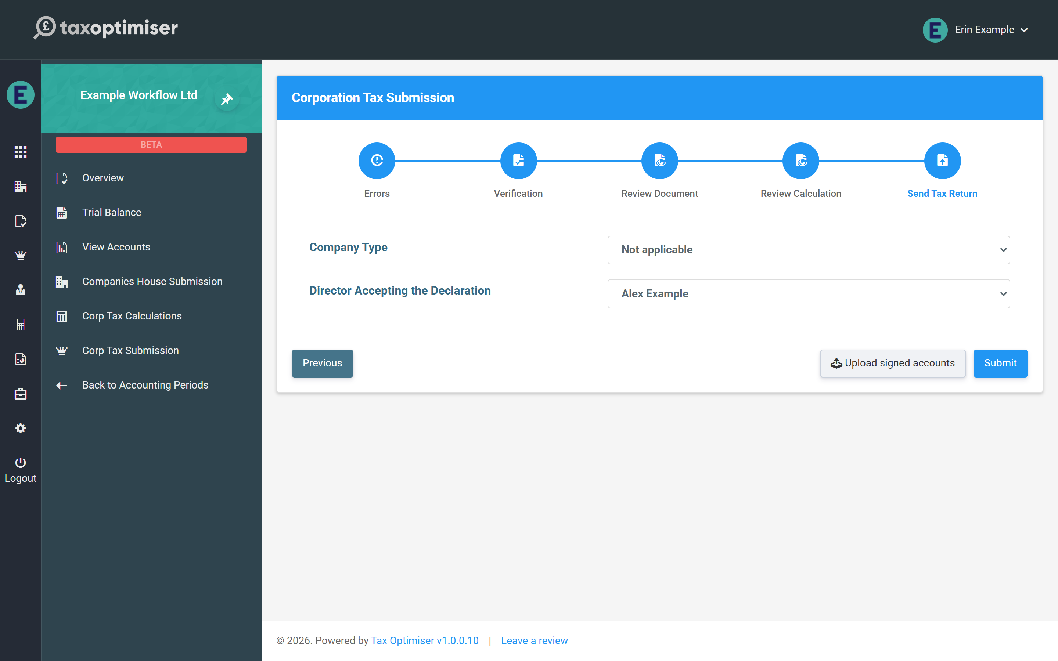
No extra payment happens here — the period’s credit (consumed when the first wizard was opened) covers this filing too (how credits work). HMRC’s response is polled automatically and the receipt is stored against the period; once both filings are accepted, lock the period from the Overview so the filed numbers can’t drift.

